

Job Application Pack
Pastoral Manager


Welcome

Thank you for considering Ridgeway Secondary School. As a school we know how big a decision to make a career change can be and want to ensure we can give candidates a flavour of the school they could be a part of. We appreciate the time you spend considering the post and subsequently look forward to receiving your application. We hope that by reading the pack below and familiarising yourself with key documents that you are able to make an informed decision about the role.

Small School
Big Family

We are a small school of 304 students with big ambitions and a big future. We converted to a secondary school in 2015 and have worked tirelessly since then to become what we are today, a small secondary school where students can achieve big results. Students at Ridgeway are happy, polite and well behaved, supported by their peers and a pastoral system which nurtures and guides students

to make good decisions and gain experiences that prepare them for the world of work and later life.

There is something about being at Ridgeway, maybe it comes from being a small school and the advantages that brings for students and staff in forging positive relationships and friendships. We are a small school, a friendly school,


a big family. Ridgeway is about people. It is a place where we know our students, our staff and where every single person counts and is recognised for making a difference to our success. We hope that by reading this information and visiting the school you will gain a sense of what it means to be at Ridgeway. We look forward to welcoming you.

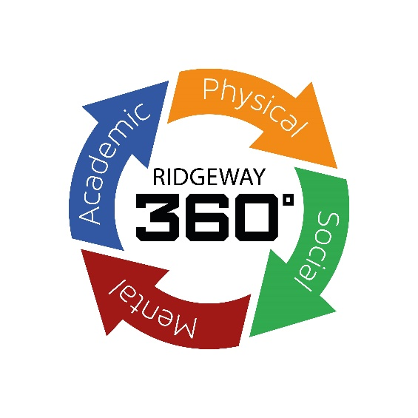
Vacancy Details
Pastoral Manager

Non-teaching
Full time
Required for November 2023 for maternity cover until 31.08.2023

Closing Date: Friday 17th November 2023

Ridgeway Secondary School is seeking an energetic, hardworking and resilient person to join our Pastoral Team. You will play a key role in supporting the personal development and academic achievement of our students within a small and dedicated Pastoral Team.

The role will support wider development and would suit candidates with experience of working with young people. Ridgeway is a small secondary school with 300 students on roll, so talented colleagues can make a huge impact and contribute to whole school ethos.

Following a poor OFSTED judgement in 2021 the school has rebuilt and with driven leadership and direction is progressing with its vision to return to being the school of choice locally. Students are polite and courteous, and it is hard to communicate effectively just how much potential for excellence there is within the school. This is an exciting time to join our school community and make a real difference to a school has improved rapidly.

We would welcome potential candidates to come and visit the school and gain a sense of what it means to be a part of Ridgeway.

Interested candidates who wish to have an informal conversation about this role are welcome to contact Matthew Ball, Headteacher. Further information, including job description, person specification and application form, are available from the school website www.ridgewaysecondary.org.uk, alternatively please email slt@rss.shiresmat.org.uk.
Applications should be made via the Ridgeway application form addressed to the Mrs H Rea, PA to Headteacher on hrea@rss.shiresmat.org.uk
Shires Multi Academy Trust is committed to safeguarding and promoting the welfare of children and expects all
staff and volunteers to share this commitment. All offers of employment are subject to an Enhanced DBS
check, and where applicable, a prohibition from teaching check will be completed for all applicants.
In accordance with our statutory obligations under Keeping Children Safe in Education, Shires Multi Academy
Trust is required to conduct an online search as part of our due diligence on appointed candidates. This may
help identify any incidents or issues that have happened, and are publicly available online, which the Shires
Multi Academy Trust might want to explore with you. The Trust is committed to the promotion of
equal opportunities and diversity. Ridgeway Secondary School is a company limited by guarantee.

Appointment will be subject to references and an Enhanced DBS check in line with school safeguarding policy.

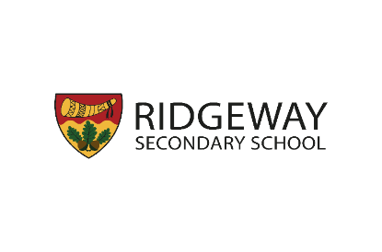

Job Description

Title of Post: Pastoral Manager – Maternity Cover
Salary Scale: SCP 15 - 20
Hours: 37 hours per week (term time only)
Responsible to: Head of Key Stage/ Deputy Headteacher

Post Purpose: To support the academic and personal development of all students in a Key Stage.

General responsibilities and duties:
- To carry out the professional duties as reasonably requested by the Headteacher.
- To act as a role-model for students and other members of staff and represent the
school in a manner consistent with its ethos and values.
- To respect the confidential nature of information in relation to the school and students.
- Attendance at appropriate staff meetings and parents evenings.
- To promote and safeguard the welfare of all students at Ridgeway Secondary School.
Principal Responsibilities:
- Provide support and advice to students in line with promoting their personal development, behaviour and welfare.
- Respond to and take steps to resolve relationship issues between students and develop their social skills and self-management techniques.
- Provide general student support outside of the classroom.
- To apply Behaviour Management systems so that effective learning can take place.
- To assist with the organisation of house competitions, celebration assemblies and rewards trips/events.
- Follow up attendance matters, including for agreed target students and contact or meet with parents/carers this will include home visits when required in own car.
- Collect and collate statements relating to incidents, following up directly when appropriate Issue, collect and follow up individual report cards for identified students and to monitor students on amber report cards.
- Contribute to pastoral support plans.
- Be aware of and comply with policies and procedures in relation to child protection and all aspects of safeguarding children.
- Supporting students who are absent for longer than usual periods of time due to e.g. illness, bereavement etc. and ensure that work is sent home if appropriate.
- Continuing the support on the student’s return to school.
- To complete referrals for student to outside agencies for support as requested.
- To monitor new in-year students especially in terms of induction, contacting previous schools to gather appropriate information.
- To escort students to and from lessons when appropriate e.g. from a classroom to a referral room.
- To liaise with the Pastoral Team and SENCo.
- To collect background information regarding incidents, record these on the appropriate forms and make appropriate decisions with respect to the referral of these incidents.
- Update student records e.g. behaviour log online where appropriate, student files etc.
- To support students with problems including support in the classroom where possible.
- To be aware of “vulnerable” students and to monitor their well-being and academic progress.
- Liaise with Attendance Officer and Assistant Headteacher to support the attendance of vulnerable students.

Communication and Liaison
- Be the first point of contact for parents/carers, being responsible for and dealing with issues when
appropriate and referring to other staff for action.
- Ensure contact is made to parents/carers whenever incidents are dealt with – e.g. bullying, racist
incident files.
- Produce appropriate records of incidents dealt with – e.g. bullying, racist incident files.
- Arrange for work to be set and collated for exclusion and other student absence.
- Seek reports on student progress from staff.
- To contact students with messages relating to lessons, messages from home, collecting
information from form tutors etc.
- To speak to parents/visitors relating to student support.
- Arranging for appropriate times for meetings with staff between parents, students and external
agencies as needed.
- To liaise with the school's Attendance Officer to identify specific areas of concern or where
progression is needed regarding absence/lates.
- To communicate effectively with all staff within the school.
- To follow agreed policies for communications in the school.

Staffing:
- To take part in the school’s staff development programme by participating in
arrangements for further training and professional development.
- To continue personal development in relevant areas and in line with whole school priorities.
- To engage actively in the Performance Management Review process.
- To ensure effective/efficient deployment of classroom support
- To work as a member of a designated team and to contribute positively to effective
working relations within school.

Quality assurance:
- To help implement school quality procedures and to adhere to those.
- To contribute to the process of monitoring and evaluation of the pastoral system in line with agreed school procedures, including evaluation against quality standards and performance criteria. To seek/implement modification and improvement where required.
- To take part, as may be required, in the review, development and management of activities relating to the curriculum, organisation and pastoral functions of the school.

Management Information:
- To maintain appropriate records and to provide relevant accurate and up to date information for SIMs, Epraise, Heads of Key Stage and Deputy Headteacher.
- To complete the relevant documentation to assist in the tracking of students.
- Collect and collate statements relating to incidents, following up directly when appropriate Issue, collect and follow up individual report cards for identified students and to monitor students on amber report cards.
- Contribute to pastoral support plans.
- To complete referrals for student to outside agencies for support as requested.
- To collect background information regarding incidents, record these on the appropriate forms and make appropriate decisions with respect to the referral of these incidents.
- Update student records e.g. behaviour log online where appropriate, student files etc.
- To track student progress and use information to help teachers inform teaching and learning.

Management of resources:
- To contribute to the process of the ordering and allocation of equipment and
materials.
- To assist the Head of Key Stage to identify resource needs and to contribute to the
efficient/effective use of physical resources.
- To cooperate with other staff to ensure a sharing and effective usage of resources
to the benefit of the school, department and the students.
- To ensure that the designated pastoral area is kept in good order with high quality
displays.

Commitment to Safeguarding Children:
- Promote and safeguard the welfare of children and young persons you are responsible for
or come into contact with by:
- Having excellent knowledge of the school safeguarding policy and procedures regarding child protection.
- Be aware of the signs and symptoms of abuse by attending relevant safeguarding training.
- Understanding and support the school by attending training relevant to current national safeguarding issues such as The Prevent Duty, Child Exploitation, Female Genital Mutilation.
- Report all causes for concern to the Safeguarding team using detailed and accurate information.
- Ensuring the safety of all students in the school learning environment both indoor and outdoor.
- It is a requirement of all staff to report any actual or potential risks to the safety or welfare of students to the Designated Safeguarding Lead (or in the case of staff to report to the Headteacher).

School Ethos:
- To play a full part in the life of the school community, to support its values and ethos and to encourage staff and students to follow this example.
- To promote actively the school’s corporate policies.
- To comply with the school’s Health & Safety policy and undertake risk assessments as appropriate.
- To comply with the school’s GDPR policy.
- To comply with the school’s Code of Conduct for employees.

Equalities:
- To understand and comply with the Equality Information and Objectives Policy.
- The Trust is committed to the promotion of equal opportunities and diversity.

Whilst every effect has been made to explain the main duties and responsibilities of
the post, each individual task undertaken may not be identified.

Signatures:

The school will endeavour to make any necessary reasonable adjustments to the job and
working environment to enable access to employment opportunities for disabled job
applicants or continued employment for any employee who develops a disabling condition.

This job description is current at the date below but will be reviewed on an annual basis
and following consultation with you, may be changed to reflect or anticipate changes in the
job requirements which are commensurate with the job title and grade. The job description
should be seen as enabling rather than restrictive and will be subject to regular review.

Special Requirements:

An enhanced Disclosure and Barring Service (DBS) check and references will be
requested in the event of a successful applicant. Where applicable, a prohibition from
teaching check will also be completed.

Signed ………………………………….. Signed …………………………………….
(Issued by - Headteacher) (Received by – staff member)

Dated …………………………………… Dated ………………………………………

Pastoral Manager: Person Specification

Qualifications and Experience | Essential | Desirable | Evidenced by A, I, T
Hold GCSEs or equivalent qualification in at least English and Maths | ✓ |  | A
Educated to degree level in a relevant subject |  | ✓ | A
Undertaken behaviour management and safeguarding training |  | ✓ | A I
Evidence of commitment to continuing professional development | ✓ |  | A I
Developing and delivering individual and group-based support to students/young people | ✓ |  | A I
Working with students/young people with behavioural issues | ✓ |  | A I
Supporting students’/young peoples’ SMEH needs | ✓ |  | A I
Implementing behaviour management strategies |  | ✓ | A I
Experience of creating individual intervention programmes for students |  | ✓ | A I
Experience of handling child protection and welfare cases |  | ✓ | A
Relevant experience of employment or placement in Education | ✓ |  | A
Use ICT effectively and creatively to enhance learning | ✓ |  | A I T
Experience of data entry and extraction i.e. student data | ✓ |  | A I
Involvement in and organisation of wider school activities, including extra-curricular activities | ✓ |  | A I
Knowledge of recent initiatives and issues in education |  | ✓ | I
Knowledge and Skills | Essential | Desirable
Knowledge of common pastoral issues and how to respond to the different situations which may arise. | ✓ |  | A I
Knowledge of child protection and safeguarding procedures | ✓ |  | A I
Knowledge of statutory requirements regarding the education sector and student wellbeing | ✓ |  | I
Knowledge of legislation regarding student attendance, safeguarding and data protection | ✓ |  | I
Knowledge of local and national support services that are available to pupils and schools | ✓ |  | A I
Proven awareness and respect for the highly sensitive status of information and its confidentiality | ✓ |  | A I
Excellent written and verbal communication skills | ✓ |  | A I
An ability to motivate colleagues | ✓ |  | A I
Knowledge of child protection and safeguarding procedures | ✓ |  | I
Knowledge of intervention strategies, including those in relation to behaviour and attendance | ✓ |  | I
A good understanding of child development, learning processes and barriers to learning | ✓ |  | I
Ability to work as part of a team, as well as independently | ✓ |  | A I
Good organisational and time management skills | ✓ |  | I
Adapt activities to ensure they are inclusive | ✓ |  | A I
Identify triggers of poor behaviour and barriers to learning | ✓ |  | A I
Manage projects and lead a group | ✓ |  | A I
Develop and implement effective support strategies | ✓ |  | A I
Ability to communicate effectively with students, colleagues and parents/carers | ✓ |  | A I
Demonstrable ability to problem solve and focus on identifying and acting on solutions | ✓ |  | I
Ability to manage behaviour effectively | ✓ |  | I
Ability to work within school-based systems and specified timelines | ✓ |  | A I
Personal Qualities | Essential | Desirable
Excellent interpersonal skills with the ability to maintain strict confidentiality | ✓ |  | I
Ability to work calmly under pressure | ✓ |  | I
Confident, polite and friendly manner | ✓ |  | I
Build positive and productive relationships with staff members, pupils and parents | ✓ |  | A I
Effectively motivate and encourage students | ✓ |  | A I
High levels of drive, energy and integrity | ✓ |  | A I
A well-developed sense of empathy | ✓ |  | A I
Demonstrate ability to prioritise | ✓ |  | I
A willingness to work outside of the timetabled day, where necessary | ✓ |  | A I
The ability to maintain successful working relationships with other colleagues | ✓ |  | A I
High expectations of self and professional standards | ✓ |  | A I
Enthusiasm and commitment to developing the whole student | ✓ |  | A I
Ability to embrace innovation and change | ✓ |  | A I
Ability and willingness to contribute to whole school improvement programmes | ✓ |  | I
Able to follow direction and work in collaboration with the leadership team | ✓ |  | I
Able to work flexibly, adopt a hands-on approach and respond to unplanned situations | ✓ |  | A I
Commitment to the highest standards of child protection and safeguarding | ✓ |  | I
Other Requirements | Essential | Desirable
Enhanced DBS Disclosure | ✓ |  | A I
Ability to understand and demonstrate a commitment to equality and diversity | ✓ |  | A I

Small School
Big Ambition


What do we stand for?

Our mission is to develop the whole person and we are committed to Ridgeway 360° for all our students and staff. Ridgeway 360° is at the heart of what it means to be at Ridgeway and underpins everything we do both inside and outside the classroom, developing young people and staff academically, mentally, physically and socially so that they leave our school a fully rounded person, equipped to meet the challenges of the next steps they take.

Small School
Big Results

Academic Excellence
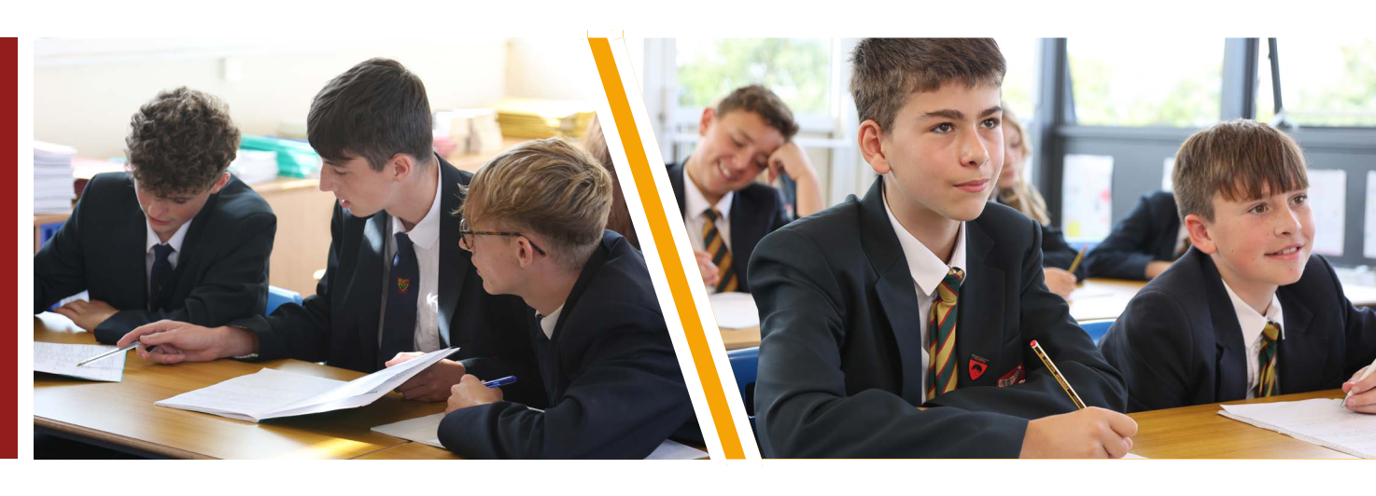

Creating an ethos of personal development and high standards enables our students to achieve academic success. Students and staff work hard and teachers use the latest evidence-based research to ensure knowledge and skills are embedded in the long-term memory. The curriculum and the lessons within it are carefully planned

in a sequence that is most conducive to retaining and applying information. As a result, our students are well placed to achieve the highest possible grades at GCSE and make excellent progress. They go on to study a wide range of courses at the very best 6th Form providers and colleges.

Small School
Big Opportunities

Curriculum

The curriculum at Ridgeway is central to our aim to develop the whole person. It is broad and varied, offering students the opportunity to learn and develop key learning skills and a depth of knowledge across a range of subjects as they journey through the school.


By coherently planning and sequencing each stage in the learning journey students benefit from a knowledge and skills rich curriculum that aims to develop all students regardless of their starting point or disposition.

In Key Stage 3, students develop new skills and refine those that they have already learned. The Key Stage 3 curriculum lasts for 3 years, giving students the opportunity to study subjects in greater depth and develop the skills, knowledge and understanding required to be successful at GCSE in Key Stage 4. The Key stage 4 curriculum has
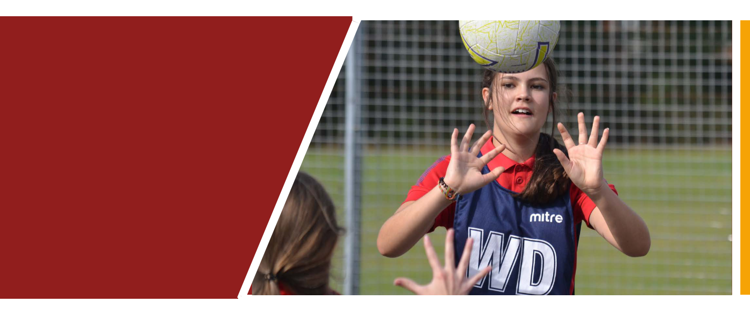

been broadened and offers a rich blend of subjects tailored to the strengths, interests and needs of the cohort. At the end of Year 9 students are selected to study the separate Sciences of Biology, Chemistry and Physics. We believe in offering subjects that allow a wide range of pathways and progression for our students in the future.


Small School
Big Futures

Careers

At Ridgeway, careers education is not an ‘add on’ to education, it is a key component of everything that we do. Within subject areas, careers education is embedded into the curriculum allowing students to see different career options within the context of their lessons.

All students receive at least one 1 to 1 careers guidance appointment from a level 6 qualified careers adviser. This helps everyone to explore a range of different pathways for success after Ridgeway. This is also done through PSHCE, as each year group have dedicated lessons to develop skills to prepare them for their future careers.

We care about every individual being successful,

not only while they are at Ridgeway but also long after

they have left.


Small School
Big Heart

Pastoral

At Ridgeway, we offer a bespoke and specialist level of pastoral care to meet the different needs of each student. Our well-equipped and highly trained Student Services and Reconnect teams work tirelessly to ensure our students can be safe, happy and engaged with all that school life has to offer.

The team is made up of key stage leaders responsible for each key stage in the school: their role is to monitor, challenge and support everything from welfare and attendance to behaviour and mental health. Alongside this we have a dedicated student and family support worker who forms a support system around the child by engaging with parents and carers, the student, the school and appropriate external agencies to reduce or break down any barriers to learning that may arise.
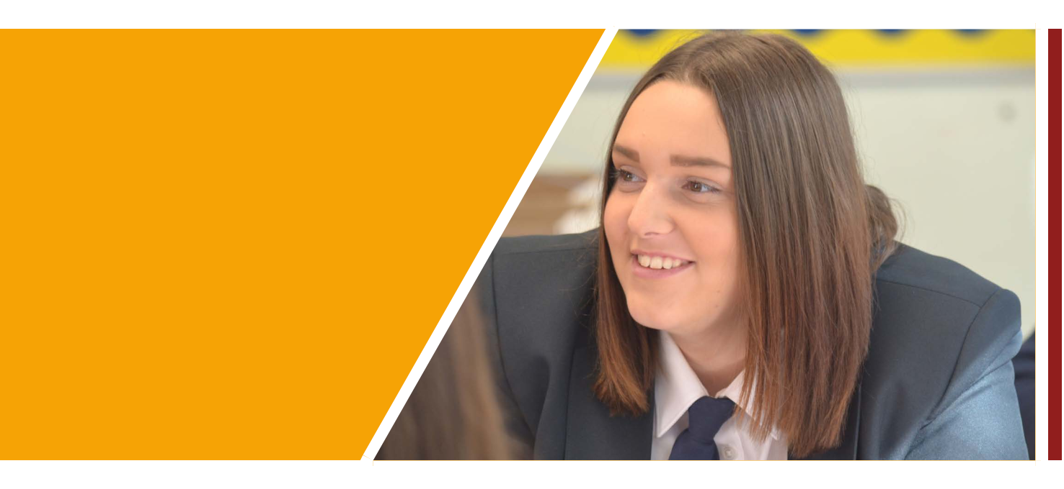

Ready, Respectful, Safe

The three words that every Ridgeway student knows are ready, respectful and safe. Quite simply these are the words that underpin every desirable behaviour that the school expects. With these rules it is easy to reinforce the high expectations we have as a school.

Ready: this refers to anything from attention, uniform, equipment or punctuality.

Respectful: relates to communication and interaction with the school environment and all of those in it.

Safe: ensures we have an emphasis on maintaining a calm and safe environment for all to flourish.

Small School
Big Experiences

Personal Development

At Ridgeway we deliver a broad and extensive Personal Development curriculum within form time. This time is spent developing each student in our four pillars of development: Academically, Socially, Physically and Mentally. In this time students will cover topics ranging from how to stay safe online and making healthy friendships to leading an active life and how to reduce stress and study effectively.

In addition to the Personal Development curriculum, we also offer an extensive enrichment programme to all students every Thursday afternoon after school. These sessions have a link to one

of the schools’ pillars and activities include everything from learning an ancient language to self-defence.

Alongside this, students have access to extra-curricular clubs in other areas across the week from competitive sport and activities to music and the arts.

At Ridgeway we understand that learning about who we are and developing as a person does not just happen in the classroom. There are those priceless experiences that we all remember from our time at school. The residential trips, visits and sports fixtures that build character and forge memories that stay with us until today.
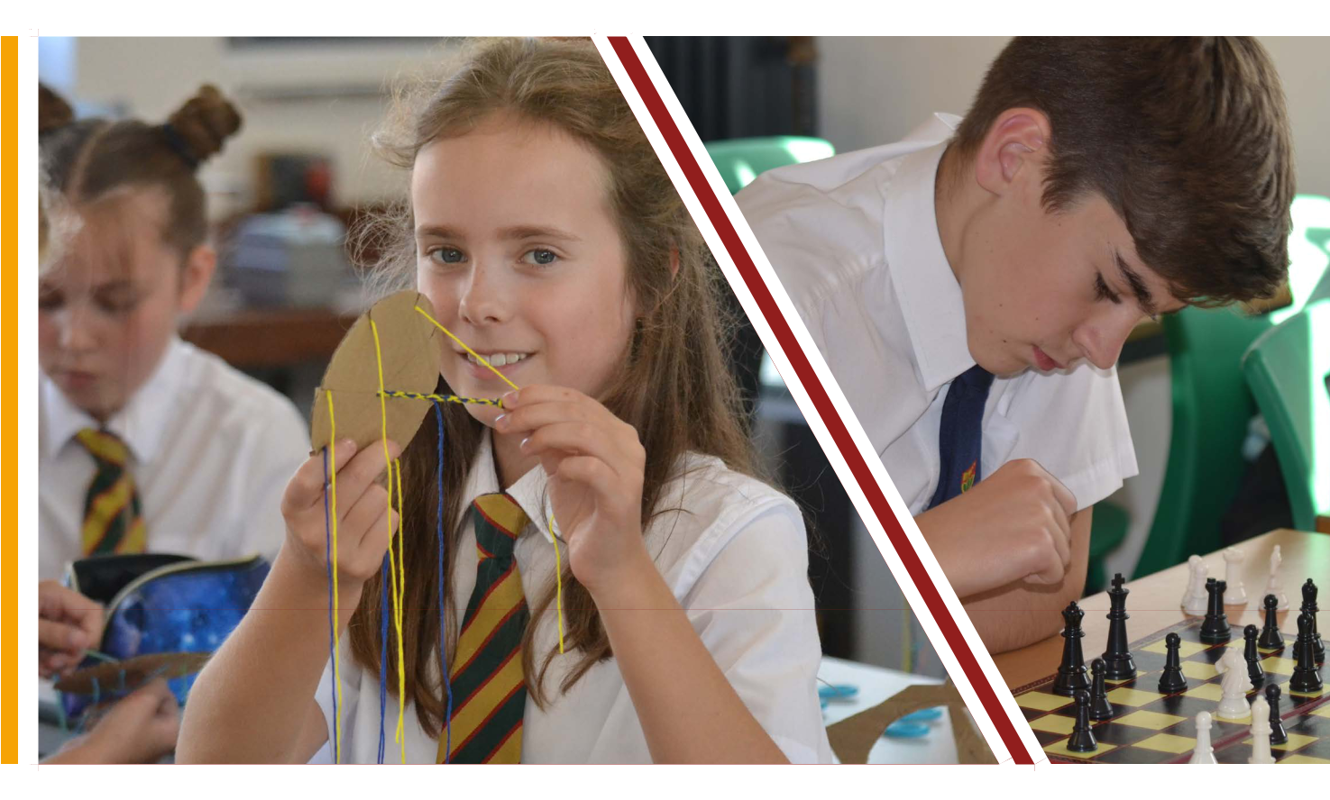

As students’ progress through the school, they have opportunities to take advantage of trips and experiences outside of the classroom. Ski trips, residentials for outdoor activities, foreign exchange visits, sports tours, museum visits and theatre performances all feature in the programme. The school also offers the Duke of Edinburgh Award to its students from Year 9 onwards with students achieving both bronze and silver levels of the award.

Thank you for your consideration of this post


Ridgeway Secondary School,

Evesham Road, Astwood Bank,

Redditch, Worcestershire B96 6BD

Tel 01527 892867

Web ridgewaysecondary.org.uk

