Skills and Techniques  Forehand- A forehand shot is where the racket is away from the body, for example if you are right handed the racket will be towards the right side of your body.  Backhand- A backhand shot is where the racket is across the body and towards the opposite side to your strong hand. For example if you are right handed it will be across your body and hitting from the left side.  Serving- There are 4 types of serve: Low, High, Flick and Drive. The low is gently placed over the net to land at the front of the court. The high is opposite, a powerful serve which lands at the back of the court. The flick serve is similar to the high but lands more mid court. The drive serve is a flat, low and powerful serve which is aimed towards the back of the court.  Grip- The grip of the racket is very similar to a hand shake. To test you have the correct grip hold the racket head in your hand, then carefully slide your hand down the racket. Then, wrap your fingers around the handle. You will slightly change your grip when you play a backhand shot as your wrist will turn towards the net.  Footwork- Side stepping will be the majority of the footwork you do, it allows you to move around the court efficiently while still maintaining proper hitting form. Your legs should be square with your body and move side-to-side. Regardless of the direction you are moving, your head should always be facing the net. | Skills and Techniques  Drop shot – A drop shot is a front of court shot, similar to a net shot but from mid court. It travels a long distance but aims to drop to the floor as soon as it goes over the net. The shuttle needs to be hit with a high elbow at the highest point possible to ensure it reaches the opponents court side.  Smash shot – This is a powerful shot which most of the time will win you the point. It is a mid-court shot which moves in a downwards motion very powerfully so it is almost impossible for your opponent to return the shuttle. This is in a downwards motion and power is needed from your shoulder and arm.  Net shot – This is where the shuttle glides just over the net, almost in touching distance. This is a hard shot to return as it is very low to the floor when it goes over the net so the player must be quick to get low and return this. You must lean over the net ensuring you do not touch it and hit the shuttle gently in a downwards motion.  Clear shot – This is a long shot which aims to land in the back tram line of the court. This is helpful if your opposition tends to play close t the net as they will not have much time to get to the back of the court to return the shuttle. To ensure this is successful you must ensure your elbow is high and you make contact with the racket and shuttle at its highest point with a lot of power.  Singles court – short and wide  Doubles court – Long and narrow | Glossary  Shot Serve Net Rally Smash Drop Drive  Forehand Backhand Grip Footwork Underarm  Shuttlecock Racket Overarm Tramline Flick  Singles doubles High Low Short Long  Pictures  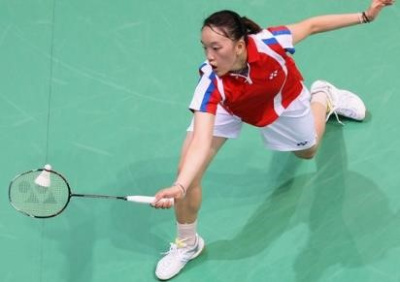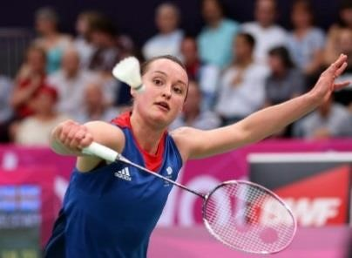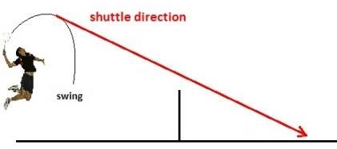  Backhand  Forehand  Smash shot
Rules  - After the serve is returned, you and your opponent will hit the shuttle alternately until s ‘fault’ is made or the shuttle goes out of play. This is called a rally.  - A badminton match consists of the best of 3 games. In men's, the first side to score 15 points wins the game. In women’s, the first side to score 11 points wins the game.  - To score a point you need to get the shuttle to land anywhere on your opponent’s floor without them being able to return it. Also, you can score if your opponent returns the shuttle and it lands outside of the court on your side. Similarly, you can score a point if any of the following faults are made by your opposition:  - The shuttle goes under the net  - The shuttle hits the wall, ceiling or any player  - The player touches the net with any part of their body or racket  - Deliberately distracting your opposition  - If the shuttle is hit twice before it goes over the net  - In doubles the whole court is used however, in singles the back tram line is classed as out. | Tactics  - Hitting the shuttle consistently high and deep to give time to recover  - Try to aim shots to the opponent’s weaker side (usually backhand), to give the advantage of a weak return.  - Try to pace shots before adding more power, because more power will usually result in more errors.  - Try to keep your opponent on the move as much as possible, rather than ‘rally’. Try moving the opponent from the net to the back of the court and from the forehand to the backhand side to fatigue them quicker.  - Keep winning: Keep playing the same way  - Keep losing; Change the style of play  - Try to change the speed of play, by mixing up shots. For example hit some slower shots, such as, drop shots and net shots, with faster shots in between, such as smashes and drives.  - Always play to your personal strengths – shots/movements you are good at.  - Exploit your opponent’s weaknesses. Find out their weaknesses and play shots to force errors. | 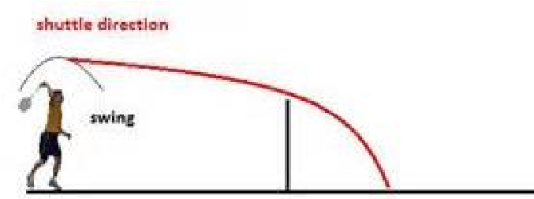  Drop shot  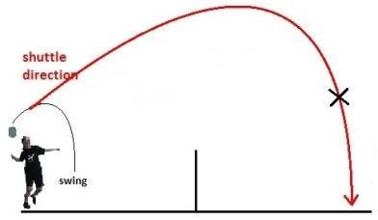  Overhead clear  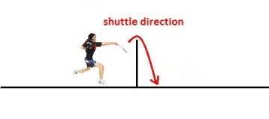  Net shot  