Key Skills/Techniques  Dribbling  Dribbling allows you to move the ball around the field without losing possession.  Keep the ball close to your feet at all times, when running with it.  Use the inside of your foot to control the ball when moving.  Don’t look down when running with the ball. Keep your head up.  Passing  Non-kicking foot is closest to the ball.  Kicking foot needs to be at a right angle to the ball.  Body need to be over the ball.  Eyes focused upon the ball and arms are to be used for balance.  Shooting  Non kicking foot needs to be next to the ball and players needs to keep their body balanced with their head slightly over the ball.  Contact the ball either with the side of the foot (placement of ball) top of the foot (to generate power).  Both legs need to be fixed but when striking the ball, kicking foot needs to be fully extended on the follow-through.  For accuracy, aim to shoot between the goal keeper and the posts  Heading The forehead is used to contact the ball. Eye must be focused on the ball. Meet the ball with your head by moving your feet or jumping to gain the extra height advantage and power. Do not wait for the ball to hit your forehead.  Chest – Used when the ball is played in the air, to bring it down onto the floor. Player needs to align himself with the ball. Roll their shoulders back to generate a greater surface for the ball to contact with. Chest needs to be slightly curved, to cushion the ball. Bend your knees to take the impact of the ball and then allow the ball to roll down your leg to your kicking foot. | Rules/Tactics  Rules  Game is started with a kickoff or restarting it after a goal is scored. It is taken at the centre part of the soccer field. During a kickoff, both teams must be on their own halves and only the kicker and the receiver can be inside the centre circle.  The game has 11 players on the pitch, consisting of a goal keeper, defenders, midfielders and strikers. A referee and 2 linesmen, officiate the game. If the ball is played outside of the pitch lines, the possession is given to the opposing team. If it goes out the side of the pitch, a throw in is awarded. If it is kicked behind the A corner kick is awarded when the whole of the ball passes over the goal line, either on the ground or in the air, having last touched a player of the defending team. If the attacking team hit the ball behind the goal line a goal kick is awarded.  If a foul is committed a free kick or penalty is issued, depending on the incident.  To score a goal the ball must cross the opposition’s goal line.  The team with the most amount of goals at the end of the game will win the game.  Tactics  Vary the passes that you make  Play to your opponents weaknesses (if they are dominantly using their left foot, then play the balls on their right).  Move opponents around he pitch to tire them out.  Vary the pace and direction of passes. | Glossary  Throw in Attack Defend Dribbling Foul  Off side Referee Volley Accuracy  Penalty Pass Formation Goal Ball Posts  Free kick Striker Midfielder Header  Tackle Passing communication Formation  Corner kick  Pictures  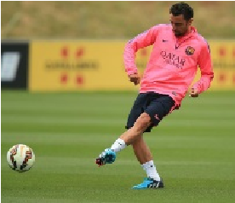  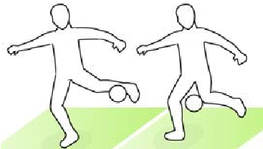  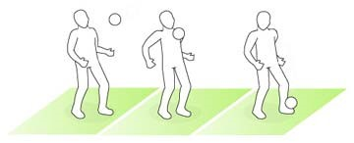
Volley – The volley involves striking a ball that is still in the air. Focus eyes upon the ball. Arms out for balance. Keep eyes focused on the ball as you get into the line of flight. Head still. Non kicking foot on the floor and lead with the kicking leg forward.  Turning with the ball  Cruyff - Great skill for losing your opponent.  Named after the brilliant Dutchman Johan Cruyff.  Shape as if to pass or cross but then drag the ball behind your standing leg with the inside of foot. Turn your shoulders and your hips so that you are back in line with the ball and then race away.  Step over – Skill for sending an opponent in the opposite direction.  Lift your foot over the top of ball to use a 'step over' and this should immediately create you time and space. Then hook the ball away with the outside of the foot and race away.  Inside Hook - You need to keep your body between the ball and your opponent.  Reach round the outside of the ball with your foot so that you can change its direction. Bend your knees so that you can transfer your weight quickly and turn your hips to change your own direction. Then get a positive first touch on the ball that puts it into an area that is comfortable for you to move on to and accelerate away from your opponent .  Outside Hook – This tricks your opponent  Use the outside of the foot to hook the ball back in the direction that you are going to go.  Drag Back - The drag back is a great turn to use when you haven't got a lot of space to work.  Place one foot on top of the ball and staying in contact with it throughout, roll it back and move off in the opposite direction. | Team formation  4-4-2 (4 defenders, 4 midfielders and 2 strikers) a traditional team set up  5-4-1 (5 defenders, 4 midfielders and 1 striker) A more defensive set up.  3-5-1-1 (3 defenders, 5 midfielders, and 2 strikers one in front of each other). A more attacking set up.  Counter attacking – The team withdraws players into their own half but ensuring that one or two players are committed to the attack  Direct long ball football – Often used to deride ‘boring’ teams, the long-ball style of play is genuine route one football. Rather than spending time on the ball picking up the pass, exploiting small gaps in the opposition’s defence or utilising the flanks, the long-ball is employed as an opportunistic method of attack.  Wide/Wing plays – The ball is played to the wings. By spreading the ball wide, you allow a different angle of attack and offer a number of opportunities for the winger; take on the fullback and drag central defenders out of position, cut inside and drive forward at an angle, or whip in a cross from deep for the strikers to attack.  Off side - An attacking player is flagged offside by the assistant referee if there is only one defending player between the player and the goal line at the time the ball is struck. The player should be in active play if the offside offense is to be called.  Throw in - A method of restarting play during the game, when the ball has exited the side of the field of play. Throw in is taken from where it went out. At the moment of delivering the ball, the thrower must face the field of play. The thrower must have part of each foot on the touchline or on the ground outside the touchline, and use both hands to deliver the ball from behind and over the head. | Cruyff Turn Inside Hook  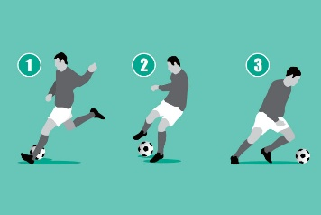  Step over Free Kick  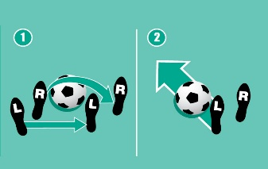  4-4-2 example Throw in  