Skills and Techniques  Orienteering is a sport that require navigational skills using a map and compass to navigate from point to point in diverse and often unfamiliar terrain whilst moving at speed. Participants are given a topographical map, usually a specially prepared orienteering map, which they use to find control points.  Running activities: All lessons start with running activities to encourage pace and speed. Cardiovascular fitness is required over different types of terrain.  Observing surroundings: Look at your surroundings (playground/ cage/ grass areas/ tree) and identify key features that help you find your precise location. You need to observe your surroundings before looking for markings on a map.  Orientating a Map. You need to orientate your map (move it) to line up with the key features on the ground and check it is the correct way round to the direction you are facing.  Directions: - understand the Cardinal Markers – North, South, East and West and their relation to features on the ground and to places beyond the school site.  Map Reading – Recognise symbols on a map, be able to use a key to recognise symbols and colours on an orienteering map.  Human features: Know that a human feature is influenced by man (buildings, benches, fences, walls)  Physical Features: Know that a physical feature is natural (rivers, beaches, hills, forests) | .Skills and techniques  KEY: know the symbols used in the key for the school and fields Maps  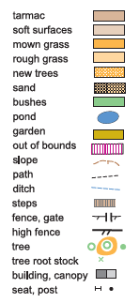 | Glossary  Orienteering, Location, Speed,  Cardiovascular Fitness, Setting a Map,  Navigation, Diverse, Direction, Key,  Cardinal Markers, Terrain, Map,  Compass, Control point, Thumbing  Pictures  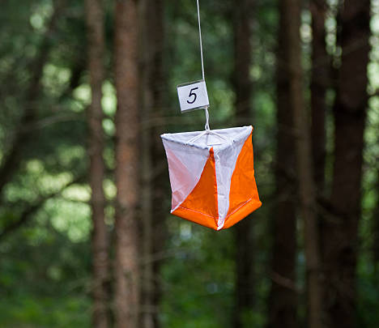  Orienteering flag  - 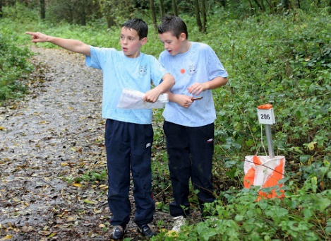  Working as a team
Rules:  The main aim of orienteering is to complete the set course by finding control markers in the correct order in the shortest time.  Although it Is based on accurate map reading it is also a test of physical fitness.  You must find all the controls you are told to visit and record them on your score sheet.  You have to consider the terrain you are moving over ensuring your safety and the safety of any team members at all times, taking into account the varying fitness level of all your team members.  If you are working in a team, you must share the responsibility of finding the controls and make sure that all members of your team have an opportunity to problem solve to find each of the controls.  Team work is necessary when you are completing an orienteering course with others. You must communicate and discuss each decision before navigating to the next control point. Mistakes can easily be made through poor communication.  All control marker are outside, you must not go inside the school building to cut through to find controls.  You and your team must find the controls yourself and not shout out control symbols to others  In order to be given a finish time for finding controls the whole team has to finish together | Tactics  A key tactic to use is pace. You must make sure that you don’t sprint off too quickly without orientating yourself and your map. You need to be able to keep a steady pace up all the way round the course.  You need to be able to orientate your map quickly by finding key features on the ground and then lining yourself and your map up to face the same direction  Each time you change direction whilst you are running you should change your grip on the map so that the map is re-orientated and remains facing the same direction as the features on the ground.  Star exercises: In a start exercise you have to run out from a central start point to a control and remember the answer on the control marker, if you are in a team you should each remember a different answer if you have to run to more than on control marker.  Courses, sometimes you will be given more than one control to find at a time which makes up a course. You may do a different course to another team and as it’s a race you should not shout out your answers.  Thumbing- to help you know where you are on the map, you mark your position with your thumb. As you move along the ground, you should move your thumb to your new position on the map.  Line features – you can use features on the ground to help you run towards the control marker, (e.g. edge of the cage/ line of trees / fence) so that you can run in the general direction towards a control and then be more precise in your navigation as you get closer to the control. | - .  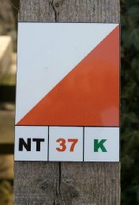  Orienteering Map  Orienteering Control  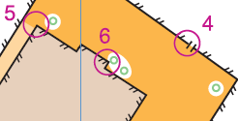  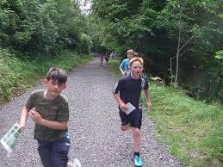  Racing to the finish

