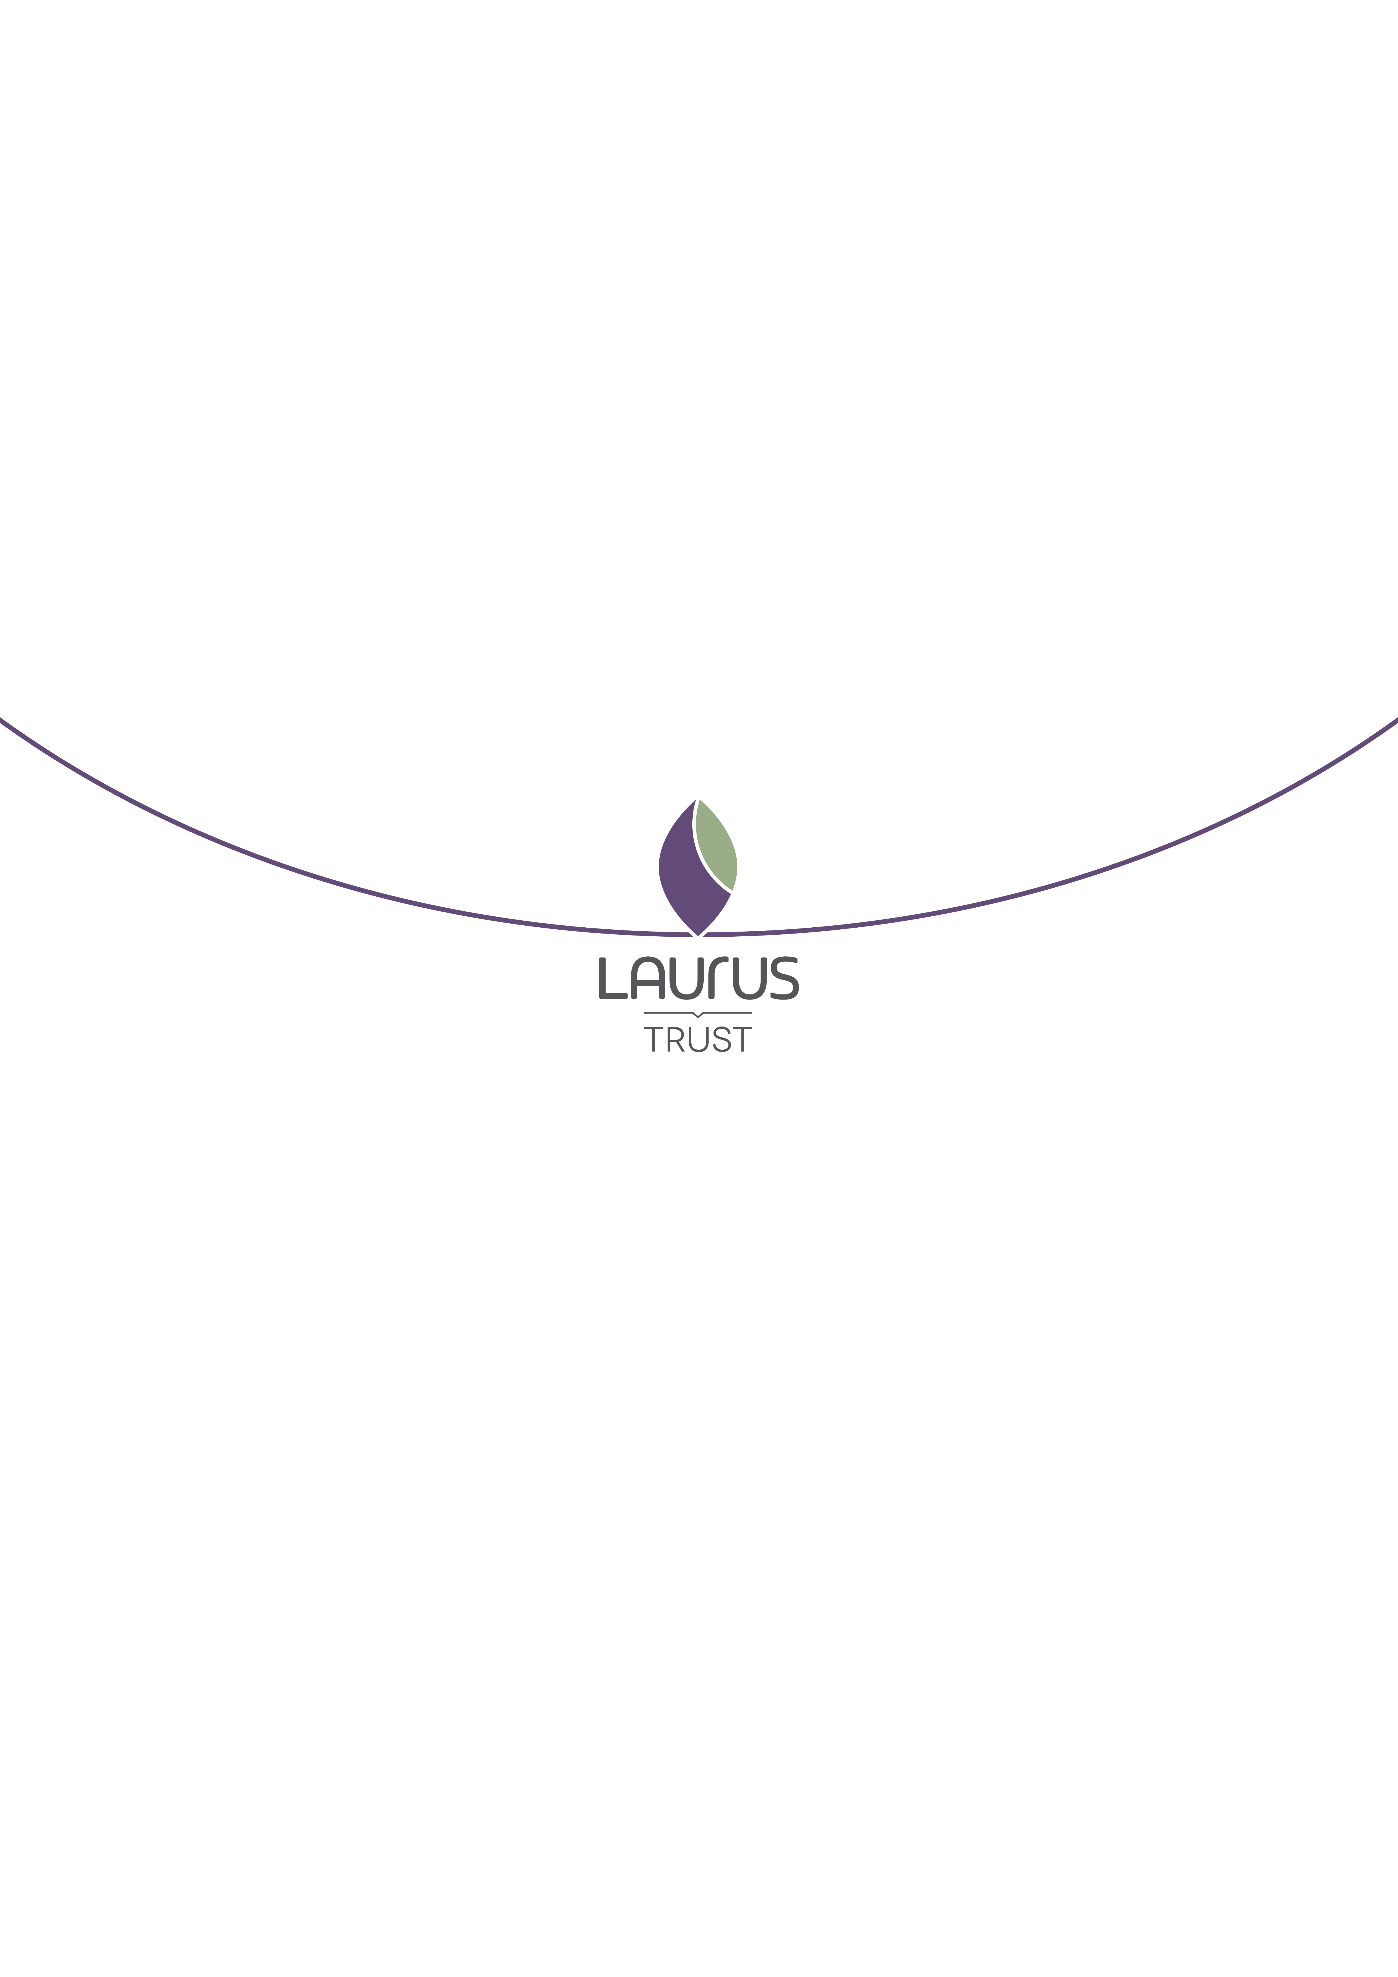
Home Language Examination
Protocol
Author: Tom Coltman
Date of Review: 17/09/26
Date of Next Review: 01/09/27

Contents
Applications and Decisions on Home Language GCSE entry 3
Timeframes and Entries 3
Administration and Preparation for Home Language GCSE Examinations 4
Administration of Exams 4
Preparation for Exams 4
Languages Available for GCSE Examination in England 6
Cost of Home Language GCSE Exam Entry 7
Applications 7

The Laurus Trust recognises the value and importance of all languages and the rich cultural heritage of all our learners, of their parents/carers and of the wider community.

We therefore aim to promote and support access, wherever possible, to accreditation through GCSE examinations for Home, Heritage and Community Languages.

In order for us to balance this aim with the practicalities of offering Home Language GCSE examinations in our schools, we have developed the following guidance and protocols.

Applications and Decisions on Home Language GCSE entry

All applications for Home Language examinations must be made by 31 December for the examinations taking place in the following June series. The application form can be found by clicking on the link below:

Home Languages Application Form

Home Language examination entries will depend upon the school being able to source a suitably qualified and experienced examiner for the Speaking exam. This cannot be guaranteed for all Home Languages and any final decision on whether to enter a student will be taken by the Laurus Trust Director of Languages.

In the event that we cannot facilitate an exam, a list of centres offering GCSE examinations to external candidates can be found below:

Private Candidates - JCQ Joint Council for Qualifications

Timeframes and Entries

In Laurus Trust schools, only students in Year 10 can be entered for Home Language GCSE examinations.

The rationale for this is as follows:

- To avoid a clash with other GCSE examinations, which may have a detrimental impact on those subjects. All Laurus Trust students take a GCSE Language exam (French/German/ Spanish) in Year 9 and all other GCSE exams in Year 11.
- To ensure that students have sufficient maturity to understand the topic content and assessment requirements of the course, as well as to prepare for, and sit, external examinations

There can be no exceptions. If you would like your child to take a Home Language GCSE in another school year, you will need to find an alternative centre. A list of centres offering GCSE examinations to external candidates can be found below:

Private Candidates - JCQ Joint Council for Qualifications

Administration and Preparation for Home Language GCSE Examinations

It is important to understand clearly what the School can and cannot do with respect to Home Language GCSE exams and to understand the responsibility of the parent/carer.

Administration of Exams

The School can facilitate Home Language GCSE exams by entering the student for the exams, completing all the necessary exam board administration and holding the examinations in a Laurus Trust school.

To avoid facilitating the same Language Speaking exam in multiple schools, often for only one student in each, we will decide on which Laurus Trust schools will hold Speaking examinations and notify parents in January, once the application deadline has closed. Other written examinations will take place in the student’s normal school.

This will mean that your child may need to travel to another Laurus Trust school to take their Speaking exam. It will be the responsibility of the parent/carer to arrange transport for your child to travel to another Laurus Trust school to take their Speaking exam.

Preparation for Exams

Our Language Departments teach French, German or Spanish. Our teachers do not typically have knowledge of other Languages. We are, therefore, not able to offer resources, preparation or support for students taking Home Language GCSEs.

In the case of French/German/Spanish, we can provide revision and support resources but cannot offer to tutor students outside of timetabled lessons.

It is, therefore, strongly advised that either parents, or a private tutor, take responsibility for understanding the requirements for the GCSE examination and preparing the student for the exam.

Please note that the Listening and Reading exams are held at the same time (students sit the Reading exam immediately after the Listening exam). The Writing and Speaking exams will be held on separate dates.

Below is a summary of key information.

GCSE Language exams have four components. Each component is equally weighted and comprises 25% of the overall GCSE grade.

- Speaking
- Listening
- Reading
- Writing

In order to understand the assessment requirements, we recommend that you read the GCSE specification document. This includes details of the following:

- Topics covered in the GCSE
- Assessment objectives
- Mark schemes
- Vocabulary and grammar lists

Full details on all Language GCSEs offered, including specifications and sample assessment material, can be found on the exam board websites:

Pearson https://qualifications.pearson.com/edexcel
AQA https://www.aqa.org.uk

Languages Available for GCSE Examination in England

Unfortunately, not all Languages are available for GCSE examination. Below is a table of the languages currently offered and by which exam board.

Language | Exam Board
French | AQA/Edexcel
German | AQA/Edexcel
Spanish | AQA/Edexcel
Arabic | Edexcel
Bengali | AQA
Chinese (Cantonese) | Edexcel
Chinese (Mandarin) | AQA or Edexcel
Greek | Edexcel
Gujarati | Edexcel
Hebrew (Biblical) | Edexcel
Hebrew (Modern) | AQA
Italian | AQA/Edexcel
Japanese | Edexcel
Panjabi | AQA
Persian | Edexcel
Polish | AQA
Portuguese | Edexcel
Russian | Edexcel
Turkish | Edexcel
Urdu | AQA/Edexcel
Welsh | WJEC

The exam board chosen will be at the discretion of the entering Laurus Trust centre.

Cost of Home Language GCSE Exam Entry

Laurus Trust schools will need to pass on certain costs for Home Language exam entry.

The total cost for parents/carers is £75 and includes the following:

- GCSE exam board entry fees
- Visiting Speaking examiner fees
- Exam invigilation fees

The cost is to be paid via MCAS, once confirmation has been provided that a Laurus Trust school can facilitate the Home Language GCSE exam.

The deadline for payment will be 31 January. Students in receipt of free school meals may be eligible for support with this cost.

Applications

Applications for a Home Language can be made until 31 December by using the following link or using the QR code:

Home Languages Application Form

