This term we are learning about our world and the characters in stories. We will also be using our music and storytelling skills..  1.How can we help the gingerbread man to cross the river?  2. What is the story disaster? Nursery rhyme disaster?  3. What is the story disaster? | 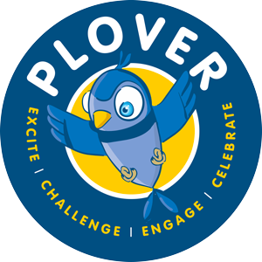 | Areas of the curriculum we are focusing on:  Understanding the world  Literacy  Expressive Arts
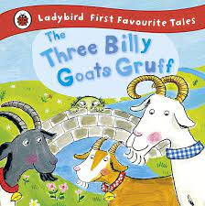 | Once upon a time  Who is in the pages of this book? | 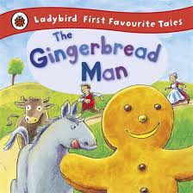
We will learn the stories of 3 Billy Goats Gruff, Gingerbread Man as well as variations of these stories.  Family learning and Celebration of learning  Plover Palace Ball - Come for biscuits and tea and dance at the Plover Palace Ball-Welcome Cinderella 1.7.25 9-10 | Presentation of learning event to the residents of Oaklands Care Home  4.7.25  The children will share their stories with the residents. | Dates  23.4 Character breakfast - the children will meet characters from stories  24.4 Dress up as a storybook character. prize to the most imaginative (not shop bought)  29.4 F2 visit to the library  12.5 Residents from Oaklands Care Home to read stories to the children  20.5 Bakers to help us bake In F2  22.5 Bakers to help us bake in nursery  9.6 Expert visitors from Doncaster Literacy Trust

Home Learning
Theme/Topic Learning | English | Maths | Life Skills
Make a den in your house and pretend to be the Troll. How did you make the den? What did you use? Could you improve it? | Share a traditional story and talk about the characters | Use different objects to create numbers | Practice fastening shoe laces, buckles, buttons.
Can you make an object to help the gingerbread man go across the river? | Find out about an author eg Julia Donaldson - the author of the Gruffalo. | Look at the characters in Goldilocks and the three bears and put in size order. | Help to wash and dry pots.
Make a finger puppet and use to retell a story. You could use a toilet roll. | Make up your own story about a character. Draw a picture of your character to share with your friends. | Practice grouping and sharing with different amounts. Pretend to be in the three bears house and share the objects with the bears. | We are going to taste and make different food. What is your favourite food? Can you try a new food and tell us about it?
What do you celebrate? Can you make a poster with pictures on of your celebrations?  You could share it with your friends | Write your own speech bubble about what your character may say..  eg I can see a ______. I can smell _______. | Explore objects in your house. Which things are heavier and which things are lighter? Which things are bigger or smaller? | Make something to eat at home. This could be baking. Send photos on Evidence Me.
Make a mask and pretend to be one of the characters. | Practice writing your name | Play hide and seek - pretend to be one of the goats. Where were you hiding? | What makes a good friend? Make your friend a picture to give to them at school.

