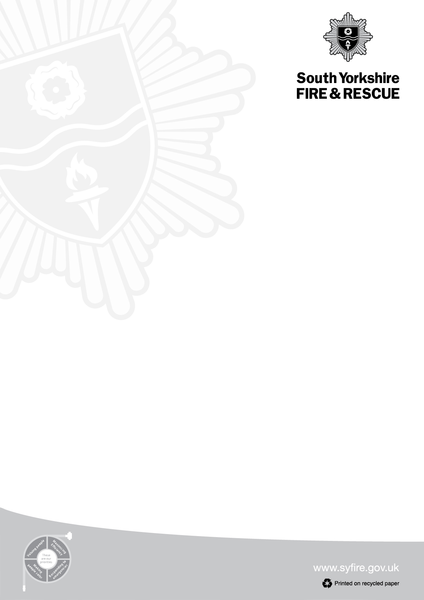

197 Eyre Street

Sheffield

S1 3FG

Tel: 0114 2727202

Fax: 0114 2532266

**Chris Kirby**

Chief Fire Officer & Chief Executive

Date: December 2023

Dear Parents,

South Yorkshire Fire and Rescue would like to bring to your attention the dangers of young people playing on frozen water as well as entering icy open water.

**Our key messages, for children of all ages across the county, are:**

* **Frozen water:** Do not to go on to frozen lakes, ponds, canals and reservoirs under any circumstances. Children and pets are particularly at risk when tempted to play on the ice formed on open water during cold weather. Do not walk or climb onto the ice to attempt a rescue and certainly don’t get into the water, you may become the next casualty.
* **Cold water shock**: The UK is a cold water country which means no open water is above 15 degrees. A public swimming pool is between 26-28 degrees. Many fatalities are caused by the cold temperature and how it affects someone when they enter the water. Firstly it causes a deep intake of breath, during which dirty water will usually be mixed with the air breathed in. Blood will be directed to their core to protect major organs, restricting supply to their arms and legs which are needed for swimming. This makes it very difficult for someone to swim and is often how lives are lost.
* **Pets**: Should be kept on leads when near frozen water and owners should refrain from throwing objects onto the ice for them to retrieve.

Don’t give in to peer pressure from your friends, the ice may look solid from the surface but will not hold your weight and could crack when stood on. It could be the last thing you do.



**What to do if you or your friends get into trouble in the water**

* If someone can’t climb out of the water, it is not advisable, as many people think, to move about in the water to keep warm while waiting for help. Instead they should conserve their energy by keeping as still as possible.
* If you see someone fall through ice or in trouble in water call 999 and ask for the fire service. Keep your eyes on them until we arrive. Do not walk or climb onto the ice to attempt a rescue.
* If you fall into the ice keep calm and shout for help. Spread your arms across the surface of the ice in front of you. If the ice is strong enough, kick your legs to slide onto the ice. Lie flat and pull yourself towards the bank. If the ice breaks, work your way to the bank by breaking the ice in front of you away. If you cannot climb out, wait for help and keep as still as possible. Press your arms by your side and keep your legs together. Keep your head clear of the water. Once you are safe, go to hospital immediately for a check-up.
* **What3Words**: Please make all young people aware of this location app. Download it to their smartphone so that if they do get into difficulty we can locate them efficiently, even if they are in a remote area.

If you are visiting the coast this year ensure children are supervised by an adult at all times and only swim where lifeguards are present.

**For more advice on enjoying the water safely go to** [**www.rlss.org.uk**](http://www.rlss.org.uk) or [**www.rnli.org**](http://www.rnli.org)

Kind Regards,

XXXX