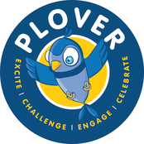
s
Thursday 17th December

All party bags will include:
Sandwich - Ham, Cheese, Tuna or Egg Mayo (children will be asked sandwich choice in advance) Cucumber Sticks
Yogurt Pouch
Crisps Juice Box
Christmas Biscuit

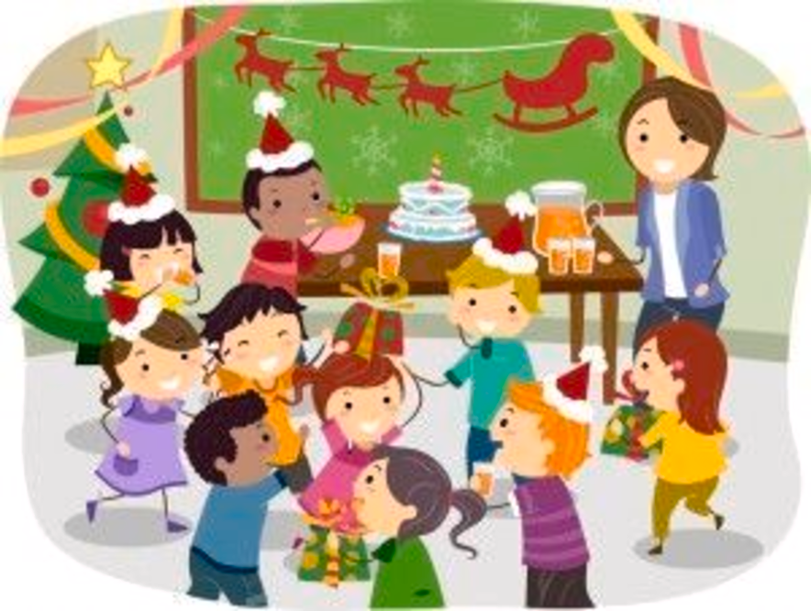
£2.35

