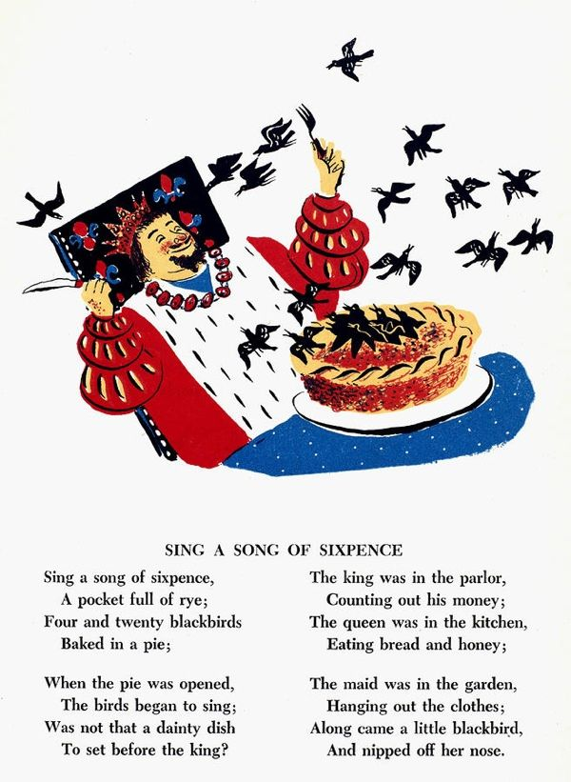

Henry liked having big parties. He was a real show off. One day the bakers baked a pie with 24 real black birds in and he cut the pie open and they all flew out. Now there is a song about it.