F2 Fundraising

Gingerbread People

£1 for 5 little people

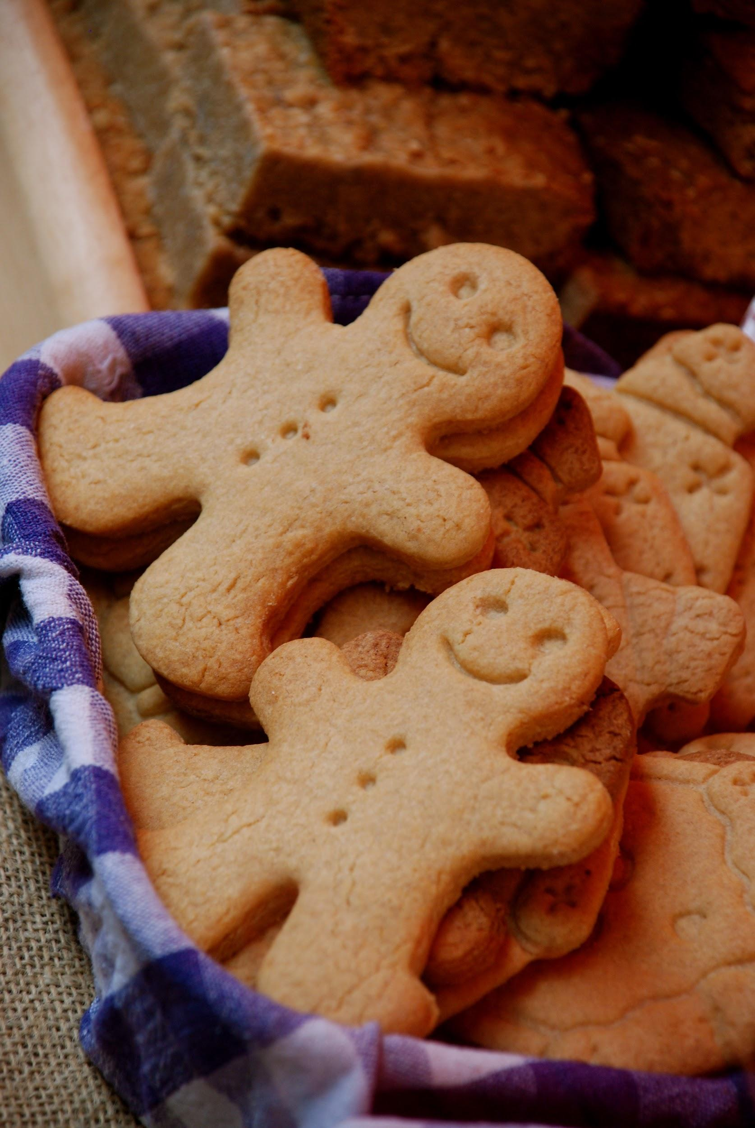

To raise money for school funds F2 are making gingerbread people as part of our theme about the Gingerbread Man. Please order your bags of gingerbread people so we know how many to bake.

Thank you

______________________

Child’s name _______________________

I would like to order __________ bags of 5 little gingerbread people at £1 per bag.