

**Tapestry**

A Parent’s Guide

**Tapestry website:** <https://eylj.org/login/>

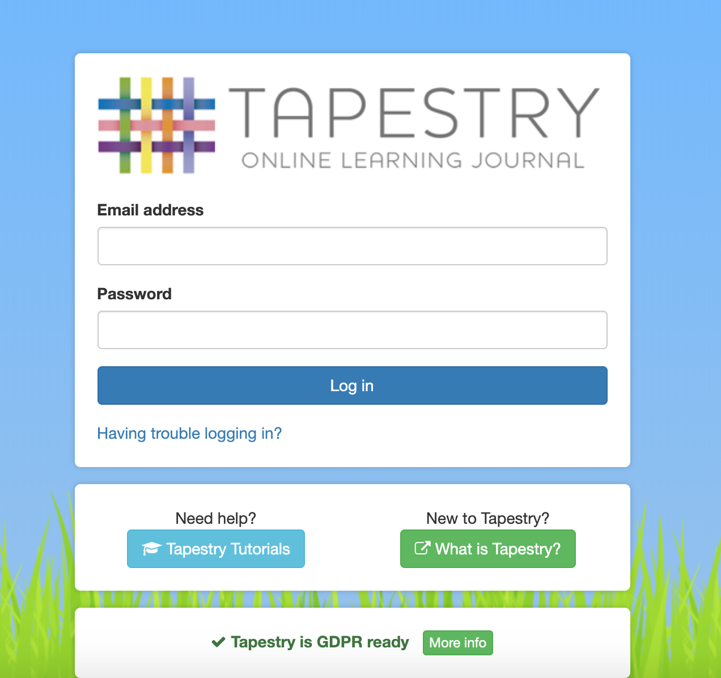

**Login Page** – enter your email address and password

**Observations** – View your child’s observations, and add your own comments, media and observations to support their learning.

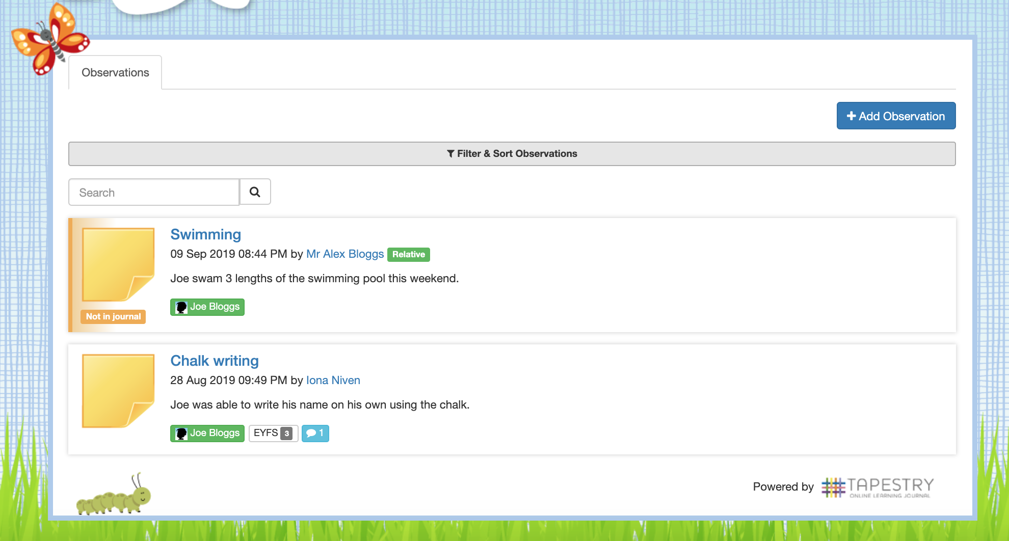

**Add Observation Button** - Click here if you want to add an observation from home

**Observations by staff** - Click on the title of the observations to read them in more detail.

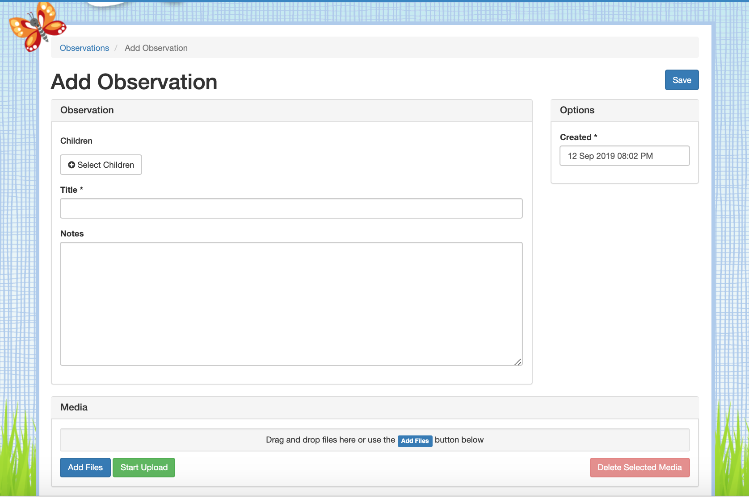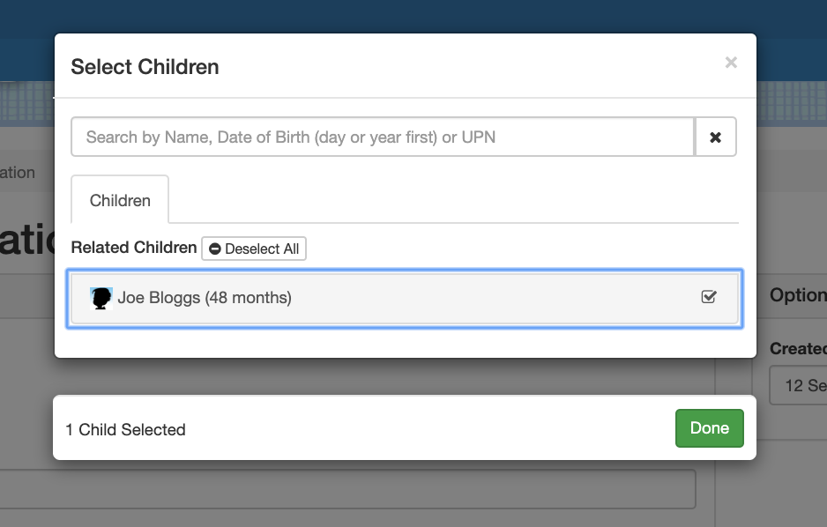

**Select children popup menu**

Click or tap your child’s name to attach them to the observation then press “Done”.

Once you have clicked **“Add Observation”** you will arrive at this page

**Select your child** from the pop-up menu (see example below)

Enter a **title** and **observation** notes for your observation

Add photos or video using the **“Add Files”** button then click **“Start Upload”**

Finally, save the observation by clicking **“Save”**