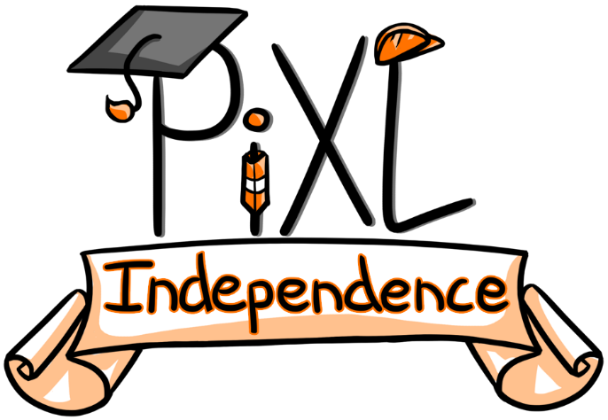

PiXL Independence:
PE – Student Booklet
KS4

Health, Fitness and Wellbeing
Contents:
- Quizzes – 10 credits each

- Reading Task – 50 credits

- Research Task – 30 credits

- Website Task – 80 credits

- Long Answer Questions – 100 credits

- Videos – 50 credits

- Quizzes
Complete the quizzes.
10 credits.
Multiple Choice Quiz
- A healthy lifestyle is:

- A state of complete physical wellbeing
- The absence of disease or infirmity
- A state of complete mental wellbeing
- A state of complete physical, social and mental wellbeing

- Which of the following does not contribute to an active, healthy lifestyle?

- Sensible alcohol consumption
- Healthy balanced diet
- Regular exercise
- Smoking

- A person’s capacity to carry out life’s activities without getting too tired is known as?

- Wellbeing
- Health
- Fitness
- Exercise

- Which of the following is not a fitness component?

- Muscular endurance
- Flexibility
- Fluency
- Co-ordination

- Which of the following words does not contribute to a person’s wellbeing?

- Worry
- Content
- Happy
- Healthy

- What activity would be classed as sedentary?

- Sitting and watching TV
- Walking the dog
- Going to the gym
- Gardening

- Which of the following is not a benefit of completing physical activity?

- Emotional
- Skilful
- Physical
- Social

- Which of the following is a physical benefit of sport?

- Meeting new friends
- Self esteem
- Body image
- Obesity

- What group does not make up part of a balanced diet?

- Carbohydrates
- Protein
- Sugar
- Fats

- Which of the following is not a good source of carbohydrates?

- Pasta
- Bread
- Rice
- Egg

- Protein is needed within a balanced diet because:

- It builds and repairs tissue within the body
- It provides us with energy for exercising
- It helps us to lose weight
- To make the diet more tasty

- Which of the following is not an example of a mineral?

- Calcium
- Potassium
- Iron
- Presidium

- Obesity means a person is:

- Underweight
- Overweight
- Significantly underweight
- Significantly overweight

- Fibre would be found in which of the following foods?

- Wholemeal bread
- White rice
- Fish
- Milk

- How much of a healthy diet should be made up of carbohydrates?

- 30%
- 40%
- 50%
- 60%

- Water is needed as part of the diet to help:

- Digestion of food
- Reduce chance of dehydration
- Reduce risk of injury
- Be able to sweat

- Increasing our glycogen stores is also known as?

- Protein loading
- Fat loading
- Carb loading
- Hydration loading

- Which of the following statements is false?

- Carbohydrates provide energy
- Too many vitamins can damage your health
- Calcium makes bones stronger
- Fats are good for you in small doses

- Which of the following needs to be taken into account before exercising?

- Eating lots of chocolate
- Drinking water
- Eating lots of pasta
- Drinking lots of fizzy drinks

- The main measurement of obesity is?

- Body Mass Index
- Skinfold measurements
- Weight
- Waist measurements

Fill in the Gap Quiz
- A healthy lifestyle is a state of complete __________________, mental and social wellbeing.

- When you sit at a computer all day completing work, it is known as a _________________ lifestyle.

- A performer who needs to keep hydrated before exercise needs to ensure they drink plenty of ___________________.

- ________________________ are found in pasta, bread and rice.

- _______________ are found in dairy products such as cheese, milk and yoghurt.

- __________________ is a feeling or mental state of being contented, happy, prosperous and healthy.

- Exercise can make you feel better about yourself and be more confident. This is increasing your ______________________.

- Calcium and zinc are examples of ________________ needed by our body as part of a balanced diet.

- __________________________ is increased by filling your body with carbohydrates for three days leading up to an event.

- _________________ fat is in the form of liquid such as vegetable oil and comes from a plant source.

- Meat, fish and eggs are examples of __________________________.

- Friendship is a ____________________ part of increasing a person’s wellbeing.

- When we exercise more, our _________________ levels increase and therefore you are less likely to tire quickly.

- _________________________ is how quickly you react to a stimulus.

- Adults should complete _________ minutes of exercise at least _____ days per week.

- _________________________ is the range of movement available at a joint.

- A _______________________ is made up of carbohydrates, protein and fats.

- _______________ is the proportion of diet which should be protein based within a balanced diet.

- _______________ is an essential part of haemoglobin which is needed to transport oxygen around the body.

- ______________ within our diet can help to prevent disease.

Open Ended Quiz
- Explain what is meant by the term ‘fitness’.

- Describe 3 physical benefits of regular exercise.

- Outline the emotional benefits of regular exercise.

- Using an example, explain what is meant by the term ‘sedentary’.

- What makes up a balanced diet?

- Why is protein essential to a balanced diet?

- Outline the importance of minerals as a nutrient for an athlete.

- Discuss what factors need to be considered when looking at sports performers and nutrition.

- Why is hydration important for a balanced diet?

- What is meant by the term ‘carb loading’?

- How can a balanced diet help to prevent obesity?

- What is meant by the term ‘health’?

- Outline the important of carbohydrates as a nutrient for an athlete.

- Explain the social benefits of regular exercise.

- Describe what is meant by ‘a balanced diet’.

- Define the term ‘wellbeing’.

- Why are vitamins an important part of a balanced diet?

- Explain what changes you would make to a balanced diet for a weight lifter.

- Explain what changes you would make to a balanced diet for a marathon runner.

- Outline the advantages and disadvantages of fat as a nutrient within a balanced diet.

- Reading Task
Read and summarise the key ideas within the article – ideally in ten points. Create 5 questions relating to both the article and your specification.
50 credits.

https://www.mnn.com/health/fitness-well-being/blogs/boomers-30-minutes-exercise-will-extend-your-life

http://www.independent.co.uk/sport/football/international/harry-kane-england-captain-spurs-tottenham-nutrition-chef-kitchen-2017-goals-a7983456.html

- Research Task
Research and find an article which supports or disclaims the ideas in the original article. Write a paragraph to summarise your findings. In this paragraph you must provide a sporting example to support your findings.
30 credits.

- Website Task
Website task: Select a website and design a power point presentation you could give to a group of students just beginning the GCSE PE course. Include of each slide key notes you could discuss.
80 credits.

- http://www.teachpe.com/gcse_health/health_fitness.php

- http://www.nutritionist-resource.org.uk/articles/sports-nutrition.html

- Long Answer Questions
Choose a longer answer question from the question bank below. Write a response to the question. You must include a plan of what you are going to include, a key word board and your final written answer which is completed in full sentences and paragraphs.
100 credits

- Using practical examples explain how health, fitness and wellbeing can lead to a person having an improved performance within sport.

- Discuss the benefits of physical activity on physical, social and emotional health and the consequences of a sedentary lifestyle on these areas.

- What dietary advice would you give to a male gymnast when following an exercise programme?

- Explain the importance of a balanced diet. Use sporting examples to show your understanding of key nutrient groups.

- Describe the process of carbohydrate loading. Explain how this could benefit a sports performer of your choice.

- Videos
Produce a video that shows the use of the body in a practical way. The video must include key sporting examples and clear explanations of what is occurring within the video.
Try to include the whole unit topic in one video.
50 credits per topic.

- Healthy lifestyle
- Fitness
- Wellbeing
- Diet
- Nutrition

Commissioned by The PiXL Club Ltd.

This resource is strictly for the use of member schools for as long as they remain members of The PiXL Club. It may not be copied, sold, or transferred to a third party or used by the school after membership ceases. Until such time it may be freely used within the member school.

All opinions and contributions are those of the authors. The contents of this resource are not connected with, or endorsed by, any other company, organisation or institution.

PiXL Club Ltd endeavour to trace and contact copyright owners. If there are any inadvertent omissions or errors in the acknowledgements or usage, this is unintended and PiXL will remedy these on written notification.

