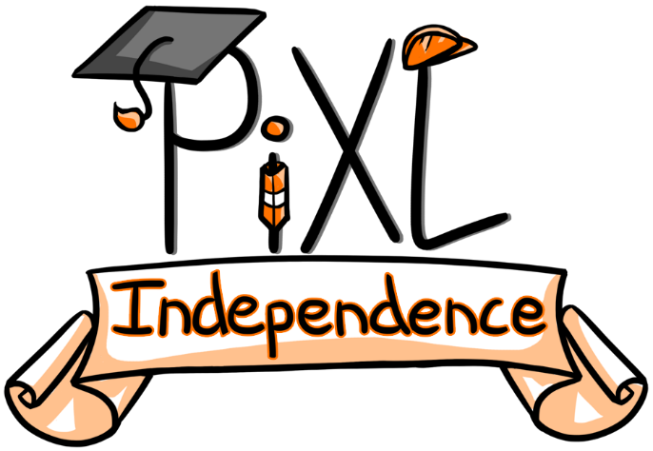

PiXL Independence:
PE – Student Booklet
KS4

Sports Psychology
Contents:
- Quizzes – 10 credits each

- Reading Task – 50 credits

- Research Task – 30 credits

- Website Task – 80 credits

- Long Answer Questions – 100 credits

- Videos – 50 credits

- Quizzes
Complete the quizzes.
10 credits.
Multiple Choice Quiz
- A motor skill is:

- Predetermined skill created before the performance
- An action or task that has a target or goal
- A movement performed within minimum energy
- A fluent and co-ordinated movement

- Which is not a characteristic of a skilful movement?

- Aesthetic
- Efficiency
- Co-ordinated
- Fast

- A complex concept that involves interpretation is a definition for which key word?

- Cognitive
- Perception
- Thought
- Aesthetic

- A sprint start in swimming is an example of what type of skill?

- Simple
- Complex
- Fine
- Open

- Which one of the following is the best example of a closed skill?

- A free kick in football
- A centre pass in netball
- A free throw in basketball
- A long corner in hockey

- Which of the following words is not part of the SMART principle?

- Specific
- Measurable
- Rewarding
- Timed

- Which of the following is not a reason for not attaining a goal?

- You did not try hard enough
- The goal was unrealistic
- Poor technique
- Opponent ability

- Which of the following is an example of a performance goal?

- To win the long jump in an athletics competition
- To finish an Insanity work out class
- To improve technique of a back somersault in trampolining
- To reach the finals of the netball competition

- Which of the following is a valid reason for setting a goal?

- To improve technique for your golf swing
- To adapt the weather in a golf competition
- To finish last in the golf competition
- To reduce skill level

- When you set a goal, which of the following should you not do?

- Pace yourself
- Reward yourself
- Punish yourself
- Be realistic

- Anxiety is:

- The feeling that something might go wrong
- The feeling that something might go right
- The feeling that you are prepared for an event
- The feeling of calmness

- Which of the following is not a mental rehearsal technique?

- Imagery
- Mental rehearsal
- Skill practice
- Selective attention

- Which one of the following is an example of mental rehearsal in sports performance?

- Visualising the run up, jump and landing in high jump
- Controlling the heart rate through meditation
- Worrying about how your 100m race will go
- Completing the hop, step, jump in triple jump

- Which one of the following is a somatic anxiety management technique?

- Warm Up
- Cool Down
- Relaxation
- Skill Preparation

- Selective attention is:

- Performer concentrates on what is relevant
- Performer concentrates on the whole picture
- Performer concentrates on opponents
- Performer concentrates on the crowd

- Which of the following is not a type of guidance?

- Visual
- Verbal
- Written
- Manual

- Which of the following is not a type of feedback?

- Confidence
- Negative
- Positive
- Extrinsic

- Which of the following is an example of mechanical guidance?

- Watching a video of a front somersault
- Listening to coach’s instructions on how to perform the front somersault
- Using a harness when performing the somersault
- Performing a forward roll to feet

- Knowledge of performance is:

- Beating another team 1-0 in a football match
- Scoring 9.6 at the end of a gymnastics floor routine
- Missing a free throw in basketball
- Receiving feedback from coach based on passing in netball

- Which of the following is not an example of extrinsic feedback?

- Swimmer diving off the blocks feels that their legs are straight
- Hockey player sees the ball go through the net
- Referee whistles for a bad tackle
- Handball players get sent off for 2 minutes

Fill in the Gap Quiz
- _____________________ is one in which a predetermined objective is accomplished with maximum efficiency with a minimum outlay of energy.

- When a footballer takes a free kick using the correct technique it looks good. This is known as ______________________.

- When you make a catch in the slip when playing cricket you have a lot of decisions to make, this is an example of a ____________________ skill.

- ________________________________ are skills that involve intellectual ability of the performer.

- If the skill is closed, it is more effective to keep ____________________ so that the skill becomes grooved.

- ___________________ is important for monitoring and making you accountable for the target/goal that was set.

- A goal will be hard to reach if the goal set is too ________________________ at this time.

- __________________ goals are when the end result is all that is concerned. For example, whether you win or lose.

- When creating goals they need to be _____________________ so that goals are clear and unambiguous so there is more chance for them to be attained.

- Goals are put in place within sport so that performers are _____________________ to achieve their best and have the drive and inspiration to achieve.

- _______________________________ is otherwise known as self talk, involves the participant in a sport being positive about past experiences.

- Visualising how to perform an activity from start to finish is known as _________________.

- ______________ ____________________ can speed up your reaction to different situations and enables you to focus and concentrate due to allowing you to relax fully.

- When you block out the crowd when shooting a penalty in football, this is a type of mental preparation called ______________________________________.

- _____________________________________ is the feeling or sense that we get when we are completing a movement.

- When a coach demonstrates how to perform a chest pass in netball, they are supporting the learning through _________________ guidance.

- An athlete gets _________________________ feedback when they perform a shot badly in basketball and they miss the shot.

- ___________________ feedback is continuous feedback throughout the performance which comes from within the performer.

- An advantage of _________________________ guidance is it can reduce the fear of a performer whilst completing an activity.

- ______________________________________ is gaining feedback at the end point when you win or lose the match.

Open Ended Quiz
- Using practical examples, explain what is meant by an open skill and a complex skill.

- Choosing a motor skill in sport, justify your classification of this skill on the environmental continuum.

- Using a sporting example, describe the main characteristics of a skilful movement.

- Describe how the classification of skill impacts on training and coaching.

- Using a practical example, outline the term ‘perception’ and its use in sport.

- How does goal setting optimise and improve performance?

- Give three reasons why goals may not be attained by a performer?

- Explain two benefits of setting appropriate goals.

- Why is it important that goals are achievable?

- Select two features of SMART goal setting, using practical examples describe the features of goal setting.

- Using a practical example, describe the term ‘mental rehearsal’?

- Give two advantages of positive thinking.

- Why is selective attention important in sport?

- Using a sporting example, explain how imagery can help to reduce anxiety.

- Describe how using mental preparation would aid your sports performance.

- Using practical examples show how negative feedback can be effective in sports performance.

- Explain the advantages and disadvantages of verbal guidance.

- Using practical examples, explain the term ‘manual guidance’.

- What is the difference between knowledge of results and knowledge of performance?

- What key factors are needed for feedback to be effective?

- Reading Task
Read and summarise the key ideas within the article – ideally in ten points. Create 5 questions relating to both the article and your specification.

50 credits.

http://www.newspressnow.com/news/local_news/parents-as-teachers-evaluates-childrens-play-skills/article_05da8fa4-805e-5b2f-9d50-ad124230274a.html

https://www.theet.com/news/free/schools-work-to-teach-importance-of-goal-setting-with-students/article_f6e2c826-a610-57ca-ad31-2717de2a6840.html

https://sports.yahoo.com/underrated-notre-dame-heard-threatening-053701286.html

http://www.theaustralian.com.au/business/opinion/feedback-the-key-to-improvement-in-sport-and-business/news-story/b3c14ac09ea0536c4b7f1b2b6a27798c

- Research Task
Research and find an article which supports or disclaims the ideas in the original article. Write a paragraph to summarise your findings. In this paragraph you must provide a sporting example to support your findings.
30 credits.

- Website Task
Website task: Select a website and design a power point presentation you could give to a group of students just beginning the GCSE PE course. Include of each slide key notes you could discuss.
80 credits

- http://www.teachpe.com/sports_psychology/ability.php

- http://www.humankinetics.com/excerpts/excerpts/goal-setting-helps-athletes-perform

- https://www.sportpsych.org/nine-mental-skills-overview

- http://www.teachpe.com/resources/gcse/gcse-sports-psychology/guidance-and-feedback

- Long Answer Questions
Choose a longer answer question from the question bank below. Write a response to the question. You must include a plan of what you are going to include, a key word board and your final written answer which is completed in full sentences and paragraphs.
100 credits

- Using practical examples, describe the four different types of guidance. Outline one benefit of each type of guidance.

- Using practical examples, explain how mental preparation can benefit sports performance.

- Feedback is an integral part of sports performance. Discuss the advantages and disadvantages of different methods of feedback within sport.

- Explain the SMART principle of goal setting and outline why goal setting is important for an active healthy lifestyle.

- Skills within sport are classified to make it clearer about what is required to learn and perform within a particular skill. Using sporting examples, explain both the environmental and difficulty continuum.

- Videos
Produce a video that shows the use of the body in a practical way. The video must include key sporting examples and clear explanations of what is occurring within the video.
Try to include the whole unit topic in one video.
50 credits per topic.

- Characteristics of skilful movement
- Classification of skill
- Goal Setting
- Mental Preparation
- Types of guidance
- Types of feedback

Commissioned by The PiXL Club Ltd.

This resource is strictly for the use of member schools for as long as they remain members of The PiXL Club. It may not be copied, sold, or transferred to a third party or used by the school after membership ceases. Until such time it may be freely used within the member school.

All opinions and contributions are those of the authors. The contents of this resource are not connected with, or endorsed by, any other company, organisation or institution.

PiXL Club Ltd endeavour to trace and contact copyright owners. If there are any inadvertent omissions or errors in the acknowledgements or usage, this is unintended and PiXL will remedy these on written notification.

