SEND TRANSITION PACK

Student Name
Current Primary School

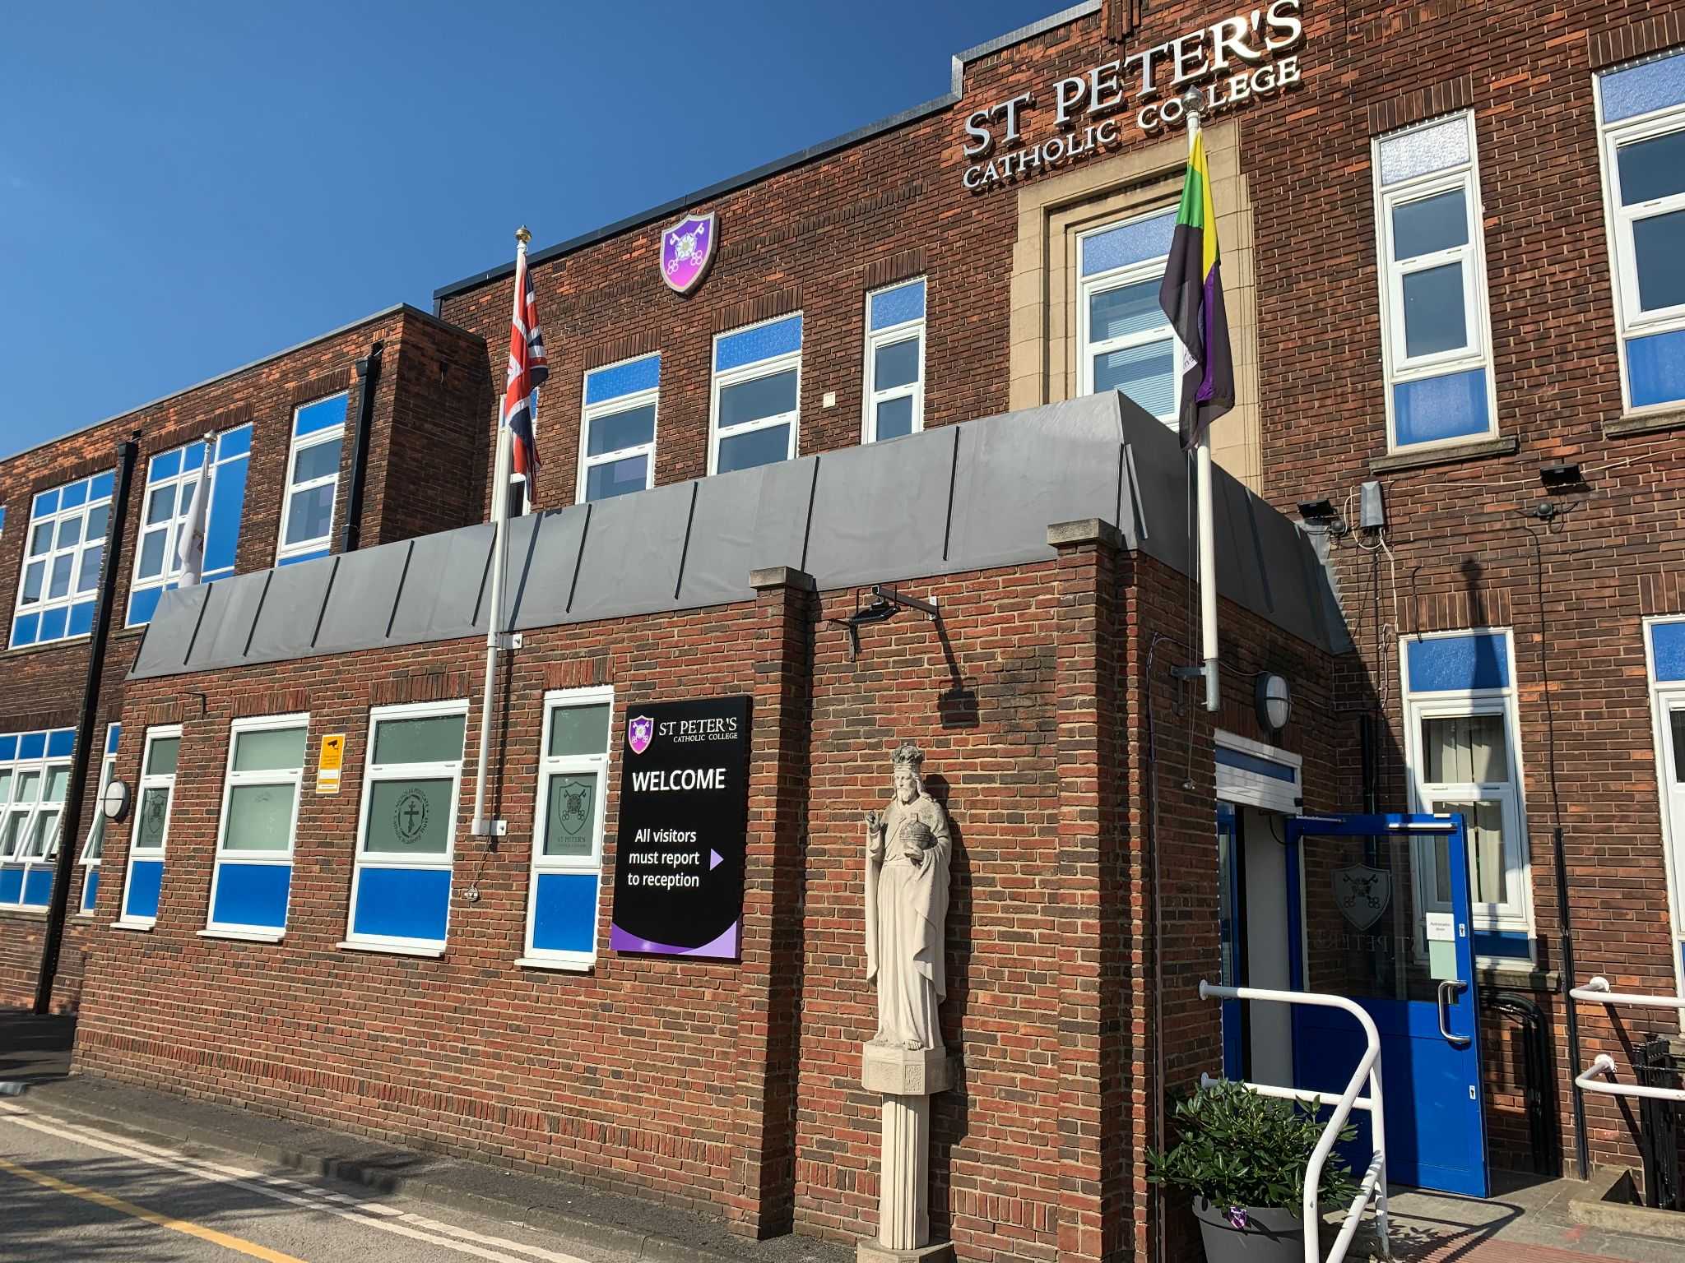
This pack is for you and your family. Coming to secondary school is a really big change and something that is a massive part of your life. It is scary and we know some things will scare you more than others, but that is okay.

Things have been really different for you as well as you have not been able to go to school and you have not been able to come to St Peters to have a look around.

This pack will hopefully help you to get to know your new school a lot more and also help you with some of your worries.

We have included some activities that may help you and you might want to do them with your family.

Introductions

Executive Head Teacher: Mr M Burns

Head of School: Mrs S Garthwaite

Trust Lead of Vulnerable Learners: Mrs S Mitchinson

Our School
Here are some pictures of our school, we think these are the most important ones you need to see now

Student entrance Student Services
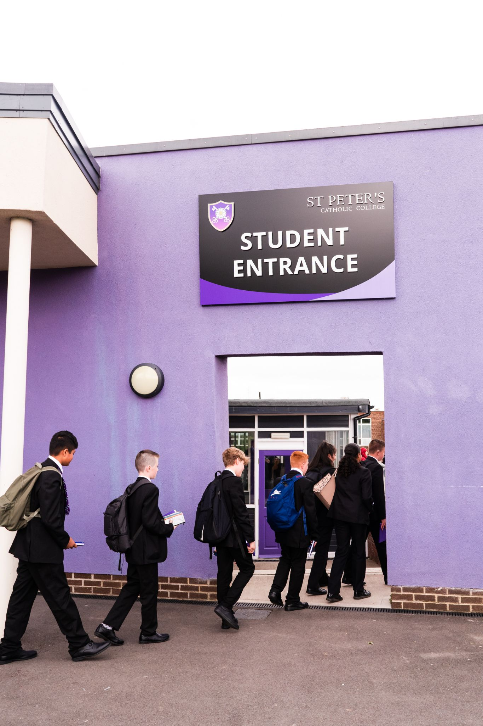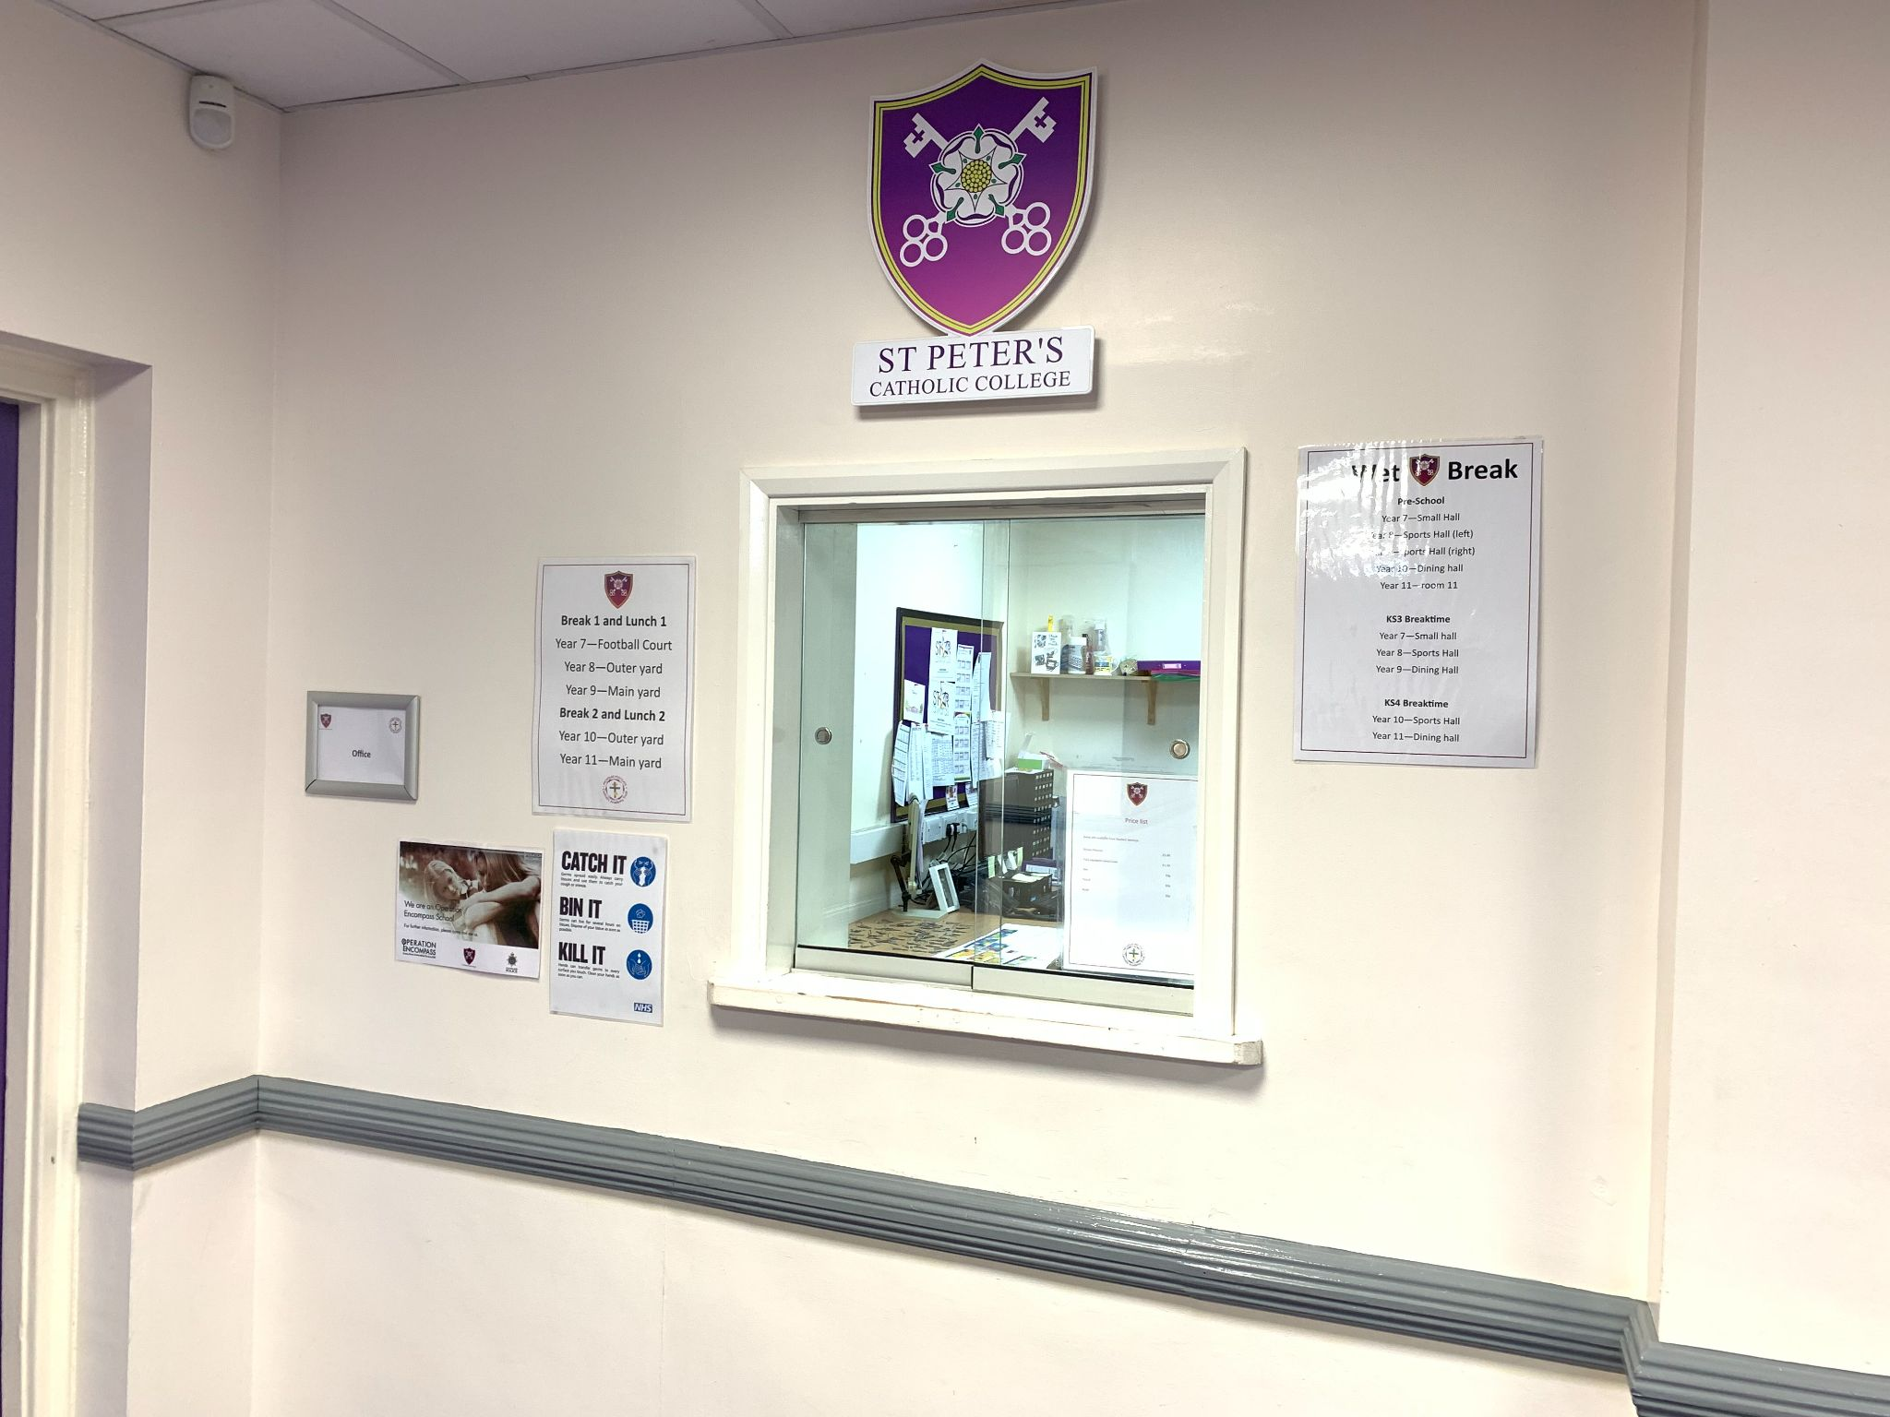

Assembly Hall Chapel
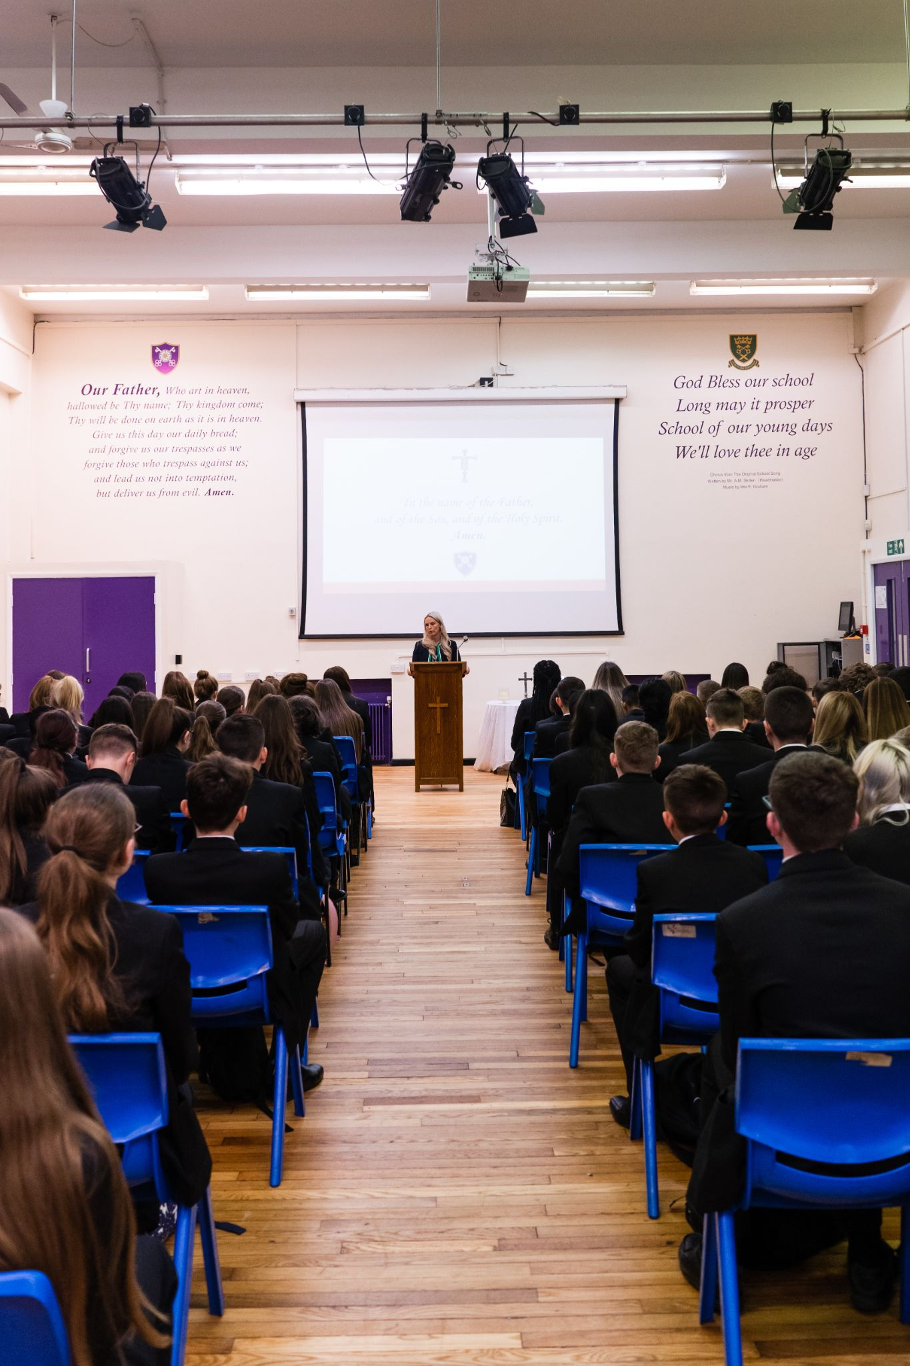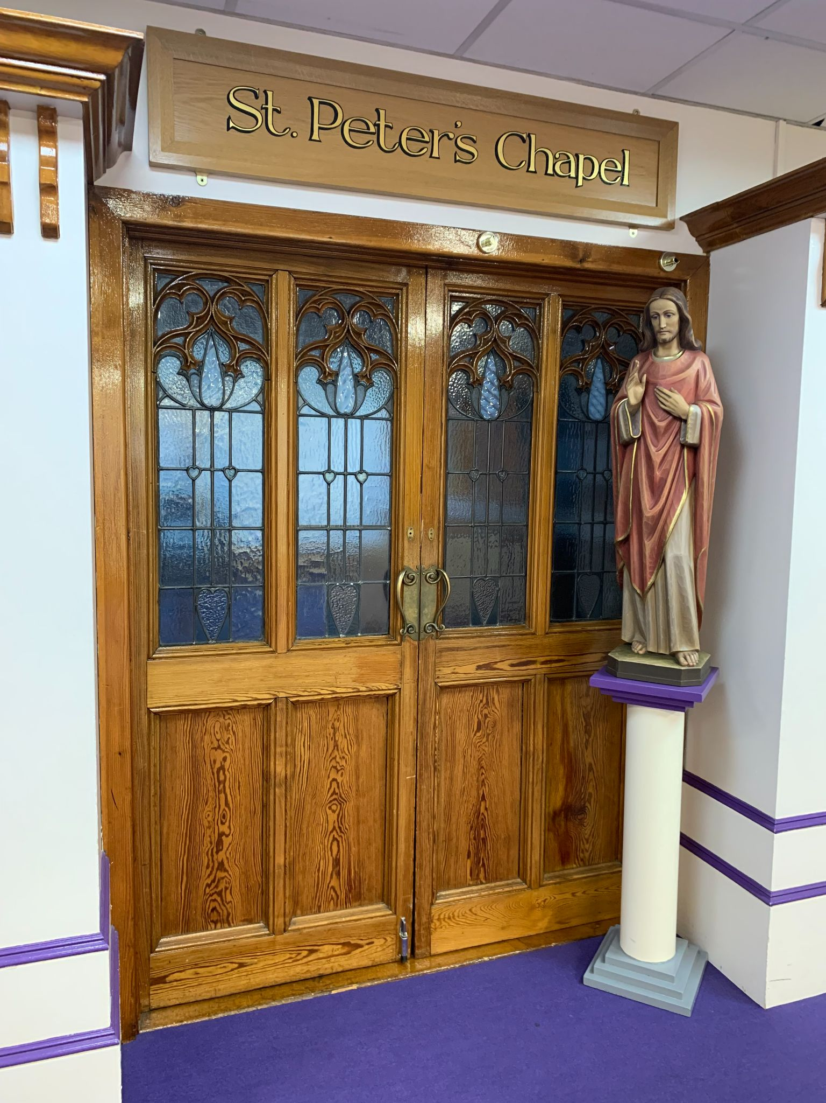

Dining Hall

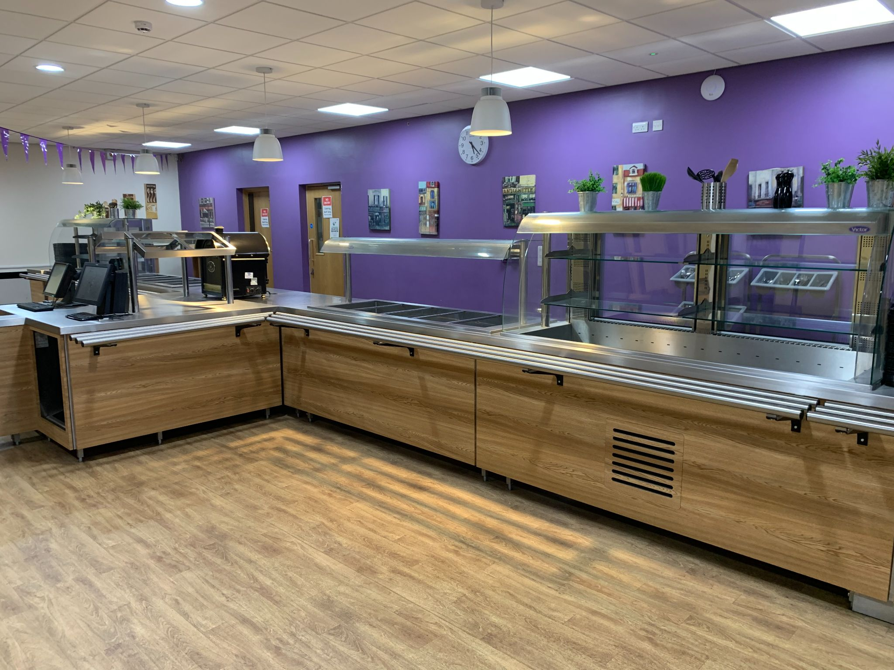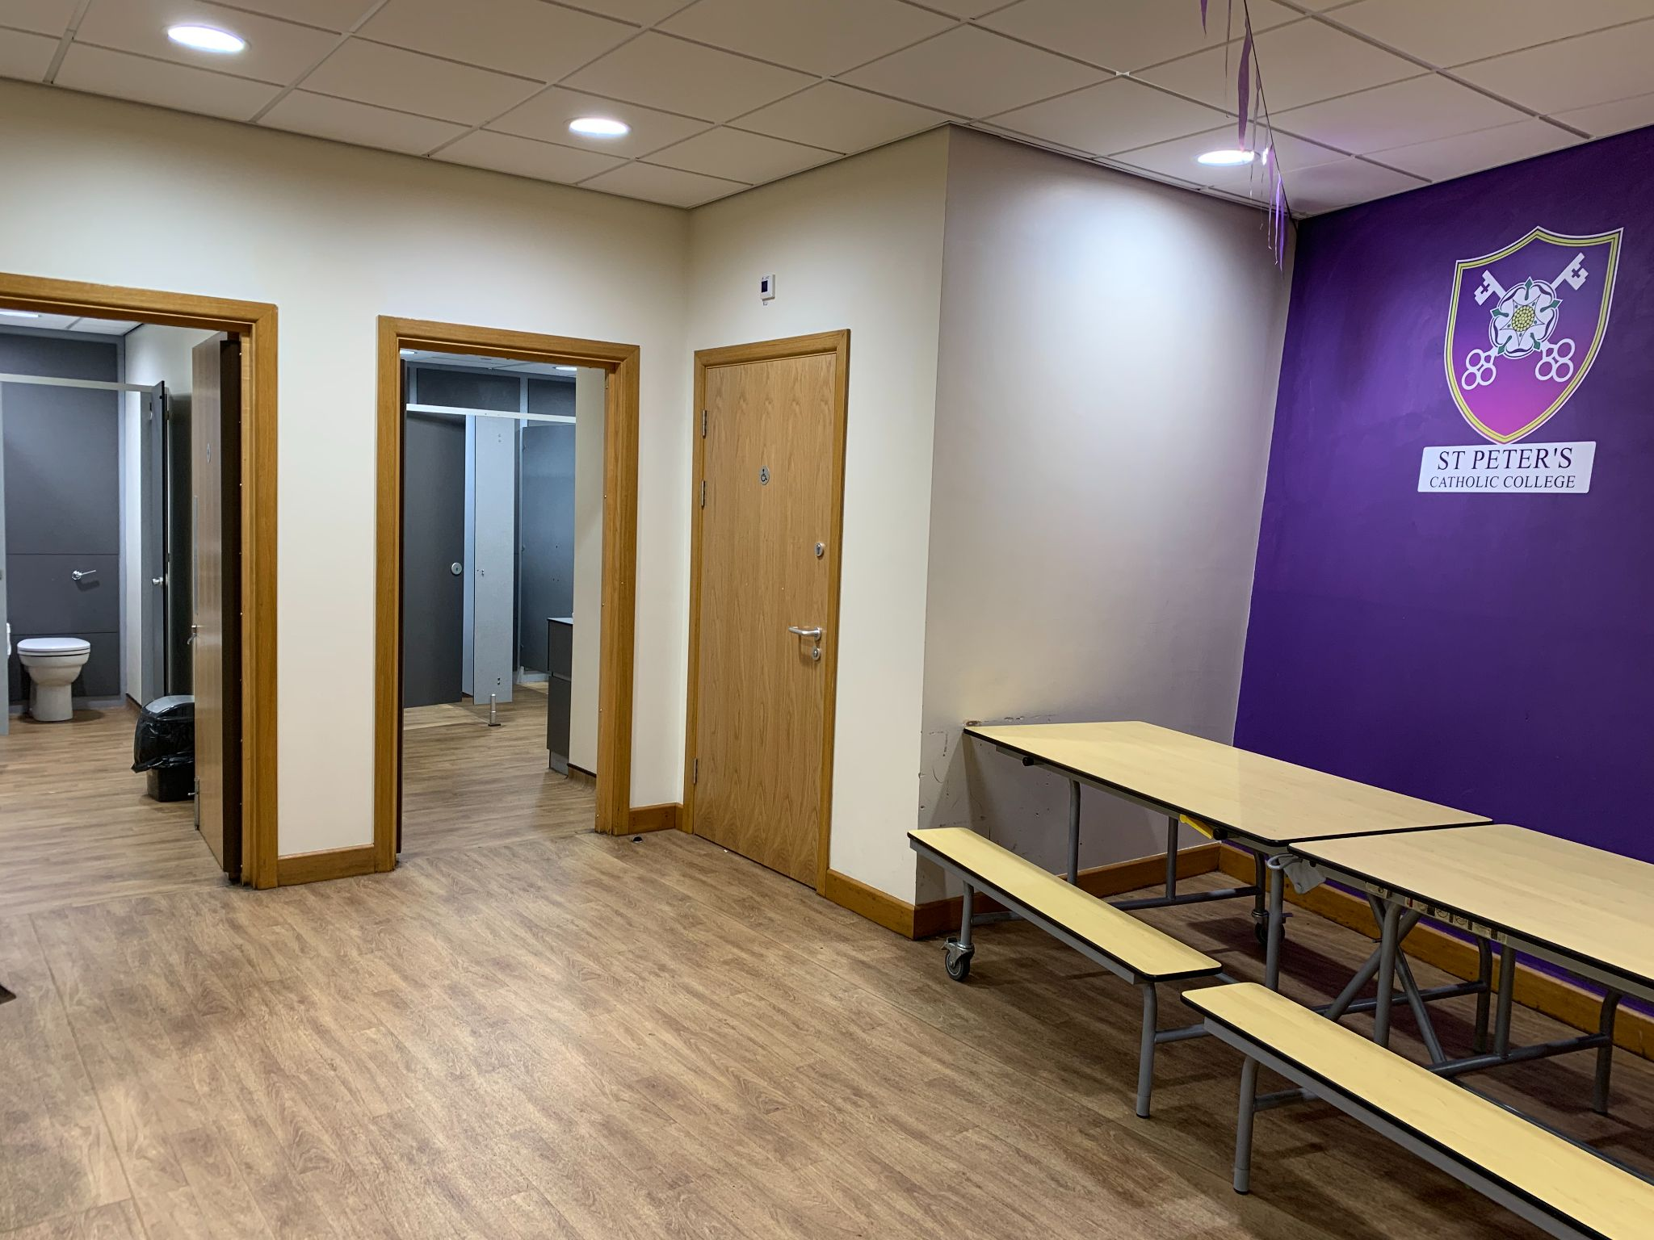

The School Day
This is a timetable of our school day, you will have a range of different lessons, but the times of the day do not change. Once we have your timetable, we can add the lessons in for you.

Period 1 | 08.30am
Period 2 | 09.30am
Break time | 10.30am
Tutor time | 10.45am
Period 3 | 11.05am
Lunchtime | 12.05pm
Period 4 | 12.35pm
Period 5 | 13.35pm
End of school day | 14.35pm

Our School Uniform
School Blazer
School Trousers/Skirt
Tie
White Shirt
Plain Black Shoes
School Jumper

Equipment you need to bring with you everyday

You will need to bring some equipment with you to school and you need to make sure that you have them in every lesson.
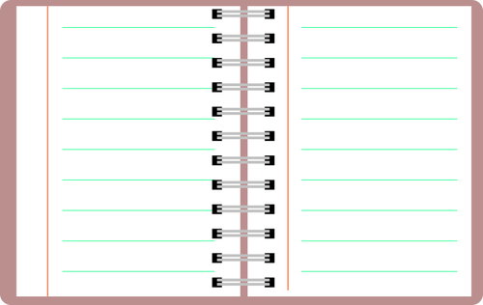
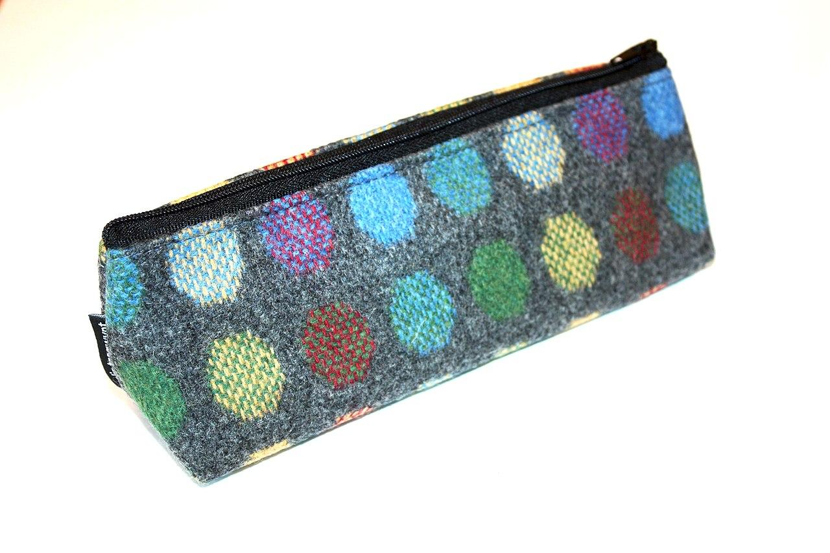
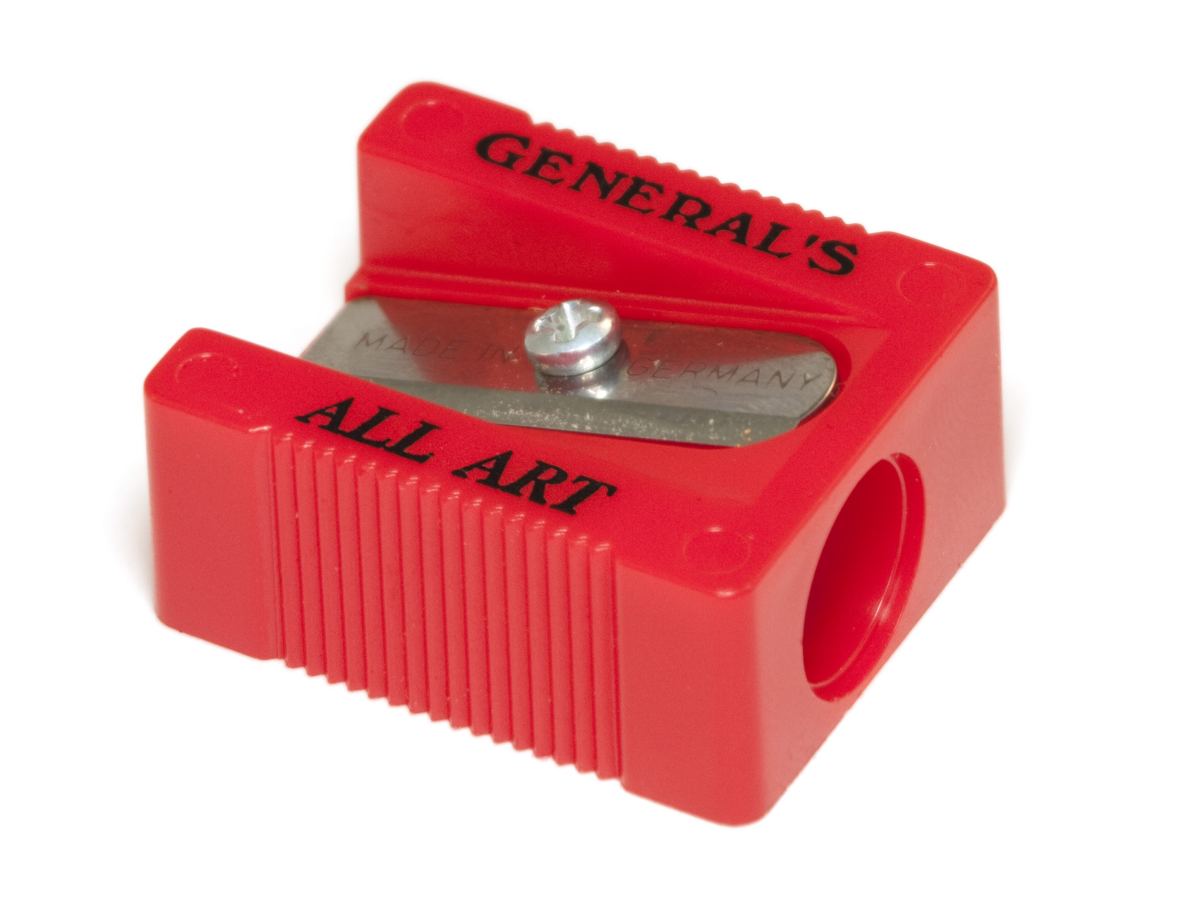
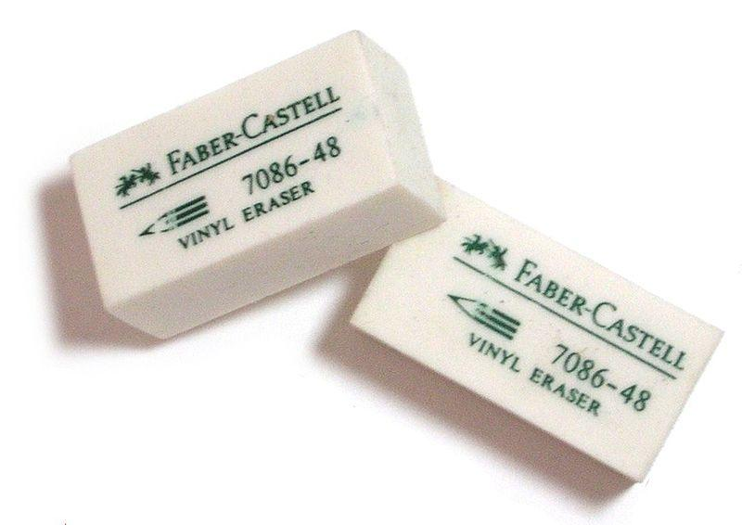
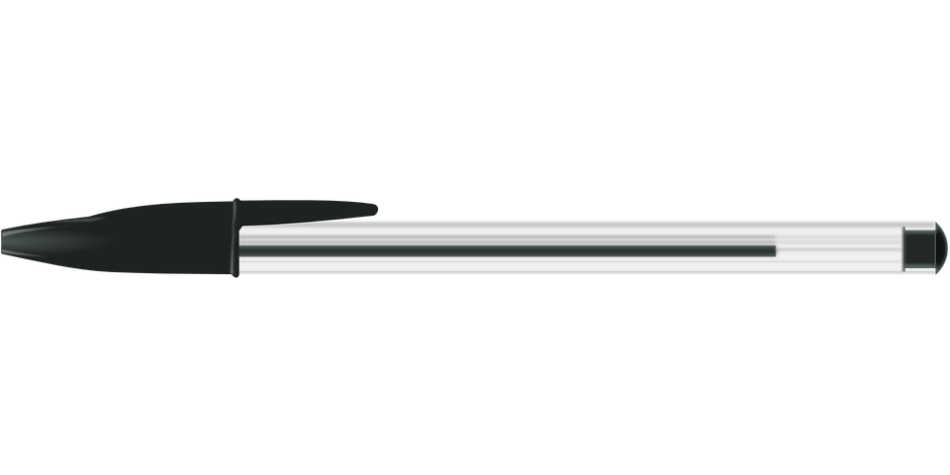
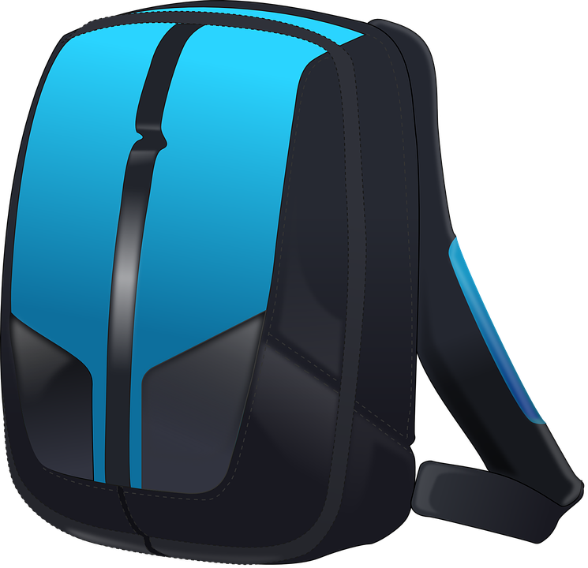
SCHOOL BAG |  | You will need a school bag that is able to hold an A4 folder
PENS |  | Blue or black ball point pens so you can write in your lessons
PENCILS |  | Pencils so that you can draw diagrams or pictures in your lessons
RUBBER |  | Erasers so you can rub out any mistakes
SHARPENER |  | Pencil sharpener so you can sharpen your pencils when they become blunt
PENCIL CASE |  | Pencil case to store all of your equipment in one place
SCHOOL PLANNER |  | School Planner this will be given to you by school, but it’s like a diary

All about me
We would love to get to know you and we would love you and your family to tell us all about you and them. This sheet lets you fill in what you would like to tell us.

This is me  (draw a picture of yourself) | These are the people who are important to me  (draw a picture of them)

Things I like  (You could draw or write these) | Things I do not like  (You could draw of write these)

Things I think you need to know about me  (Tell us what you would like us to know about you) | The best way for me to learn is ....  (Tell us the things that help you learn)

Some things to help you with your worries

We know that you will be worried about coming to (school name) and we want to try and help you with this. We have put together some resources that will help you get all of your worries onto paper and hopefully you will be able to talk them through with someone you trust

Transition Worries
It is very normal to be worried about coming to year 7, this year though it is even harder as you have not been in school for long periods of time and we know that this will cause you even more worry than normal, but we are here to help you through this.

This sheet is to try and help you think about your worries and then of things you can do to help you or to make these worries a little less scary. It will also get you to think about the happy and positive thoughts that you might be feeling about coming to (name of school) in September. The aim is that you try and have more happy thoughts than scary ones. Have a go at it and then try again in a week or so and see if your worries become less and less. We are here to help and we are excited to meet you
These are my happy thoughts about coming to St Peters in September

This is what I can do to help me deal with my worries

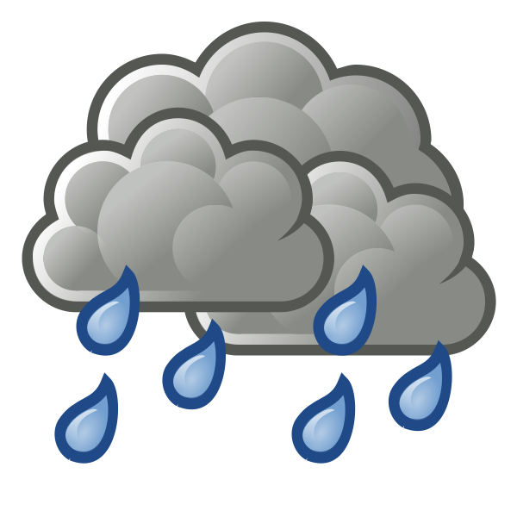
These are my worries about coming to St Peters in September

My Three Bubbles
We all have things that make us happy, things that make us worry and things we hope for in the future and (name of school) is your future. We would like you to be as honest as possible using the three bubbles below and fill them in, we may even talk about these again when you come to (name of school)
Bubble of happy/good things
What things in life make you happy?

Bubble of dreams
What do you hope for in (school name)

Bubble of worries
What things do you worry about?

My Stress Thermometer
This is a tool that can help you think about how stressed, anxious or frustrated you feel. The aim is that you know how you are currently feeling and can describe this and think of things that will help you calm down and feel better. We ideally want to be in the green zone as this is our happy place. Write down your strategies to take you down to the next level on the scale below

I feel stressed and anxious
I feel really angry and unhappy
I feel like I am going to explode
I feel like I may hurt someone or break something

I feel tired today and I cannot be bothered with anything or anyone
I feel down and sad
I feel irritated by things

I feel slightly stressed & anxious
I feel like something is bothering me
I feel agitated
I feel like the smallest thing might me me angry

Feel ok some things are annoying me
Feel like I can cope and get on
Feel like I can have a good day if things carry on this way

I do not feel stressed or anxious and things are going well today
I feel happy and I am in a good place
People are not annoying me today and I am enjoying their company

Some suggested strategies
Below are some sug that you could use and put into whatever box you like to support you, remember this is personal and each strategy is personal to you

Ask me questions

Give me something else to talk about

Let me draw something

Get me to a safe space

Get me my favourite toy

Do not speak too loud

Give me some space

Do not ask me how I am feeling

Let me listen to my music

Let me eat something

Give me something to take my mind off this

Do not challenge me

Get me to my trusted adult/member of staff

Do not talk to me

Ask me how I am feeling

Get me a drink please

Do not make me do the work

Let me read

Get me my worry book

Let me go and play sport

Let me play with my fidget toy

A Safe Space
When we are stressed or anxious it is good to have a safe space to go to. This needs to be a place where you can think and relax and that will allow you to calm down. This could be your bedroom and you could hide under the covers or put some music on, it could be in your garden or your local park where you can just breathe and self-regulate. This means that you are able to calm yourself down.

A Trusted Person
It is a really good idea to have someone that you can talk to if you're worried about anything, they cannot promise to keep everything to themselves, especially if you are in danger, they have to make sure that they tell someone else who can help you. This is scary, but you MUST trust them that they are helping you.

Make sure that you remember that this person is someone that you trust and they are not going against you by telling someone else, but they only have to tell someone if you are in danger or they are concerned for your physical or mental health.

We will help you find someone that you trust in St Peters when you get here.

