St Peter’s English Department

Are you ready to do the world a favour?

If you could help change the world would you? What does the world mean to you? Why should we think about the world? What does the world expect of you?
Think of an idea to change the world and put it into action!
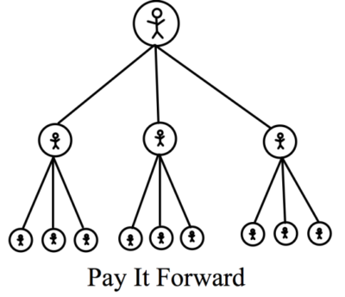
What is your idea? Why do you think it is worth doing? How can it help many people?
WHAT CAN YOU DO?
- Make someone a cup of coffee or bake something.
- Get the next person’s food, drink etc.
- Help someone out in need.
- Do chores at home to help family members.
- Write and illustrate a picture book for children in hospital.
- Create greeting cards to cheer people up: teachers, family members, neighbours etc.
- Let others know about Pay it Forward Day through your social media channels.
- Donate to a worthwhile cause.
- Be creative!!! Go onto the following website for more ideas:
http://payitforwardday.com/

In America Pay It Forward Day is celebrated on April 28th every year. When you have paid a good deed you are meant to pass out a card to share what you have done with the recipient.

Task:

- Plan out some good deeds.
- Document how your deeds are helping others. You need to be persuasive and convincing for this initiative to be successful.
- Create your own PIF Card
- You must then create a presentation to share with St Peter’s to detail how you have Paid It Forward. You can include: photographs, videos and any other resources to show how you have made a difference to our world.

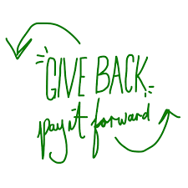
By paying a good deed forward you can learn that the deeds can make a positive difference to other people’s lives. The ripple effect is visible, motivating and energising. Everyone can
make a difference!

