Primary P.E. & Sport Premium Funding


PEPSA - Physical Education, School Sport and Physical Activity
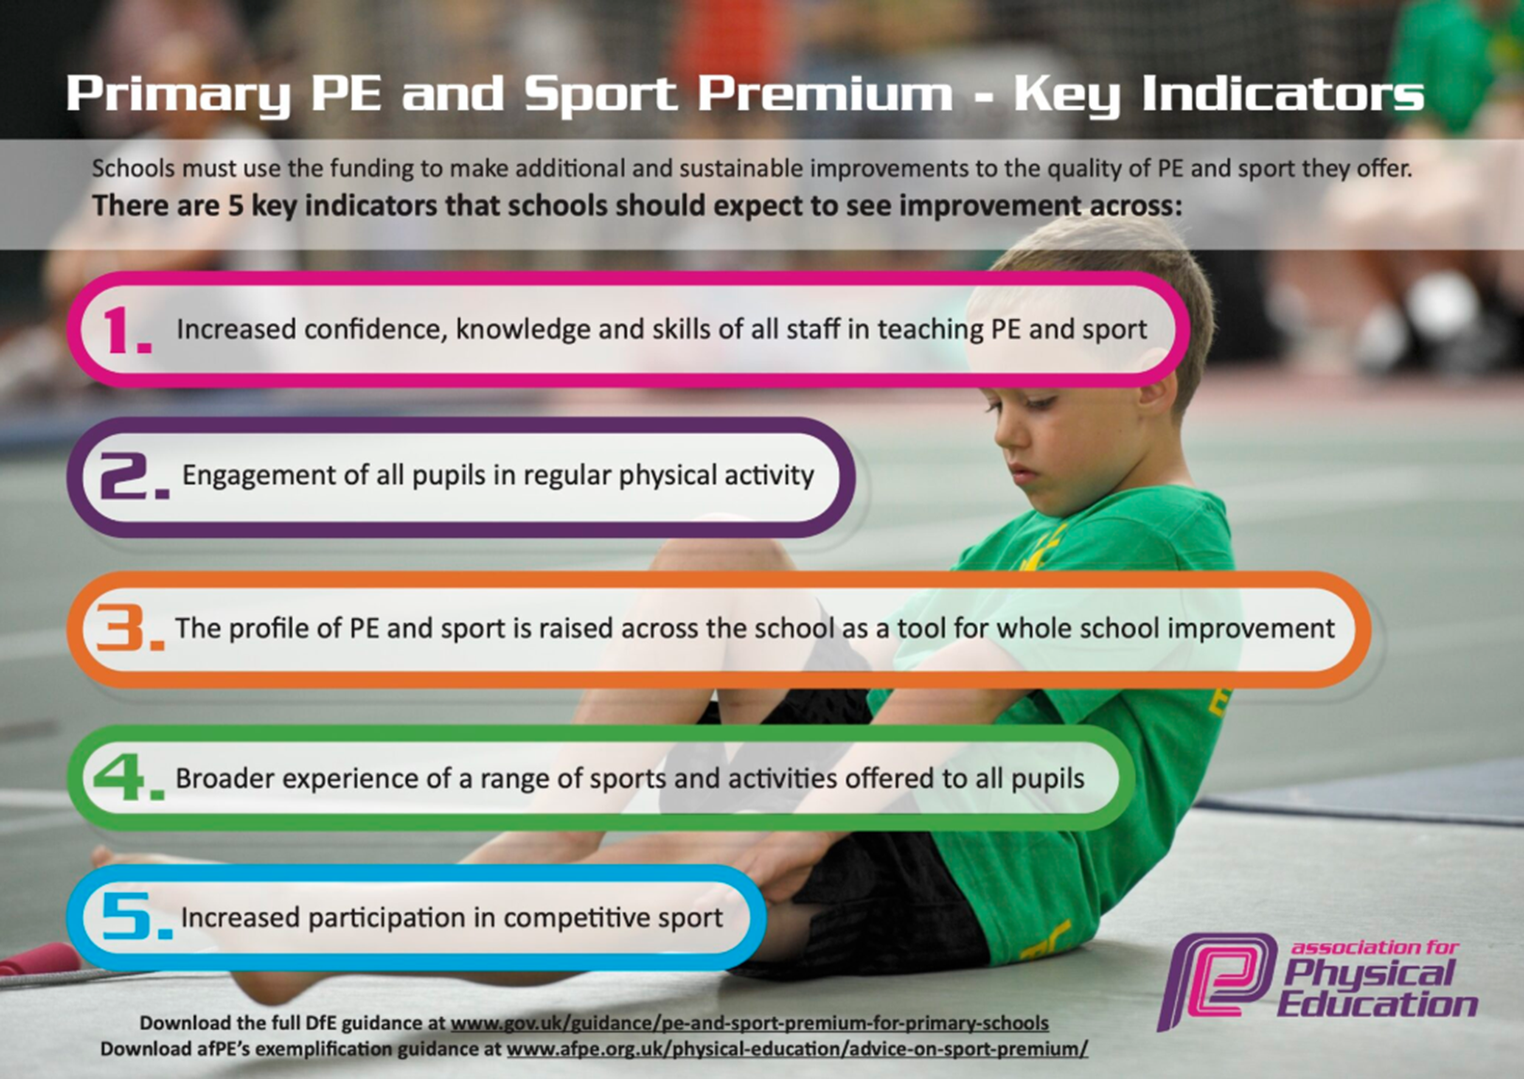

Review of last year’s spend and key achievements (2024-2025)
Start by reflecting on the impact of current provision and reviewing your previous spend.
Activity/Action | Impact | Comments
- Achieved Diamond NPCAT Trust Mark – previously Platinum.  - Percentage of children engaged in extracurricular sports has increased.  From the data of pupil participation, we have had great pupil participation for these after school clubs with % of children in the whole school attending.  - SEND children's experiences in residentials increased. They attended a bespoke multi -sports event.  - NPCAT Competitions: Termly competitions were attended:  - Physical development is considered when planning curriculum subjects other than P.E. to allow children to experience outdoor learning using both gross and fine motor skills, from Nursery to Y6. Nursery, Reception and Year 1 have their own outdoor learning areas.  - Residentials: Children have enjoyed visits to Carlton and Skiing in France.  - Sports Leaders were recruited in Y5/Y6 to support their peers in break and lunchtime. They have been using personal challenges and provided children with a range of opportunities to get involved in sporting activities (during break/lunchtimes). They have NPCAT sports leader training.  - Parental communication in encouraging healthy lifestyle choices through social media, sponsored events and out of school clubs.  - All children have had access to an activities calendar to complete at home and in school.  - Staff CPD This year staff received training on the Responsive Teaching model in PE, focusing on how to adapt instruction in real time to meet pupils’ developmental, physical and technical needs. Training strengthened teachers’ understanding of the knowledge, skills and techniques pupils are expected to develop across key stages, including fundamental movement skills, sport-specific techniques, tactical awareness and safe participation. Staff also reviewed what effective assessment in PE looks like, with an emphasis on ongoing observation, immediate feedback, use of success criteria and purposeful questioning to identify next steps in learning. Across the subject, teachers were supported to embed key vocabulary linked to movement, tactics and evaluation—such as balance, coordination, control, accuracy, space, strategy, resilience and performance. CPD also included specialist tennis training, enabling staff to deliver high-quality lessons focused on racket control, footwork patterns, rallying, sending and receiving skills, and progressive drills that build precision and consistency. | This year the school secured the Diamond NPCAT Trust Mark, demonstrating significant improvement in PE quality and whole-school physical activity. Extracurricular participation rose to 65%, meaning more pupils are now regularly active and engaged in sport. SEND pupils experienced greater inclusion through increased residential participation and access to a bespoke multi-sports event, leading to higher confidence and engagement.  Regular involvement in NPCAT competitions and increased outdoor learning across the curriculum strengthened pupils’ physical development, coordination and resilience from Early Years to Year 6. Residentials, including Carlton and skiing in France, provided valuable opportunities for challenge, teamwork and independence.  The introduction of trained Sports Leaders in Years 5 and 6 created more active break times, improved peer leadership skills and increased daily physical activity. Stronger parental engagement and the home–school activities calendar supported healthier habits beyond school.  Staff CPD on Responsive Teaching in PE and specialist tennis training led to more adaptive teaching, clearer assessment and higher-quality skill development in lessons, improving pupil progress and confidence across the subject.  Staff have deepened their understanding of progression in key knowledge, skills and vocabulary, while specialist tennis CPD has enhanced confidence and subject knowledge in delivering high-quality racket sports instruction. This has resulted in more consistent teaching, clearer feedback for pupils and improved overall lesson quality across the school.  Collectively, these developments have led to improved participation, increased confidence among pupils, stronger staff expertise and a richer, more inclusive PE curriculum that continues to drive positive outcomes for all learners.

Key Priorities and Action Planning (2025-2026)
This planning template will allow you to accurately plan your spending.
What are you planning to do? | Who does this action  impact? | Which key indicator does this meet? | What is the impact and how will sustainability be achieved? | What costs are linked to the action?
Establish and Engage in New Partnership with Stockton Schools Partnership  To increase access to inter-school competitions, festivals and staff support networks through active participation in the Stockton Schools Partnership. | • Greater range of competitive and non-competitive opportunities for pupils  • Improved staff confidence through shared practice and networking.  • Raised profile of sport across the school. | KI 5 – Increased participation in competitive sport. | • Annual membership will ensure continued access to competitions.  • Staff will develop confidence organising and attending events, embedding participation as normal practice.  • Long-term relationships will support ongoing collaboration and resource-sharing.
Purchase and Implement ‘Complete PE’ Curriculum  To introduce a high-quality, progressive PE curriculum that supports staff planning, assessment and delivery. | • Lessons become more consistent, structured and aligned to clear learning outcomes.  • Improved teacher confidence in teaching skills, vocabulary and assessment.  • Increased pupil progress across all strands of the PE curriculum. | KI 3 – Increased confidence, knowledge and skills of all staff in teaching PE and sport. | • Staff trained once can continue to use and adapt resources annually.  • Continuous updates within Complete PE ensure the curriculum remains relevant.  • Builds a long-term, whole-school approach to high-quality PE delivery.
Clarify and Develop the Role of the PE Coach and Move Good Lessons to Outstanding  To strengthen the impact of the PE coach through clearer expectations, CPD and a focus on responsive teaching to raise lesson quality. | • More outstanding lessons delivered across school.  • Improved differentiation and real-time feedback leading to better pupil outcomes.  • Greater consistency across staff and year groups. | KI 3 – Increased confidence, knowledge and skills of all staff in teaching PE and sport. | • Ongoing coaching model embeds continual professional improvement.  • Role clarity ensures expectations remain consistent year-on-year.  • School develops internal expertise, reducing reliance on external training.
Develop Sports Enrichment  To broaden the range and number of after-school sports clubs to increase pupil participation and engagement. | • Higher numbers of pupils taking part in daily physical activity.  • Improved pupils' confidence, motivation and enjoyment of sport.  • Greater variety of sports encourages lifelong activity habits. | KI 4 – Broader experience of a range of sports and activities offered to all pupils. | • Staff upskilled to deliver diverse clubs each year.  • Pupil voice used to shape clubs ensures continued relevance and interest.  • Partnerships (e.g., Stockton Schools Partnership) provide ongoing support and resources.
Establish a Year 6 Pupil Leadership Group (Sports Leaders)  To train Y6 pupils as Sports Leaders to support active playtimes, encourage participation and develop leadership skills. | • Increased levels of physical activity during break and lunchtime.  • Younger pupils supported and encouraged to take part in organised games.  • Leadership, responsibility and teamwork skills strengthened in Year 6 pupils. | KI 1 – Engagement of all pupils in regular physical activity. | • Annual recruitment and training cycle embeds leadership roles into school culture.  • Leaders serve as role models, inspiring future cohorts.  • Resources and training materials reused each year.
Promote a Culture of Inclusive Competition  To widen participation in competitive events with a focus on inclusion, enjoyment and personal challenge rather than solely winning. | • More pupils, including SEND and less-active pupils, engaged in competition and festivals.  • Improved attitudes towards sport, resilience and personal achievement.  • Reduced anxiety around performance; increased motivation to try new sports. | KI 5 – Increased participation in competitive sport  KI 2 – Engagement of all pupils in regular physical activity. | • Inclusive competitions become embedded in the school’s annual calendar.  • Staff trained in inclusive practice continue to plan events that are accessible to all.  • Strong partnerships ensure long-term access to festivals and inclusive formats.
Work Towards and Gain the School Games Mark  To achieve the School Games Mark by increasing participation, strengthening competition pathways and raising the profile of PE and physical activity. | • Whole-school engagement in physical activity increases.  • Stronger inclusion for SEND and less-active pupils.  • Improved visibility and celebration of sport, motivating pupils and staff.  • Staff more confident in organising competitions and tracking participation. | KI 1 – Engagement of all pupils in regular physical activity.  KI 2 – Profile of PE and sport raised across the school.  KI 5 – Participation in competitive sport increased. | • Annual self-evaluation against School Games criteria ensures continuous improvement.  • Established tracking systems make future applications easier and more robust.  • Strengthened competition pathways and partnerships secure long-term participation.  • Pupil sports leaders help maintain momentum and culture.
Lesson support to be planned each term to target specific CPD and intended outcomes in order to achieve consistently high teaching & learning, working with Jamie Poole Sports and NPCAT Sport.  Teaching to be of a high standard consistently - maintaining Teaching & Learning for Gold and work on project/ cases study to improve journey for others. | Staff and children. | Increased confidence, knowledge and skills of all staff in teaching PE and sport. | Sequential curriculum to build sustainability and progression for each genre. Confident teaching in everyday practice with ongoing CPD to support change and staff development. | JP Cost for teaching for the year = £8000.  NPCAT Trust £6200
NPCAT Competitions - To use the competition calendar to increase performance and participation for all children. This will provide staff CPD in supervising competitive sport. | Staff and children. | Increased participation in competitive sport. | Opportunities for staff CPD and for children to exhibit skills and a goal to work for. | Transport budget  £3000
Develop a strong and effective team of Sports Leaders (Y6). These Leaders will provide opportunities for children to attend clubs on Mornings, Lunchtimes and Afterschool with support from PE Lead. They will be timetabled and trained to encourage activities and run areas during the school day. | Sport Leaders (Running)/ Whole school (participating). | 2, 3, 4, 5. | Children across all key  stages will have the  opportunity to  participate in active  play and sport with the  Sports Leaders.  Current Y5 Sport  Leaders to take a role  in developing new  sports leaders once  they move into Y6. To  be involved in the  decision making and  application process.
Sport to be showcased on social media to celebrate Sport at St Patrick’s.  Leaders will plan, organise and deliver a range of sporting competitions for  children with school. | All Staff | 3 | Children grow a sense of  achievement within  sport. Involves parents  and wider school  community with  opportunities the  children can experience.
Links with local clubs – Development days and variety of sports.  Teesside Golf Club  Thornaby Squash  Stockton Rugby Club.  Thornaby Badminton.  Stockton Netball.  Thornaby Cricket Club.  W2 Football Academy.  All children will have further opportunities to keep fit and healthy and to broaden their experiences of a wider range of sporting activities.  Visitors and local teams/clubs to be organised so that children gain knowledge of new sports. | Mr Sherrington | 3, 4 | Provide Pathways for  children to continue  their progression in  Sport. | Urban Kaos dance  £1000  Emily Wratten: Specialist Ballet and Contemporary dance Teacher: £300  Swimming boosters: 30 children for 2 weeks = £915.00
Outdoor/extra-curricular trips to be made available for all children if they wish to go.  Ski trips all offer subsidies for those families who may need support. | Residential Leader Teachers, Staff and children. | Broader experience of a range of sport and activities offered to all pupils. | Continue to plan and deliver these trips at a cost-effective price for parents.  Holland  64% PP attended.  Skiing  63% PP attended. | Ski- £8000

Key Achievements (2025-2026)
This template will be completed at the end of the academic year and will showcase the key achievements schools have made with their Primary P.E. and Sport Premium spending.
Activity/Action | Impact | Comments

Swimming Data (2025-2026)

Meeting National Curriculum requirements for swimming and water safety. Priority should always be given to ensuring that pupils can perform safe self-rescue even if they do not fully meet the first two requirements of the National Curriculum programme of study

Question | Stats | Further context relative to local challenges
What percentage of your current Year 6 cohort swim competently, confidently and proficiently over a distance of at least 25 metres?
What percentage of your current Year 6 cohort use a range of strokes effectively [for example, front crawl, backstroke and breaststroke]?
What percentage of your current Year 6 cohort perform safe self-rescue in different water-based situations?
Schools can choose to use the Primary PE and Sport Premium to provide additional provision for swimming but this must be for activity over and above the national curriculum requirements. Have you used it in this way?
Have you provided CPD to improve the knowledge and confidence of staff to be able to teach swimming and water safety?

Headteacher: | Mr Ryan/Mr Conwell
PE Lead: | Miss Hobson
Governor: | Mr Morgan
Date: | 12.9.25

