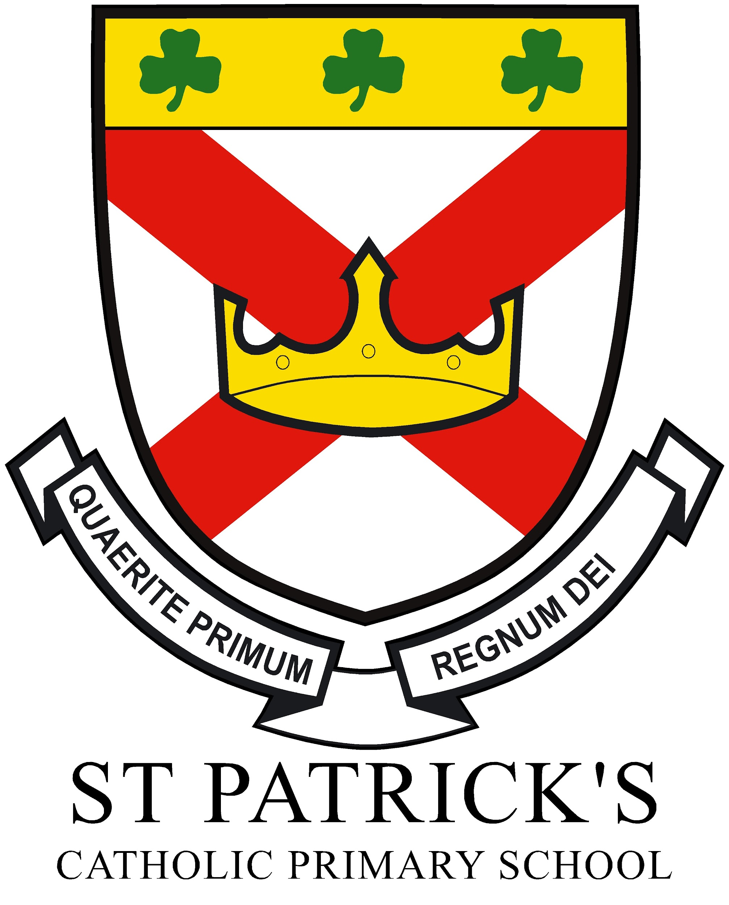


St Patrick’s School Calendar 2023-2024

Autumn Term 2023 Start date: 05/09/23 End date: 21/12/23
September  PD 1st September  21st September World Peace Day  25th September- Little Way Week  29th September- Welcome Mass |  | November  Monday 6th :Return to school  6th-9th November- Parent’s Evening  9th November- Grandparent’s Day- Classes 3,4 and 5  12th November-Remembrance Sunday  13th November - Class 7 School Trip - Danelaw Centre  15th November Anti-bullying Week  17thNovember- Y6 visit to Eureka  20th November- Road Safety Week  29th November- Pupil Voice Parliament Visit  30th November- Storyteller Visit
October  2nd October- Black History Month begins  9th October- Y5 Bikeability/ School Photograph Day  10th October-World Mental Health Day  15th October- ESafety Internet Legends  16th October- Big Sing Liturgy Thing  17th October- NSPCC Workshops Y5 and 6  19th October- International Music and Languages Day  20th October- Class 4 Beamish Visit  21st October- European Languages Day  22nd October- Harvest Mass in Church 11am  24th October- Stay and Read session  26th October- Class 6 School Trip - Danelaw Centre  Friday 13th: PD Day  Friday 27th :Term ends |  | December  3rd December-Advent Begins  5th December-Stay and Read session- Classes 3,4 and 5  8th December 5 Lamps Carols  13th December Class 3 Nativity at 10am  13th December Class 4 Nativity at 2pm  14th December Class 5 Nativity at 2pm  15th December Class 1 Nativity at 10am  15th December Class 2 Nativity at 2pm  15th December- Christmas Mass in Church 10am  18th Dec Nursery-Nativity at 10am and 2pm  18th December-Classes 6,7 and 8 Advent Service 2pm  19th December- Classes 9 and 10 Advent Retreat 2pm  20th December- Classes 11 and 12 Advent Retreat 2pm  Thursday 21st: Term ends  Friday 22nd: PD Day
Spring Term 2024 Start date: 08/01/24 End date: 22/03/24
January  Monday 8th: Return to school  26th Holocaust Memorial Day | March  3rd- 9th Ski Residential in Italy  15th- Mid Term Reports  15th St.Patrick’s Feast Day Celebrations  21st- Parents Evenings  22nd World Water Day  28th March-Maundy Thursday  29th March- Good Friday  31st March- Easter Sunday  Friday 22nd : Term ends
February  8th February-Safer Internet Week- Cleveland Police  14th February- Ash Wednesday and Lent Begins  28th FairTrade Fortnight  Thursday 8th : Term ends  Friday 9th : PD Day  Monday 19th : Return to school | April  Monday 8th April: Return to school  10th-12th April- Y4 Carlton Residential  15th April- World Faith Week
Summer Term 2024 Start date: 08/04/24 End date: 19/07/24
May  5th May- May Procession in Church  13th-16th May KS2 SATs week  19th May-Pentecost Sunday  Monday 6th : Bank holiday  Friday 24th :Term ends | July  9th July EYFS Sports Day  10th July Y1,2,3 Sports Day  11th July Y4,5,6 Sports Day  12th July- End of Year Reports to Parents  Thursday 19th: Term ends
June  Monday 3rd June : Return to school  3rd June-Y4 Multiplication Tables Check opens  9th-15th June- Year 6 Holland Residential  10th June Y1 Phonics screening checks begin  17th June- Walk to School Week  16th-22nd June- Refugee Week  22nd June-First Holy Communion Day 1  29th June- First Holy Communion Day 2  24th-28th June- Disconnect to Reconnect Week | Notes  Please note: due to circumstances out of our control these dates may be subject to change but we will try our very best to keep to the planned dates and times in order to assist with your planning. Also, some classes have not yet confirmed school trips at this time. Other events may occur too across the year.

