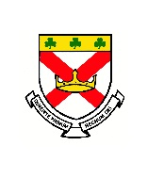**Welcome to Class 7 Summer Overview**

Dear Parents and Carers,

Welcome back to the Summer Term. Your children have worked so very hard this year and we are looking forward to them continuing to make progress. We will be preparing them for their next class and have outlined the areas which we will be covering.

Thank you all for your continuing support and please do contact us if you have any ideas or questions about your child’s learning.

God Bless, Ms Sims and Miss Oliver

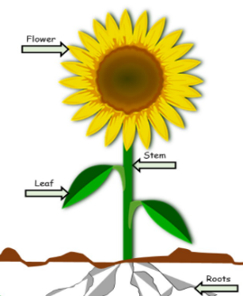

**Science**

During the Summer term we will be learning about plants and their development. We will be studying plants and vegetable growth to observe and investigate the best conditions for them to flourish.

We will then finish our science studies with our ‘Awe and Wonder’ topic focusing on experiments and investigations.

**RE**

The Summer topics we will look at this term are Choices (Reconciliation) and Special Places. In these topics, we will look at how God wants us to love and respect our family.

We will be developing our understanding of the Holy Spirit, showing an understanding of building friendships and recognising the importance of admitting when we are wrong and being reconciled with one another and God.

Finally, we will be learning about how ordinary people can do extraordinary things and how different saints show people what God is like.



**Maths**

Our daily Maths lessons continue to be exciting and challenging. We are continuing to focus on the four basic number rules so that we are able to use and apply them to all maths topics. Times tables and mental arithmetic will be practised daily to improve our rapid recall skills. Weekly ‘times tables tests’ will be completed on a Friday. Please support your child in learning all of their times tables with a focus on 3’s, 4’s and 8 times tables. We encourage the children to use TT Rockstars and Hit the Button to improve their speed of recall.

The main areas we will cover this term are:

• Problem solving using the four operations.

• Geometry and shape

• Calculating fractions.

• Statistics and measures. 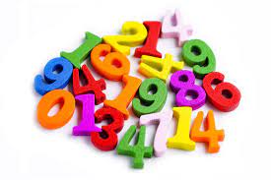

**English** 

This term, we will look at the genres of story-writing, poetry, diary entry and non-chronological reports.

In our reading sessions we will practise comprehension skills to help our understanding of a text. All children will be learning a range of vocabulary which will coincide with their reading topic.

Grammar, punctuation, spelling and handwriting will be practised weekly in class. We will now be moving on to spellings from the Year 3-word lists and explore how sentences can be written using different structures.

Finally, we will be encouraging all children to speak clearly in full sentences, as this is a focus we are having throughout the year.



**Art, Music and D&T**

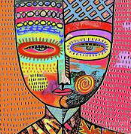

Art will be based around the artist, Sandra Silbertzweig. They will learn about her style of art and the inspiration behind her work. The children will explore warm and cold colours using chalks.

In music the children will be listening, singing and performing “Three Little Birds” by Bob Marley. They will be learning to play glockenspiels to accompany their performance.

In D and T, the children will learn and explore how pneumatics can help with lifting and that the output can be significant! The children will design a lift mechanism to raise the jaw of a creature or monster as part of a moving toy product.



**PE ** The children will continue to have two PE lessons a week. They will be developing their tennis skills; their athletics skills and they will be learning to play cricket.

Children will be competing in the annual Sports day using the skills which they develop in their athletics lessons.

New equipment has been bought to ensure that games are played during the playtimes and we will continue to ensure that your child stays active throughout the school day.

PE lessons are on Mondays and Fridays, so remember to have PE Kits in school (White tops/black shorts and trainers).

**History & Geography** 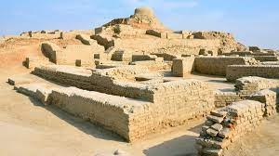

We will be learning all about the ancient Indus Valley this term. We will look at how this early civilization had a lasting impact on the world. The children will use map skills to locate and discover why these people chose the River Indus as their home.

**Important Dates!**

Summer half term: 26th May returning 6th June

End of the school year 15th July.

Don’t forget to visit our website for more information: https://stpatrickscp.npcat.org.uk

**Computing**

We will be using the Hour of Code website to work on our programming skills. This can be accessed at home from this link:

<https://studio.code.org/s/course2>

Please continue to encourage safe internet use at home and good and legal use of social networks. Thank you.

**Homework**

Reading is very important! Please listen to your child read regularly and ensure they bring their reading book and record to school every day. It would be appreciated if you could also write a comment to let us know how your child is getting on at home with their reading.

Children need to complete one session of **Reading Plus** each week at home.

Spellings will continue to be sent home each Friday. Please help your child to learn their words each week for a test on a Friday.

Maths: Please practise your child’s key instant recall facts. These will be very beneficial to children if used regularly.

**French**



In French we will be learning about colours, numbers and fruits. The children’s lessons have opportunities for the children to listen, speak and write in French.

In every lesson, children start by going over common greetings and phrases.