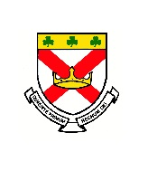
Welcome to Class 6 Summer Overview

Dear Parents and Carers,
We hope you have had a wonderful Easter!

As we have now entered the final term of Year 3, it is now time to prepare the children for their journey into their next class. They have developed a good understanding of what is expected from them in the curriculum and it is now important that they continue to make good progress, ready for the challenges of next year.
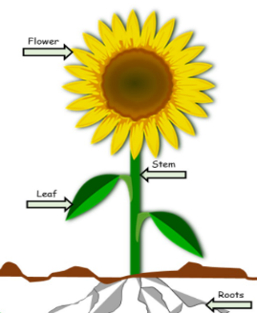
Thank you, Mr Sherrington and Mrs Duffie.
Science
During the Summer term we will be learning about plants and their development. We will be studying plants and vegetable growth to observe and investigate the best conditions for them to flourish.

We will then finish our science studies with our ‘Awe and Wonder’ topic focusing on experiments and investigations.

RE

Our Summer topics we will look at this term are Choices (Reconciliation) and special places. In this topic, we will look at how God wants us love and respect our family.

We will be developing our understanding of the Holy Spirit, show an understanding of building friendships and recognising the importance of admitting wrong and being reconciled with one another and God.

Finally, we will be learning about how ordinary people can do extraordinary things and how different saints show people what God is like.
Maths

Our daily Maths lessons continue to be exciting and challenging. We are continuing to focus on the four basic number rules so that we are able to use and apply them to all maths topics. Times tables and mental arithmetic will be practised daily to improve our rapid recall skills. Weekly ‘times tables tests’ will be completed on a Friday. Please support your child in learning all of their times tables with a focus on 3’s, 4’s and 8 times tables. We encourage the children to use TT Rockstars and Hit the Button to improve their speed of recall.
The main areas we will cover this term are:
• Problem solving using the four operations.
• Geometry and shape
• Calculating fractions.
• Statistics and measures.

English

This term, we will look at the genres of story-writing, poetry, diary entry and non-chronological reports.
In our reading sessions we will practise comprehension skills to help our understanding of a text.
Grammar, punctuation, spelling and handwriting will be practised daily in class. We will now be moving on to spellings from the Year 3-word lists and explore how sentences can be written using different structures.
Finally, we will be encouraging all children to speak clearly in full sentences, as this is a focus we are having throughout the year.

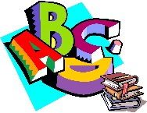
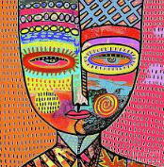
History & Geography
We will be learning all about the ancient Indus Valley this term. We will look at how this early civilization had a lasting impact on the world. The children will use map skills to locate and discover why these people chose the River Indus as their home.

Art, Music and D&T
Art will be based around the artist, Sandra Silbertzweig. They will learn about her style of art and the inspiration behind her work. The children will explore warm and cold colours using chalks. They will learn how to express mood through colour and mix and match colours to create different effects, shades and tones. They will sketch an abstract self-portrait using bold lines and shapes. In the style of, Sandra Silbertzweig the children will produce a final self-portrait using bold shapes and colours.

Important Dates!
Summer half term: 26th May returning 6th June
End of the school year 15th July.
Don’t forget to visit our website for more information: https://stpatrickscp.npcat.org.uk
Computing
We will be using the Hour of Code website to work on our programming skills. This can be accessed at home from this link:
https://studio.code.org/s/course2
Please continue to encourage safe internet use at home and good and legal use of social networks. Thank you.

Homework
Reading is very important! Please listen to your child read regularly and ensure they bring their reading book and record to school every day. It would be appreciated if you could also write a comment to let us know how your child is getting on at home with their reading.

Spellings will continue to be sent home each Friday. Please help your child to learn their words each week for a test on a Friday.
Maths: Please practise your child’s key instant recall facts. These will be very beneficial to children if used regularly.

French
Bonjour! We will be learning how to identify family members and say the alphabet in French.
We will also be learning numbers 21 – 31, months of the year and how to ask for various snacks. Au revoir!

PE
Our P.E lessons are delivered by Mr Poole. The children will learn to play tennis.
They will practise various athletics activities and then compete against each other in races and events for sports day.
This will take place on a Tuesday morning and a Thursday afternoon, so remember to have PE Kits in school (White tops/black shorts and trainers).

