Remote learning - Week beginning 4th January 2020

Our story of the week is a wintery Gruffalo’s child!
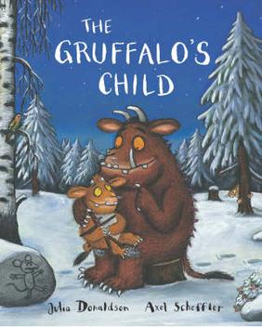

Can you read or listen to the story of The Gruffalo’s child.
https://www.youtube.com/watch?v=MuQm8Qb64EI

What is your favourite part of the story?
Can you join in with the sounds from the story ‘aha, oho!’
‘I’m not scared…’ said the Gruffalo’s child!

