Remote learning - Week beginning 4th January 2020

Our number of the week is 1

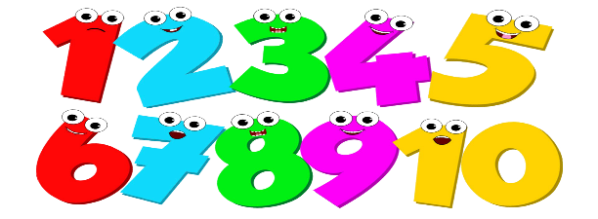
This Photo by Unknown Author is licensed under CC BY-NC

Can you count to 1 – 1!
Can you find 1 thing
Can you recognise number 1
Can you write number 1

Can you count up to 10?
https://www.youtube.com/watch?v=dk9Yt1PqQiw

Can you count the cakes to give to Teddy?
https://www.topmarks.co.uk/learning-to-count/teddy-numbers

