Remote learning - Week beginning 4th January 2020

For our nursery children! Our weekly focus this week are:
Number 1
Colour yellow
Sound s and phase 1 environmental sounds
Shape circle Can you go on a hunt around your home to find the number, shape and colour of the week? Have fun!

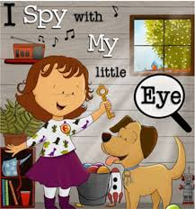

Our rhyme of the week this week is Hickory Dickory Dock!
Can you sing along and join in with the actions!
Our rhyme of the week this week is Hickory Dickory Dock! Can you sing along and join in with the actions!
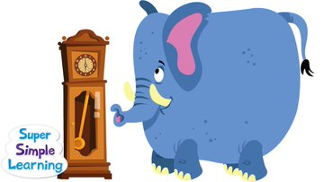
Hickory Dickory Dock | Super Simple Songs
https://www.youtube.com/watch?v=HGgsklW-mtg

Our story this week is 'The Gruffalo's child' by Julia Donaldson. Listen to and enjoy the story. Can you join in with 'I'm not scared...' said the Gruffalo's child!
https://www.youtube.com/watch?v=MuQm8Qb64EI
