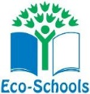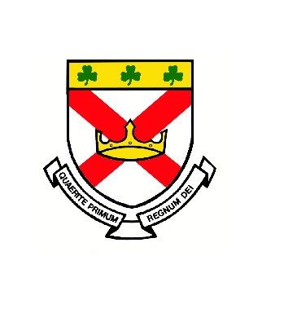

St Patrick's Eco Code

Energy - Save energy and turn things off

Climate change - Keep the planet green and help nature grow.

Oceans - Stop using single use plastic that can go into the oceans.

COVID - Stop spreading germs and wash your hands properly.

Overusing - Stop over fishing and destroying wildlife.

Deforestation - Stop deforestation and plant trees.

Environment - Stop pollution and wasting materials and recycle when you can.

Developed by Class 11 2020 Eco code

