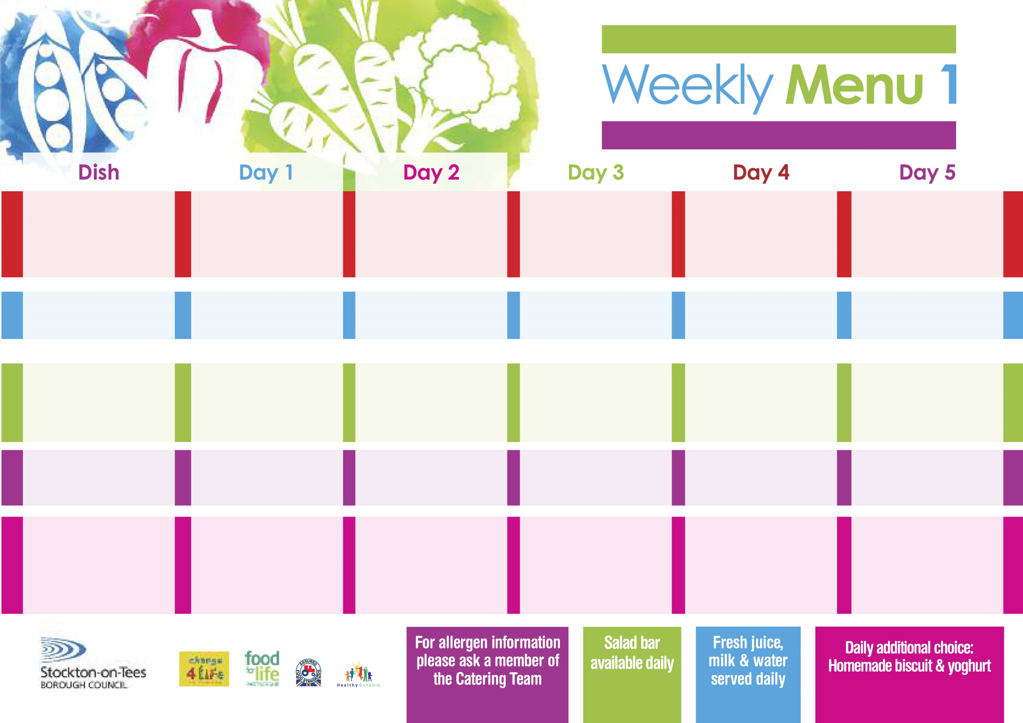

**1st September, 28th September, 2nd November & 30th November, 2020**

**Minced Beef Pie**

**Creamed Potatoes**

**Sweetcorn**

**Garden Peas**

**Minced Quorn Pie(V)**

**Tuna or Cheese Sandwich**

**Baked Jacket Potato**

**Chocolate Crunch**

**with Custard Sauce**

**Cold Bar**

**Fresh Fruit Salad**

**Chicken Casserole**

**& Herby Dumplings**

**Oven Roasted Potatoes**

**Carrots**

**Mixed Vegetables**

**Quorn Casserole & Dumplings(V)**

**Egg Mayo or Tuna** **(V)**

**Sandwich**

**Oven Roasted Potatoes**

**Ginger Pudding**

**with Custard Sauce**

**Cold Bar**

**Melon Boat**

**Baked Sausages**

**Oven Roasted Potatoes**

**Spaghetti Hoops**

**Baked Quorn Sausages(V)**

**Ham or Egg Mayo (V)**

**Oven Roasted Potatoes**

**Apple Pie**

**with Custard Sauce**

**Cold Bar**

**Watermelon Slices**

**Christ The King & St Patrick’s Primary School**

**+**

**Fish Fillet Fingers**

**Oven Baked Jacket Potatoes**

**Spaghetti Hoops**

**Cheese or Ham Sandwich (V)**

**Baked Jacket Potatoes**

**Chocolate Chip Sponge**

**with Custard Sauce**

**Cold Bar**

**Fresh Fruit Bowl**

**Fish Goujons**

**Oven Baked Chips**

**Garden Peas**

**Baked Beans**

**Cheese or Tuna Sandwich (V)**

**Oven Baked Chips**

**Vanilla Sponge**

**with Custard Sauce**

**Cold Bar**

**Fresh Fruit Bowl**

**Hot Meal**

**Cold Selection**

**Desserts**