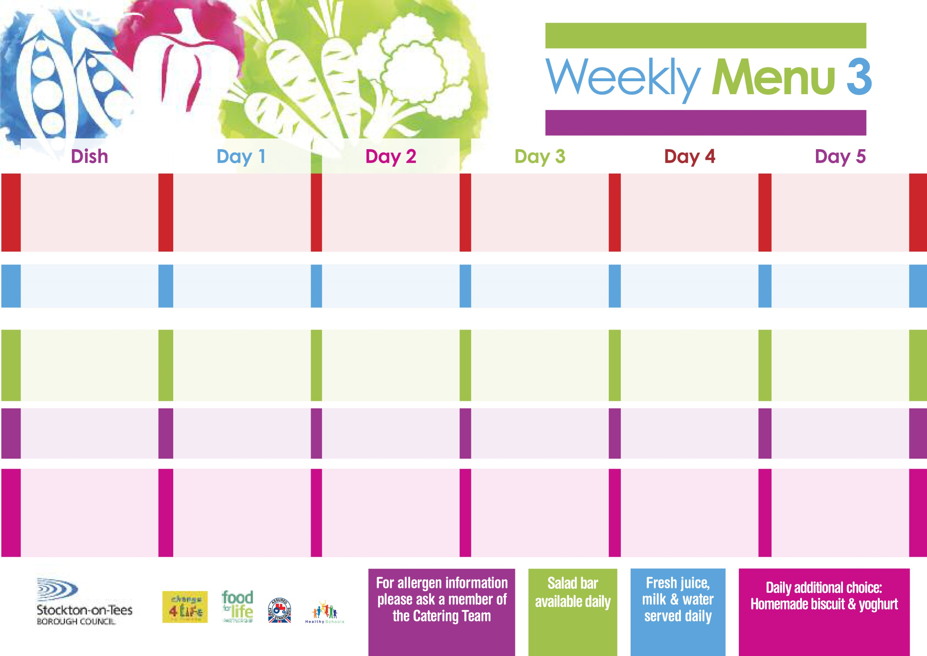

**14th September, 12th October, 16th November & 14th December, 2020**

**Fish Goujons**

**Oven Baked Chips**

**Garden Peas**

**Baked Beans**

**Egg Mayo or Tuna Sandwich (V)**

**Oven Baked Chips**

**Cornflake Tart**

**with Custard Sauce**

**Cold Bar**

**Fresh Fruit Platter**

**Homemade Margarita Pizza (V)**

**Oven Roasted Potatoes**

**Baked Beans**

**Egg Mayo or Tuna Sandwich (V)**

**Oven Roasted Potatoes**

**Mixed Fruit Pie**

**with Custard Sauce**

**Cold Bar**

**Fresh Fruit Bowl**

**Lasagne**

**Homemade Garlic Bread**

**Garden Peas**

**Quorn Lasagne (V)**

**Ham or Cheese Sandwich (V)**

**Baked Potato Wedges**

**Creamy Rice Pudding**

**& Peaches**

**Cold Bar**

**Melon Boats**

**Roast Turkey with**

**Sage & Onion Stuffing**

**Creamed Potatoes**

**Broccoli**

**Diced Carrots**

**Homemade Quiche (V)**

**Ham or Cheese Sandwich**

**Baked Jacket Potatoes**

**Chocolate Sponge**

**with Custard Sauce**

**Cold Bar**

**Fresh Fruit Salad**

**Pork & Carrot Meatballs**

**In Tomato Sauce**

**Oven Roasted Potatoes**

**Sweetcorn**

**Green Beans**

**Cheese & Vegetable Bakes**

**(V)**

**Tuna or Egg Mayo Sandwich**

**Oven Roasted Potatoes**

**Jam Sponge**

**with Custard**

**Cold Bar**

**Fresh Fruit Kebab**

**Hot Meal**

**Cold Selection**

**Desserts**

**Christ The King & St Patrick’s Primary School**