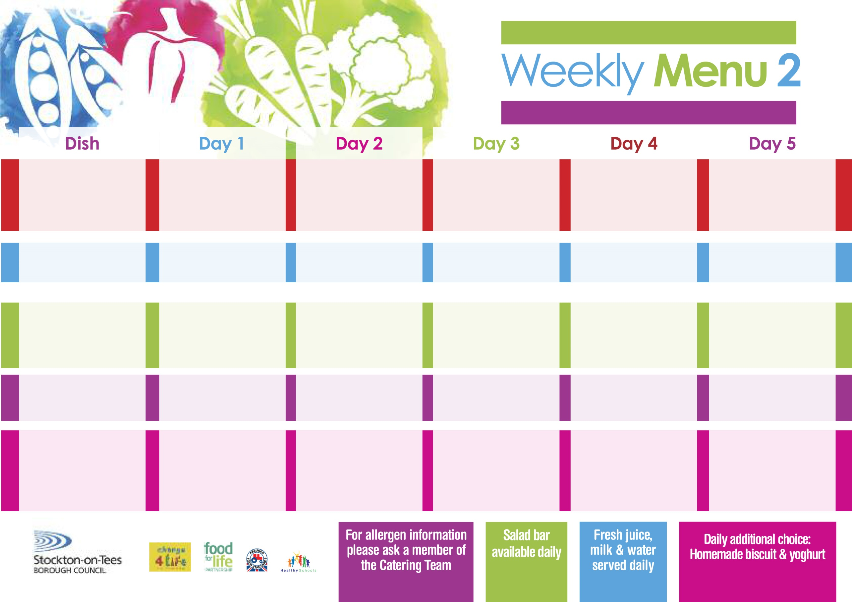

**7th September, 5th October, 9th November & 7th December, 2020**

**Pizza Whirl (V)**

**Oven Roasted Potatoes**

**Garden Peas**

**Baked Beans**

**Tuna or Ham Sandwich (V)**

**Oven Roasted Potatoes**

**Bakewell Tart**

**with Custard Sauce**

**Cold Bar**

**Fresh Fruit Platter**

**Spaghetti Bolognaise**

**served with Garlic Bread**

**Sweetcorn**

**Mixed Vegetables**

**Quorn Spaghetti Bolognaise****(V)**

**Tuna or Egg Mayo Sandwich**

**Oven Baked Jacket Potato**

**Marble Sponge**

**with Custard Sauce**

**Cold Bar**

**Fresh Fruit Salad**

**Mince & Dumplings**

**Baby Boiled Potatoes**

**Broccoli**

**Mixed Vegetables**

**Quorn Mince & Dumplings(V)**

**Cheese or Egg Mayo Sandwich**

**Baby Boiled Potatoes**

**Syrup Sponge**

**with Custard Sauce**

**Cold Bar**

**Fresh Fruit Bowl**

**Harry Ramsden**

**Fish Fillet**

**Oven Baked Chips**

**Garden Peas**

**Baked Beans**

**Cheese or Egg Mayo Sandwich**

**Oven Baked Chips**

**Creamy Rice Pudding**

**& Jam Sauce**

**Cold Bar**

**Melon Boat**

**Breaded Chicken Breast**

**Oven Roasted Potatoes**

**Garden Peas**

**Diced Carrots**

**Homemade Quiche(V)**

**Ham or Tuna Sandwich (V)**

**Oven Roasted Potatoes**

**Jam Roly Poly**

**with Custard Sauce**

**Cold Bar**

**Watermelon Slices**

**Christ The King & St Patrick’s Primary School**

**Hot Meal**

**Cold Selection**

**Desserts**