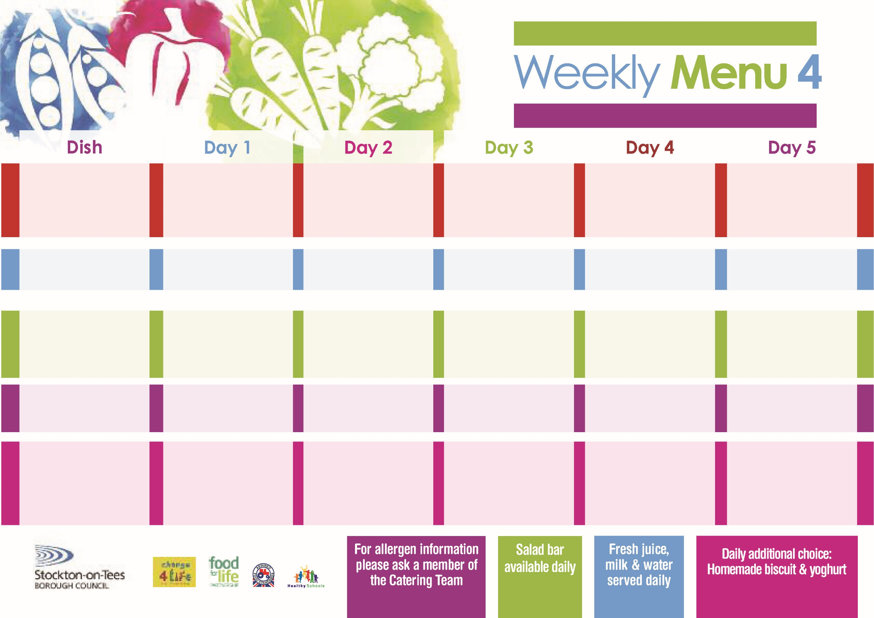

**Tempura Battered**

**Fish Fillet**

**Oven Baked Chips**

**Garden Peas**

**Baked Beans**

**Egg Mayo or Tuna Sandwich (V)**

**Oven Baked Chips**

**Apple Crumble**

**with Custard Sauce**

**Cold Bar**

**Fresh Fruit Kebab**

**Toad In The Hole**

**Baby Boiled Potatoes**

**Broccoli**

**Diced Swede**

**Quorn Sausages with Yorkshire Pudding (V)**

**Ham or Cheese Sandwich**

**Baby Boiled Potatoes**

**Feathered Sponge**

**with Custard Sauce**

**Cold Bar**

**Watermelon Slices**

**Turkey Burger in a Bun**

**Oven Roasted Potatoes**

**Garden Peas**

**Baked Beans**

**Quorn Burger in a Bun (V)**

**Tuna or Egg Mayo Sandwich (V)**

**Oven Roasted Potatoes**

**Creamy Rice Pudding**

**& Jam Sauce**

**Cold Bar**

**Fresh Fruit Bowl**

**21st September, 19th October & 23rd November, 2020**

**Homemade Pizza (V)**

**Oven Baked Jacket Potatoes**

**Spaghetti Hoops**

**Tuna or Cheese Sandwich**

**Oven Baked Jacket Potatoes**

**Mandarin Orange Sponge**

**with Custard Sauce**

**Cold Bar**

**Fresh Fruit Salad**

**Fish Fillet Fingers**

**Oven Roasted Potatoes**

**Garden Peas**

**Sweetcorn**

**Egg or Ham Sandwich (V)**

**Oven Roasted Potatoes**

**Syrup Roly Poly**

**with Custard Sauce**

**Cold Bar**

**Melon Boat**

**Hot Meal**

**Cold Selection**

**Desserts**

**Christ The King & St Patrick’s Primary School**