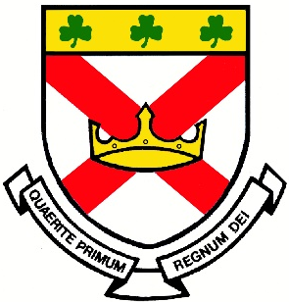
20th March 2020
Dear Children,
Today is the last day that we will be in school together and we are not sure when we will be able to be in school as one big St.Patrick’s family again- hopefully it will be soon. Some of you will do your learning at home and some of you will still come to school.
You have all heard about the Caronavirus and things will be different for a while in our lives. Schools, shops, Churches and places to visit will be different for a while but you do not need to worry- things will return to being normal again!
We don’t want anyone to worry about the virus as we have lots of doctors and nurses that will help people to get better if they become poorly. Children and most grownups are not in any danger and we all need to help one another to stay fit and well. You have all been brilliant in school recently at washing hands and remembering to cough into your arm. Well done for this and keep up this good work!
Please remember that if you are worried you will all have an adult or a friend that you can talk to and care for you. Being worried about things you are not sure about is normal sometimes in life and there will always be someone who you can talk to- just like you do in school and you can do this at home too.
Remember to keep yourself safe when you are at home and there will be times that you need to stay indoors to catch up on some school work. Your teacher has reminded you about how to stay safe on line but speak to an adult at home if you see or hear something that makes you feel uncomfortable- they are there to help you. We have organised lots of interesting things for you to be doing while away from school so enjoy them and be good for the adults who are looking after you. If you have brothers and sisters- try not to argue and squabble and enjoy playing games with them. Remember to read lots of books- books take you to wonderful places to meet all sorts of characters!
At the end of each day, sit with your family and take it in turns to say 3 good things about the day you have just had and before you go to sleep, say a little prayer for your family, friends and people around the world-especially our doctors and nurses. We will see you all soon so that you can tell us all about what you have been up to! Stay safe and happy children!
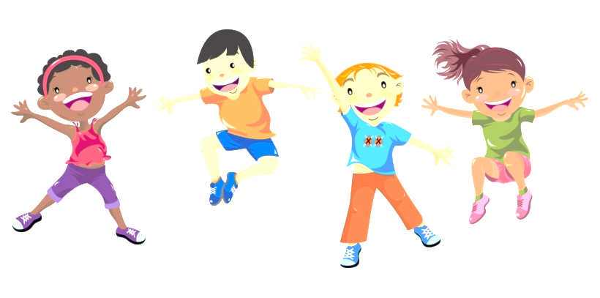
God Bless from us all at St.Pat’s!

