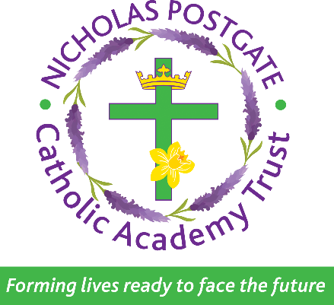
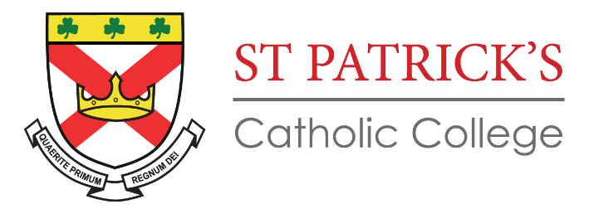

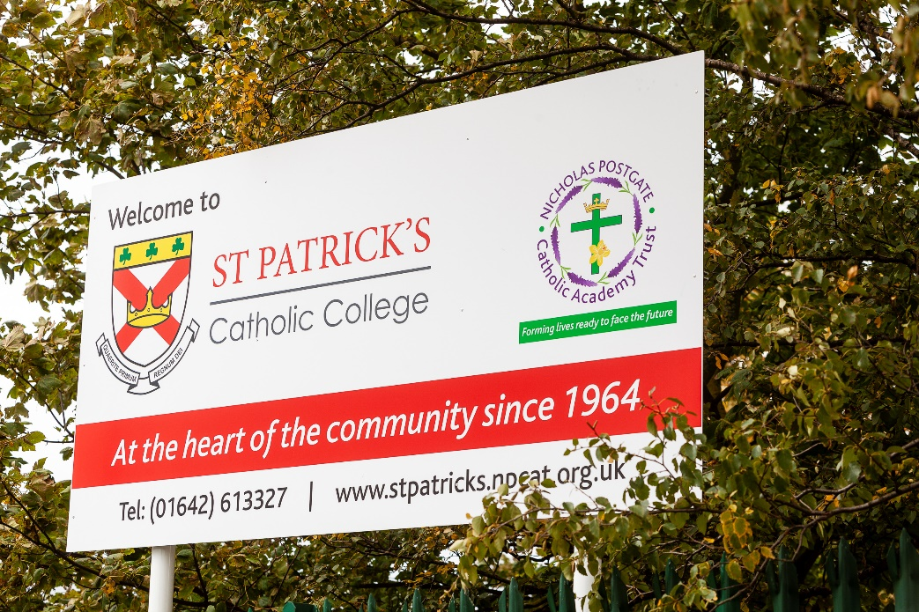

Transition Booklet

Information for Parents/carers and students

Welcome from the Headteacher

St Patrick’s Catholic College is now entering an exciting time, the investment that Nicholas Postgate Catholic Academy Trust is putting into the college is a reflection of the intent we have to see standards improve rapidly in all areas of school and we are delighted to be able to share our vision with you.
Choosing a secondary school is an important decision for all families and is a decision not to be taken lightly. As a parent, I understand that the decision to send your child to the right school must be made with due care and attention in order to make an informed choice. That’s why we have made some key decisions that will increase the rate of change even faster at St Patrick’s Catholic College.
During my career in leadership, I have extensive school improvement experience in a range of different schools across the North East, making a rapid improvement to achievement, progress, behaviour and attendance. The improvements made have been recognised by OFSTED and the local authority and include 30% improvement in GCSE results in just 2 years, with pupils making positive progress across a range of different abilities.
I intend to lead the school by:
- Ensuring everything we do is centred around the life and teachings of Jesus Christ.
- Improving the quality of education.
- Setting the highest expectations of pupils and their outcomes.
- Improving the life chances of all our young people, nurturing their unique gifts and talents.

Our mission does not only include achieving the highest standards of behaviour and academic achievement but providing our pupils with the best possible holistic education. As a Catholic school, nurturing children’s spiritual development is central to everything we do. As part of the Middlesbrough Diocese, we belong to a family of Catholic primary and secondary schools with whom we share the same distinct ethos.
At St Patrick’s Catholic College, we will continue to build strong relationships and parental engagement, to ensure that as a community, we have family at the centre and together, can support your child to fulfil their potential. We will ensure that pupils are nurtured, respected, safeguarded, loved, supported and have the guidance that I had myself, to be successful during their time at our school and beyond.
Yours Sincerely,
Mr M Burns
Our Mission Statement

‘Seek Ye First the Kingdom of God…’
Matthew 6.33

At St Patrick’s Catholic College our aim is to provide a high-quality education based upon the teachings of Christ; where all pupils are valued members of our community and able to develop their talents to the full.
True Catholic education is concerned with academic success and is also about helping young people to grow and appreciate their worth and value. It is our responsibility to help pupils realise their dignity and discover their purpose.
We acknowledge that each person is a unique individual and strive to respect each individual irrespective of circumstance, gender, race or creed. We will encourage everyone to develop their unique personality and educate the whole person within a loving and caring Christian environment. To this end, we will promote a happy and caring environment within, which each individual can develop their potential to the full.

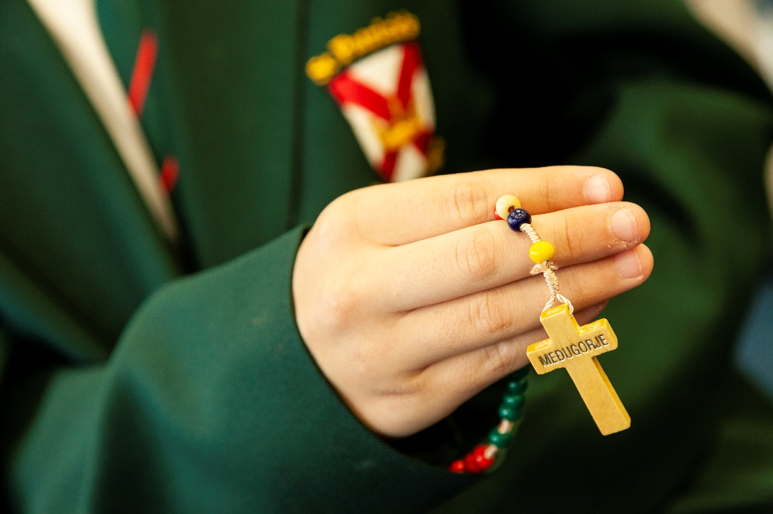

Ethos and Values
As a Catholic school our core values are the Gospel values expressed as follows:
- Growth – We will encourage all to recognise and develop their full potential.
- Openness – We will be open and fair in our dealings with others.
- Special – We will recognise that each individual is created in the image of God.
- Prayer – We will give all the opportunity to understand their faith and God.
- Everyone – We will learn and teach with enthusiasm, excitement and energy.
- Learning – We will recognise the individual and provide support for all.
- Valued – We will provide a safe and secure Christian environment.
- Acceptance – We will be a celebratory community accepting and trusting in the will of God.
- Love – We will show courtesy and good manners in all that we do.
- Unique – We value the unconditional acceptance of each individual.
- Experiences – We will be open to our responsibilities and links in the wider community.
- Service – We value lives of service, sacrifice and community.

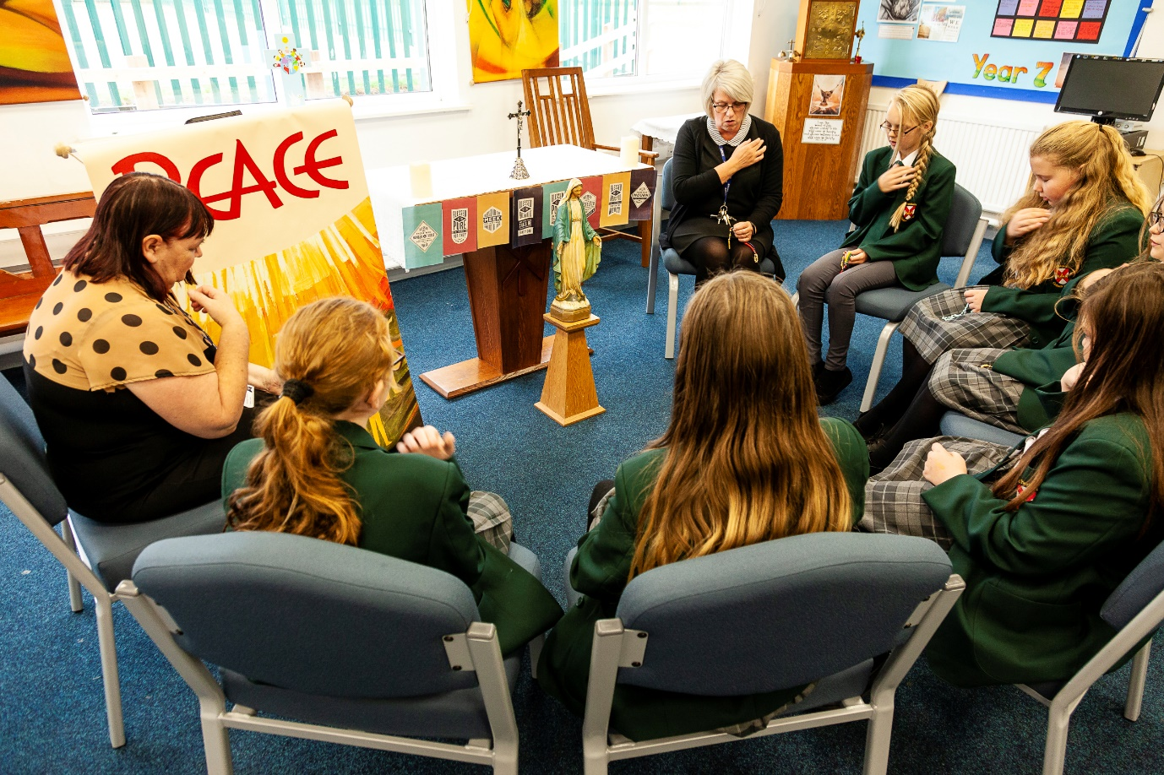

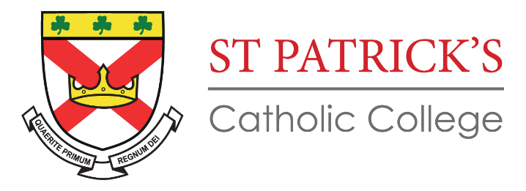
Student Expectations

Student expectations exist so that the school is a safe, orderly, happy environment where students can learn to the best of their ability and flourish in a place of educational excellence. We aim to be positive and encourage good behaviour through a system of respect and reward.

Respect and Consideration for Others
- The dignity of all members of St Patrick’s Catholic College must be nurtured and respected at all times through both word and action.
- Staff must be addressed respectfully as ‘Sir’ or ‘Miss’.

During Lessons
- Enter the classroom and listen carefully to all instructions given by the Teacher.
- Always give your best effort in lessons and be resilient when faced with difficult challenges.
- All instructions from the teacher must be followed immediately and without question.
- No-one must disrupt a lesson through poor behaviour or attitude to learning.

Movement
- Students should move around on the left-hand side of corridors and staircases.

Dress - Uniform
- Students must be dressed properly in full school uniform including shirts being tucked in.
- Correct footwear must be worn at all times.
- Outdoor coats are not to be worn in the school building.

Jewellery
- No Jewellery, nail varnish, acrylics or make up are allowed.
- No exceptions – a wristwatch is the only item students are now able to wear.

Hair styles
- Only hair styles deemed socially acceptable are permitted. Hair styles must be simple, and any hair colouring must look natural.
- The College does not permit hairstyles that reflect the extremes of fashion – unnatural or extravagant colours, extensions, beads, or designs cut into the hair are not permitted. No hair should be shorter than a No. 2 cut.
- Long hair being tied up must use plain black or grey bobbles or bands.

Mobile phones
- Mobile phones/smart watches and other audio devices: to be switched off at the College gate, kept out of view and remain switched off until students leave the College site at the end of the school day. If your child is seen with any of the above items in the College, they will be confiscated, placed in the safe and will only be returned to the parent/carer.

Equipment
- All students must have the basic equipment of a bag, planner, pen, pencil, rubber, ruler.

Food
- Food must be consumed in designated areas.
- Chewing gum is not allowed anywhere on the school site.
- No eating is allowed during a lesson.

Harmful Substances
- Under no circumstances must students bring alcohol, tobacco, E-cigarettes or drugs onto school premises.
- All medicines must be handed in to the school office with a completed medical form.

Bounds
- Students must remain in the areas supervised by staff at all times: ie on the playgrounds.
- All pupils remain on site all day.

Timing of the School Day

Time | KS3  Year 7, 8 & 9 | Time | KS4  Year 10 & 11
08:30 – 09:30 | Lesson 1 | 08:30 – 09:30 | Lesson 1
09:30 – 10:30 | Lesson 2 | 09:30 – 10:30 | Lesson 2
10:30 – 10:45 | Break | 10:30 – 10:50 | Tutor
10:45 – 11:05 | Tutor | 10:50 – 11:05 | Break
11:05 – 12:05 | Lesson 3 | 11:05 – 12:05 | Lesson 3
12:05 – 12:35 | Lunch | 12:05 – 13:05 | Lesson 4
12:35 – 13:35 | Lesson 4 | 13:05 – 13:35 | Lunch
13:35 – 14:35 | Lesson 5 | 13:35 – 14:35 | Lesson 5

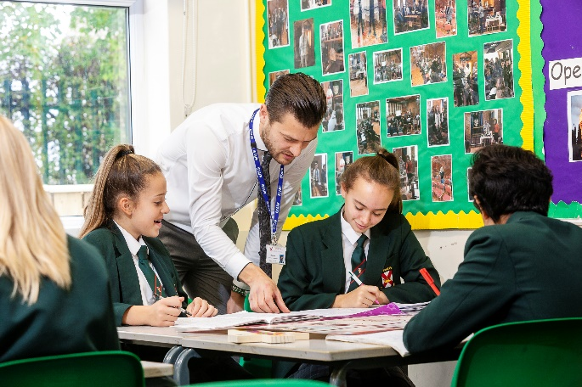

Term Dates

The term dates for the Academic Year 2020 – 2021 are shown below.
In addition to the dates below, schools will be closed to pupils on Thursday 2nd April and Monday 3rd May (Bank Holiday).
Two dates within these term dates will be used for professional development for staff. These dates are:
- Monday 4th January
- Friday 16th April
School will be closed to pupils on these dates.

Autumn Term 2020
Start of Term | Half Term | Last day of Term
Wednesday 2 September 2020 | 26 – 30 October 2020 | Friday 18 December
Spring Term 2021
Start of Term | Half Term | Last Day of Term
Tuesday 5 January 2021 | 15 – 19 February 2021 | Thursday 2 April
Summer Term 2021
Start of Term | Half Term | Last Day of Term
Monday 19 April 2021 | 31 May – 4 June 2021 | Friday 16 June
Enrichment

At St Patrick’s we offer a wide range of enrichment activates for all students to attend. These session take place during lunch time and at the end of the school day, usually between 2-35pm and 3-30pm, although with prior arrangements some sporting fixtures may go on longer than this.
Below are some examples of some of the activities that have already taken place at St Patrick’s:
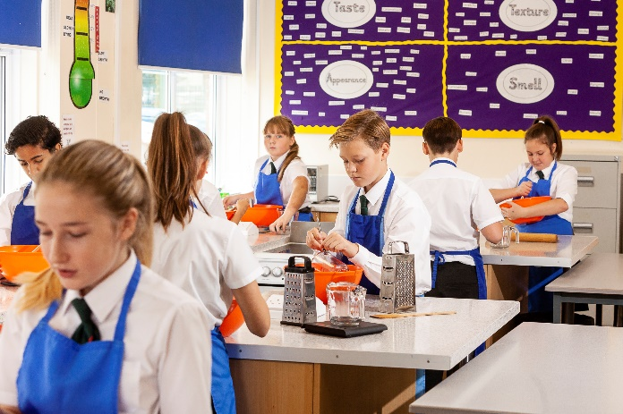
- Art Club
- Chess Club
- Choir
- Craft Club
- Cooking Club
- Dance
- Dodgeball
- Enterprise Group
- Football (Boys and Girls)
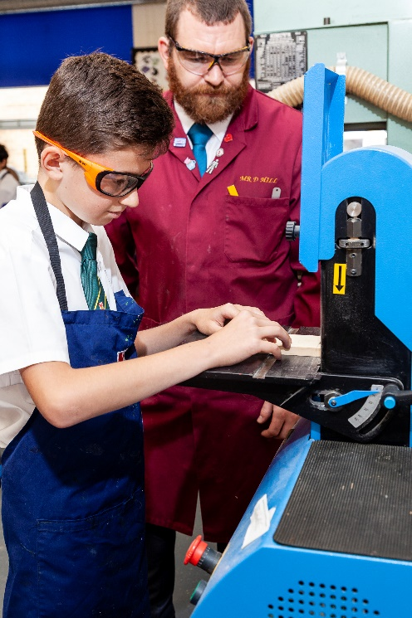
- Guitar Group
- Keyboard Blub
- Rugby
- Science Club
- Textiles Club
- Table Tennis Club
- Ukulele Group
- Young Christian Workers
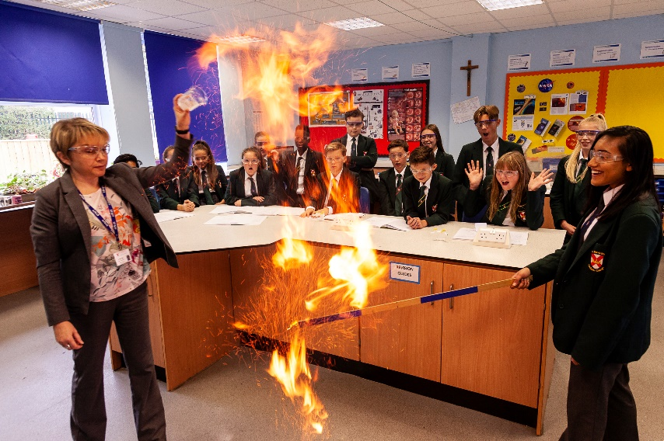
- Young Vincentians

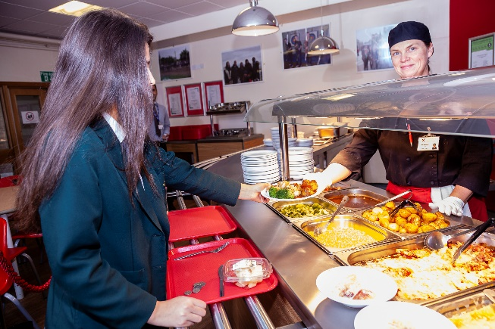
Catering
We operate a cashless system of school meals which uses Biometric finger printing to manage the money that has been spent. This helps to speed up the process of paying for food in the dining hall and also helps you as parents/carers to manage what is being spent.
Payment Method
Cash Loader: Students are able to load money onto their account with coins on notes whilst in school. The cash loader is situated in the main entrance area of the school. Parents/carers are also able to upload money onto their child’s account online through the use of Parent Pay.
Sample Menu
We have a wide variety of meals available to students on a daily basis. Below is a typical menu of what could be on offer over the course of a week.
 | Monday | Tuesday | Wednesday | Thursday | Friday
Option 1 | Steak Pie, new potatoes,  carrots | Chicken Tikka Masala | Smothered Chicken | Enchiladas | Battered Fish and Chips
Option 2 | Chicken Fillet Burger | Panini | Goujon Wrap | Jumbo Sausage Bun | Baked Potatoes
Option 3 | Vegi Burger | Vegetable Curry | Vegetable Lasagne | Vegi Sausage Bun | Vegetable pasta bake
Option 4 | Pasta Pot | Pasta Pot | Pasta Pot | Pasta Pot | Pasta Pot
Desserts | Toffee Pudding | Apple Crumble | Apple & Caramel Wedge | Chocolate Pudding | Waffles

There is also a wide range of sandwiches, fruit biscuits available on a daily basis.

Curriculum
During Key Stage 3 (year 7-9), you will have the opportunity to study a wide range of subjects before you decide which subjects you would like to continue to study at GCSE.
The subjects that you will study are:

Science:
Biology
Chemistry
Physics
English Literature & English Language
Maths

Geography
History
Religious Education

French
Art
Computing

PE
Design Technology:
Textiles
Engineering
Food Technology
Music

PSHE

