My ‘All About Me’ Booklet

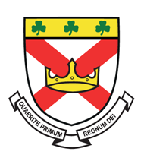
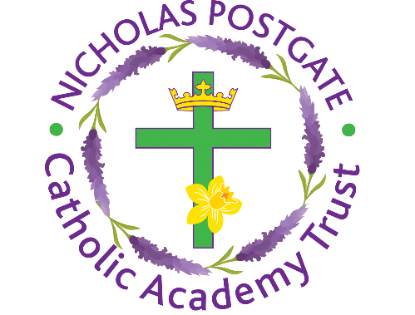

Name:________________________
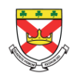
All About Me

Name:_______________________________________________________
Draw or stick a picture of yourself in here

Primary School:________________________________________________

Favourite Colour:_______________________________________________

Favourite Animal:_______________________________________________

My Family
Draw or stick a picture of your family in here

Tell us a little bit about your family? Who are they? What do you enjoy doing the most together as a family?

Tell us a little bit more about yourself by answering the following questions
What are your hobbies?

What are your favourite subjects?

If you could have a superpower, what would it be? Make sure you explain why!

What is the best place you have ever been to? Make sure you explain why!

What is the country that you would like to go to most? Make sure you explain why!

What is your dream job? Make sure you explain why!

Clubs and Activities

At St Patrick’s College, we have lots of different clubs for students to join. Some of them are:
- Music Clubs – Choir, Keyboard Club, Guitar/Ukulele Club
- Sport – Boys and girls Football, Rugby, Dodgeball, Badmington
- Dance and Drama groups
- Arts and crafts clubs
- Science and Chess Club
- Cooking, Textiles and Woodwork clubs
- Young Vincentians

What clubs would you like to join when you start at St Patrick’s?

Are there any activities that you would like to see taking place that are not on the list above?

List 4 things…
List four things you are a little worried or nervous about:
1.

2.

3.

4.
List four things you are most looking forward to about joining St Patrick’s College:
1.

2.

3.

4.

My Goals for Secondary School
When you go to Secondary School, you will learn a huge number of new skills, and improve skills you have practiced in Primary School. In the goal below, use the list to write in 10 new skills or things you’d like to build on in your years at Secondary School.

Be in a school play or production | Speak another language | Represent your school in a national competition
Learn to play a musical instrument | Volunteer in the local community | Travel to another country
Play for a school team | Learn how to survive in the wild | Take care of the school garden
Learn how to manage money | Taste food from another country | Walk the school dog
Cook a new meal from scratch | Read new books | Take part in a fancy dress day
Create a piece of art | Raise money for charity | Become Head Boy or Girl
Learn how to read a map | Join an after school club | Learn to dance
Use computers to create your own website | Learn First Aid | Improve your singing
Make new friends from other schools | Work as part of a team | Try camping

