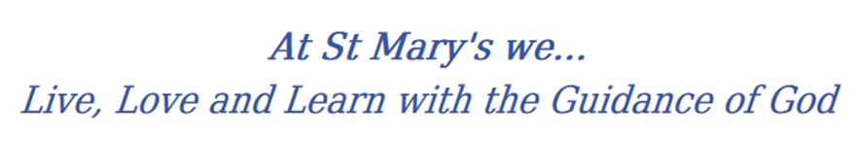
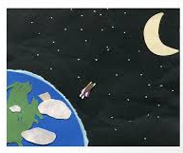
Year 6 Long Term Curriculum Map

2019-20 | Autumn 1 | Autumn 2 | Spring 1 | Spring 2 | Summer 1 | Summer 2
RE | Loving  Vocation and commitment | Expectations  Judaism | Sources  Unity | Death and new life | Witnesses  Healing | Islam  Common good
PSHE | Being Me In My World  Identifying goals for the year  Global citizenship  Children’s universal rights  Feeling welcome and valued Choices, consequences and rewards Group dynamics  Democracy, having a voice  Anti-social behaviour  Role-modelling | Celebrating Difference  Perceptions of normality  Understanding disability  Power struggles  Understanding bullying  Inclusion/exclusion  Differences as conflict,  difference as celebration  Empathy | Dreams and Goals  Personal learning goals, in and out of school Success criteria  Emotions in success  Making a difference in the world  Motivation  Recognising achievements  Compliments | Healthy Me  Taking personal responsibility  How substances affect the body Exploitation, including ‘county lines’ and gang culture Emotional and mental health  Managing stress | Relationships  Mental health  Identifying mental health worries and sources of support Love and loss  Managing feelings  Power and control  Assertiveness  Technology safety  Take responsibility with technology use | Changing Me  Self-image  Body image  Puberty and feelings  Conception to birth  Reflections about change  Physical attraction  Respect and consent  Boyfriends/girlfriends  Transition
English | 1.Narrative  2.Journalistic Style | 1.Poetry  2. Biography  3.Narrative  4. Diary | 1.Argument  2.Non-Chronological Report  3.Explanation  4.Letter of Complaint | 1.Instructions  2.Myths  3.Descriptive Poetry | 1.Balanced Argument  2.Informal Letter  3.Narrative | 1.Persuasive Writing  2. Letters  3.Poetry
Class Text | 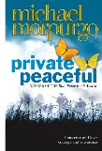 |  |  |  | 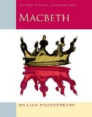 | 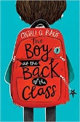
History | Industrial Revolution (Turning point in history) WW1 WW2 Battle of Britain(Turning point in history) Present Day  Food Transport Democracy
Geography | Locational and place knowledge  Investigating and locating major world cities / locations from WW1 and WW2  Focussing on their key characteristics  How are they similar and different  Human and physical geography  Transformation of societies (changes in manufacturing and transportation).  Geographical Skills and Field Work  Use maps, atlases, globes and digital media to locate countries  Use four and six figure grid references |  |  | Locational Knowledge:  UK main rivers(e.g. Tyne, Wear, Tees, Thames, Mersey, Severn) trade links  World Rivers  Coasts  Human and physical geography  Rivers: trade links, natural resources including energy, food, minerals & water.  Compare geographical areas.  Water Cycle – including supply problems  Geographical Skills and Field Work  Use maps, atlases, globes and digital media to locate countries  Use four and six figure grid references  Interpret OS Maps
Science | Animals inc humans:  circulatory systems and healthy lifestyles | Electiricity :Circuits, symbols, voltage and investigations | Chemical reactions: Irreversible changes and separating materials | Living things and their habitats: classification and micro-organisms | Evolution and Inheritance | Light and sound: reflection and refraction
Working Scientifically
Develop pupils’ skills in working scientifically and create more independent, analytical scientists who plan their own lines of enquiry.
Scientists that changed the world
Compare scientists from then and now; looking specifically at Hawking and Darwin
Maths
Art | Drawing: Use a variety of techniques to add interesting effects (e.g. reflections, shadows, direction of sunlight).Choose a style of drawing suitable for the wo(e.g. ealistic or impressionistic). | Painting: Sketch (lightly) before painting to combine line and colour.  Use brush techniques and the qualities of paint to create texture.  Combine colours,  tones and tints to enhance the mood of a piece. | Sculpture:  Show life-like qualities and real-life proportions or, if more abstract, provoke different interpretations.  Use frameworks (such as wire or moulds) to provide stability and form. | Collage: Mix textures (rough and smooth, plain and patterned).  Combine visual and tactile qualities. Use ceramic mosaic materials and techniques. | Digital media  Enhance digital media by editing (including sound, video, animation, still images and installations). | Print: Build up layers of colours. Create an accurate pattern, showing fine detail. Use a range of visual elements to reflect the purpose of the work.
DT | Food  Celebrating culture and seasonality  (including cooking and nutrition requirements for KS2) |  | Mechanical Systems  Pulleys or gears |  | Textiles  Combining different fabric shapes  (including computer-aided design)
Music | Pop/Motown | Jazz, Latin, Blues | Benjamin Britten  (Western Classical Music), Gospel, Bhangra. | Music And Identity | The music of Carole King | Western Classical Music and your choice from Year 6
PE | Invasion games (RRC)  Running, throwing, catching, passing  (Tag rugby)  Swimming | Invasion games  Running, throwing, catching, passing  (Tag rugby)  Swimming | Gymnastics  Sequence speed, level, direction, rotation  Dance | Outdoor and adventurous | Striking and fielding  Running, throwing, jumping, | Athletics  Running, throwing, jumping, competing.
MFL | Verbs and grammar | At School | The Weekend | WW11 | Health Lifestyle | Habitats
Computing | Week 1 2 3 4 5 6 7 8 9 10 11 12 13 14 15 16 17 18 19 20 21 22 23 24 25 26 27 28 29 30 31 32  YEAR 6 * Unit 6.1 Coding Number of Weeks – 6 Main Programs – 2Code Unit 6.2 Online safety Weeks – 2 Programs - Various Unit 6.3 Spreadsheets Weeks – 5 Programs – 2Calculate Unit 6.4 Blogging Weeks – 5 Programs – 2Blog Unit 6.5 Text Adventures Weeks – 5 Programs – 2Code, 2Connect Unit 6.6 Networks Weeks – 3 Unit 6.7 Quizzing Weeks – 6 Programs – 2Quiz, 2DIY, Text Toolkit, 2Investigate

