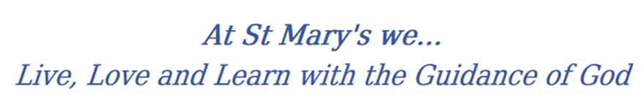
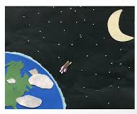
Year 5 Long Term Curriculum Map

2019-20 | Autumn 1 | Autumn 2 | Spring 1 |  | Spring 2 | Summer 1 |  | Summer 2
RE | Ourselves  Life choices | Hope  Judaism | Mission  Memorial sacrifice |  | Sacrifice | Transformation  Freedom and Responsibility |  | Islam  Stewardship
PSHE | Being Me In My World  Planning the forthcoming year  Being a citizen  Rights and responsibilities  Rewards and consequences  How behaviour affects groups Democracy, having a voice, participating | Celebrating Difference  Cultural differences and how they can cause conflict  Racism  Rumours and name-calling  Types of bullying Material wealth and happiness  Enjoying and respecting other cultures | Dreams and Goals  Future dreams  The importance of money  Jobs and careers  Dream job and how to get there  Goals in different cultures  Supporting others (charity)  Motivation |  | Healthy Me  Smoking, including vaping  Alcohol  Alcohol and anti-social behaviour  Emergency aid  Body image  Relationships with food  Healthy choices  Motivation and behaviour | Relationships  Self-recognition and self-worth  Building self-esteem  Safer online communities  Rights and responsibilities online  Online gaming and gambling  Reducing screen time  Dangers of online grooming  SMARRT internet safety rules |  | Changing Me  Self- and body image  Influence of online and media on body image  Puberty for girls  Puberty for boys  Growing responsibility  Coping with change  Preparing for transition
English | - Non-chronological report  - Descriptive narrative  - Poetry  ; | - Instruction writing  - Adventure Narrative  - Haiku poetry | 1.Newspapers  2. Historical Narrative  3. Kenning poetry  4. Letters |  | 1.Myths & Legends  2. Biographies & Autobiographies  3. Narrative Poetry/Saga | 1.Balanced Argument  2. Haiku Poetry  3. Diary |  | 1.Persuasive Writing/Letters  2. Narrative Poetry/Saga  3. Adventure Narrative
Class Text | 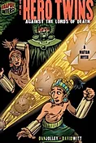  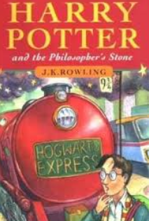 | 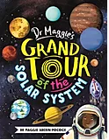 | 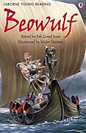  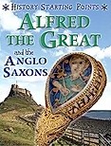  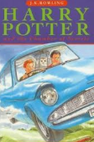 |  |  | 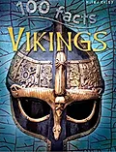  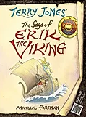 |  | 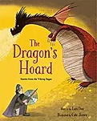
History | Mayan Civilisation  Exploring the Mayan civilisation and its contrasts with British history. Developing knowledge through a range of resources. Furthering understanding of world history.  Anglo Saxon/Scots  Exploring and developing knowledge on Britain’s settlement by the Anglo- Saxons and Scots. Developing understanding through a range of resources. Furthering understanding of British history.  Viking/Anglo Saxon struggle for the UK  Developing chronological understanding of the Viking and Anglo-Saxons struggle for the kingdom of England to the time of Edward the Confessor. Identifying events over time and beyond.  Food Transport Politics
Geography | Locational and place knowledge  - Locate the Amazon Rainforest and its majors geographical features  - Understand similarities and differences between Rainforests and with UK  - Trade links – chocolate!  Human and Physical  - How does the climate affect/influence its trade  Geographical Skills and Field Work  - Use maps, atlases, globes and digital media to locate countries  - Use four figure grid references |  |  | Location Knowledge  - Locate World countries using Maps, atlases and globes  - Identify positions of significant longitudes and latitudes; biomes and vegetation belts.  Human and Physical  - Why do these conditions affect the inhabitants of the climate?  - Describe types of settlements and land use  - Understand how land has changed over time  Geographical Skills  - Use maps, atlases, globes and digital media to locate countries  - Use four and six figure grid references |  |  | Locational Knowledge:  - Identify the position and significance of longitude, Northern Hemisphere, Southern Hemisphere, Arctic and Antarctic Circle.  Human and physical geography  - Rivers: trade links, natural resources including energy, food, minerals & water.  - Compare geographical areas.  - Water Cycle – including supply problems  Geographical Skills and Field Work  - Use maps, atlases, globes and digital media to locate countries  - Use four and six figure grid references
Science | Properties and changes to materials  Compare and group together everyday materials on the basis of their properties, including their hardness, solubility, transparency, conductivity (electrical and thermal), and response to magnets. | Earth and Space  Describe the movement of the Earth, and other planets, relative to the Sun in the solar system. | Forces  Explain movement using the idea of push and pull. |  | Animals including humans  Describe the changes as humans develop to old age. | Living things and their habitats  Describe the differences in the life cycles of a mammal, an amphibian, an insect and a bird.
Working Scientifically
Develop pupils’ skills in working scientifically and create more independent, analytical scientists who plan their own lines of enquiry.
Scientists that changed the world
Compare scientists from then and now.
Maths
Art | Drawing  Try out tools and techniques, applying them to materials and processes. Use a variety of techniques to add interesting effects Choose a style of drawing | Sculpture  Show life-like qualities and  real-life  proportions or, if more abstract, provoke different interpretations  Use tools to carve and add shapes, texture and pattern.  Combine visual and tactile qualities.  Drawing  Try out tools and techniques, applying them to materials and processes. Use a variety of techniques to add interesting effects Choose a style of drawing  Digital media  Enhance digital media by editing (including sound, video, animation, still images and  installations) | Watercolours  Sketch (lightly) before painting to combine line and colour.  Use the qualities of watercolour and acrylic paints to create visually interesting pieces.  Combine colours, tones and tints to enhance the mood of a piece.  Use brush techniques and the qualities of  paint to create texture  Collage  Mix textures (rough and smooth, plain and patterned).  Combine visual and tactile qualities |  | Textiles  Show precision in techniques e.g. sewing Choose from a range of stitching  Combine previously learnt techniques  Create original pieces that show a range of  influences and styles  Digital media  Enhance digital media by editing (including sound, video, animation, still images and  installations) | Investigate artists  Give details (including own sketches) about the style of some notable artists, artisans and designers  (Walt Disney/Andy  Warhol)  Collage  Use ceramic mosaic materials and techniques. |  | Print  Build up layers of colours. Create an accurate pattern, showing fine detail. Use a range of visual elements to reflect the purpose of the work.  Investigate artists  Give details (including own sketches) about the style of some notable artists, artisans and designers  (Walt Disney/Andy  Warhol)
DT | Structures  Frame structures |  | Food  Celebrating culture and seasonality  (including cooking and nutrition requirements for KS2) |  |  | Electrical Systems  More complex switches and circuits (including programming, monitoring and control)
Music | Rock | Jazz | Pop Ballads |  | Hip Hop | Motown |  | Western Classical Music and your choice from Year 5
PE | Invasion games (RRC)  Running, throwing, catching, passing  Swimming | Invasion games  Running, throwing, catching, passing  Swimming | Gymnastics |  | Dance | Striking and fielding  Throwing, catching, striking |  | Athletics  Running, throwing, jumping, competing.
MFL | Do You Have A Pet? OR Rooms Of The House | What Is The Date? | The Weather |  | Clothes | The Romans |  | Habitats
Computing

