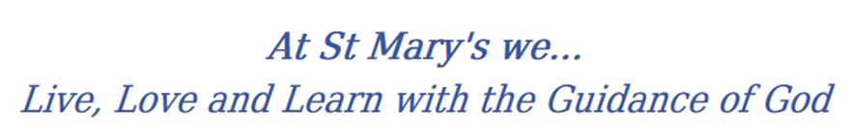
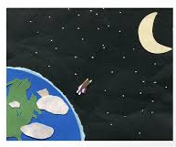
Year 4 Long Term Curriculum Map

2019-20 | Autumn 1 | Autumn 2 | Spring 1 | Spring 2 | Summer 1 | Summer 2
RE | People  Called | Judaism  Gifts | Community  Giving and receiving | Self-discipline | New life  Building Bridges | Islam  God’s people
PSHE | Being Me In My World  Being part of a class team Being a school citizen Rights, responsibilities and democracy (school council) Rewards and consequences  Group decision-making  Having a voice  What motivates behaviour | Celebrating Difference  Challenging assumptions Judging by appearance  Accepting self and others  Understanding influences  Understanding bullying  Problem-solving  Identifying how special and unique everyone is  First impressions | Dreams and Goals  Hopes and dreams  Overcoming disappointment  Creating new, realistic dreams  Achieving goals  Working in a group  Celebrating contributions  Resilience  Positive attitudes | Healthy Me  Healthier friendships  Group dynamics  Smoking  Alcohol  Assertiveness  Peer pressure  Celebrating inner strength | Relationships  Jealousy  Love and loss  Memories of loved ones  Getting on and Falling Out  Girlfriends and boyfriends  Showing appreciation to people and animals | Changing Me  Being unique  Having a baby  Girls and puberty  Confidence in change  Accepting change  Preparing for transition  Environmental change
English | Setting description  Character Description  Persuasive writing – leaflet | Persuasive writing – letters.  Instructions  Poetry – dreadful menace (Literacy shed) | Poetry  Newspaper report  Non-chronological report | Explanation text  Narrative – adventure  Reports | Narrative story  Character description  Poetry | Diary entry  Report  Informative writing.
Class Text | 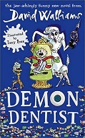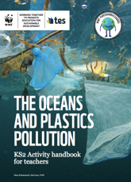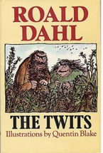 | 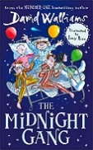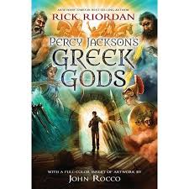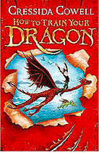 | 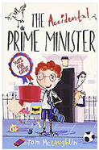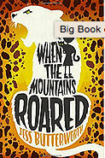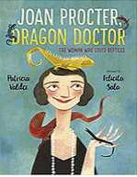 | 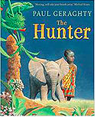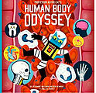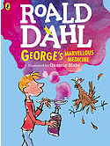 | 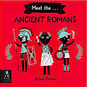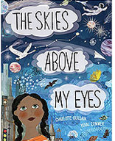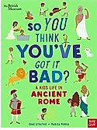 | 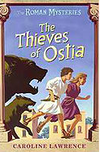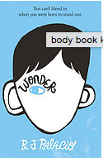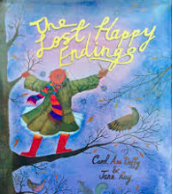
History | Ancient Greeks  Developing chronological understanding when were the Ancient Greeks around. Identifying trends over time during the Ancient Greeks and beyond.  Roman Empire and its impact on Britain  Using a range of sources to understand how the past is constructed. Developing knowledge on a significant turning points in Roman history, how the Romans have affected the world.  Food Transport Democracy
Geography | Locational and place knowledge  - Locate Greece and its cities  - Identify key topographical features (hills, rivers, seas and costs etc.)  Human and Physical  - Geographical formations including mountains, seas and islands.  - Aegan Sea and the Meditteranean.  - How does the climate affect/influence its trade  Geographical Skills and Field Work  - Use four figure grid references |  | Locational and place knowledge  - Locate Italy and European countries of the Roman Empire and their major geographical features  - Identify key topographical features (hills, rivers, seas and costs etc.)  Human and Physical  - How does the location affect/influence where the settlements are and their lifestyle  – especially Italy. Why did they not invade Scotland? - climate  Geographical Skills and Field Work  - Use maps, atlases, globes and digital media to locate countries  - Use four figure grid references |  | Locational and place knowledge  - Locate key countries of the Roman Empire their major geographical features  - Identify key topographical features (hills, rivers, seas and costs etc.)  Human and Physical  - How does the location affect/influence where the settlements are (rivers and  trade for example)  Geographical Skills and Field Work  - Use maps, atlases, globes and digital media to locate countries  Use four figure grid references
Science | Animals including human  Describe the simple functions of the basic parts of the digestive system in humans. | Electricity  Identify whether or not a lamp will light in a simple series circuit, based on whether or not the lamp is part of a complete loop with a battery. | Living things and their habitats  Recognise that environments can change and that this can sometimes pose dangers to specific habitats. |  | Sound  Recognise that vibrations from sounds travel through a medium to the ear. | States of matter  Compare and group materials together, according to whether they are solids, liquids or gases.
Working Scientifically
Developing pupils skills in working scientifically and create more careful, accurate and thoughtful scientists.
Scientists that changed the world
Compare scientists from then and now.
Maths
Art | Drawing  Use different hardness’s of pencils to show line, tone and texture.  Annotate sketches to explain and elaborate ideas.  Sketch lightly (no need to use a rubber to correct mistakes). Use shading to show light and shadow. Use hatching and cross hatching to show tone and texture. Select & arrange materials for a striking effect.  Ensure work is precise;  Use coiling, overlapping, tessellation, mc & montage. | Painting  Use a number of brush techniques using thick and thin brushes to produce shapes, textures, patterns & lines. Mix colours effectively.  Use watercolour paint to produce washes for backgrounds then add detail.  Experiment with creating mood with colour  Artist  Replicate some of the techniques used by notable artists, artisans and designers.  • Create original pieces that are influenced by studies of others. | Print  Use layers of two or more colours. Replicate patterns observed in natural or built environments. Make printing blocks (e.g. from coiled string glued to a block). Make precise repeating patterns. | Digital Media  Create images, video & sound recordings and explain why they were created. | Sculpture  Create and combine shapes to create recognisable forms (eg shapes made from nets or solid materials).  Include texture that conveys feelings, expression or movement.  Use clay & other mouldable materials. Add materials to provide interesting detail. | Textiles Shape & stitch materials.  Use basic cross stitch & back stitch.
DT | Food  Healthy and varied diet  (including cooking and nutrition requirements for KS2)  Electrical Systems  Simple circuits and switches (including programming and control) |  |  | Mechanical Systems  Levers and linkages |  | Food  Healthy and varied diet (including cooking and nutrition requirements for KS2)
PE | Invasion games  Throwing, catching, possession and passing  Gymnastics  Sequences. Speed, height, travel | Invasion games  Throwing, catching, possession and passing | Dance | OAA | Swimming  Athletics  Running, throwing, jumping, competing. | Swimming  Athletics  Running, throwing, jumping, competing.
Music | ABBA | Learning basic instrumental skills by playing tunes in varying styles | Grime, Classical, Bhangra, Tango, Latin Fusion | Gospel | The Beatles | Western Classical Music and your choice from Year 4
MFL | Presenting Myself | Family | Rooms Of The House OR Habitats | At The Café | The Classroom | Goldilocks
Computing

