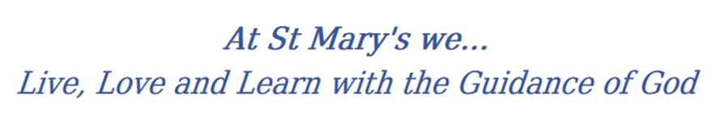
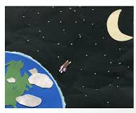
Year 3 Long Term Curriculum Map

2019-20 | Autumn 1 | Autumn 2 | Spring 1 | Spring 2 | Summer 1 | Summer 2
RE | Homes  Promises | Judaism  Visitors | Journeys  Listening and sharing | Giving all  Energy | Choices  Islam | Special places
PSHE | Being Me In My World  Setting personal goals  Self-identity and worth  Positivity in challenges Rules, rights and  responsibilities  Rewards and consequences  Responsible choices Seeing things from others’ perspectives | Celebrating Difference  Families and their differences  Family conflict and how to manage it (child-centred) Witnessing bullying and how to solve it  Recognising how words can be hurtful  Giving and receiving compliments | Dreams and Goals  Difficult challenges and achieving success  Dreams and ambitions  New challenges  Motivation and enthusiasm Recognising and trying to overcome obstacles  Evaluating learning processes  Managing feelings  Simple budgeting | Healthy Me  Exercise  Fitness challenges  Food labelling and healthy swaps  Attitudes towards drugs Keeping safe and why it’s important online and off line scenarios  Respect for myself and others  Healthy and safe choices | Relationships  Family roles and responsibilities  Friendship and negotiation  Keeping safe online and who to go to for help  Being a global citizen  Being aware of how my choices affect others  Awareness of how other children have different lives  Expressing appreciation for family and friends | Changing Me  How babies grow  Understanding a baby’s needs  Outside body changes  Inside body changes  Family stereotypes  Challenging my ideas  Preparing for transition
English | Character Description  Setting Description  Report Writing | Non-Chronological Report  Instructions  Poetry – creating images | Newspaper report  Narrative – historical story  Letters | Poetry - performance  Recount – diary  Explanation text | Narrative – adventure  Persuasive writing  letters | Poetry  Reports  Narrative –stories by the same author
Class Text | 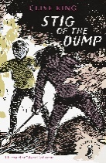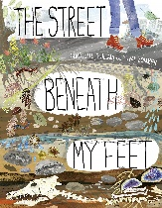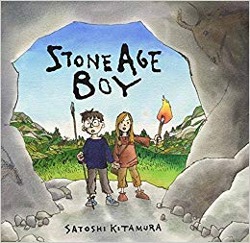 | 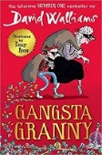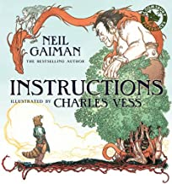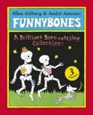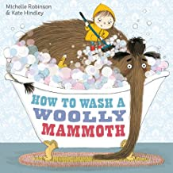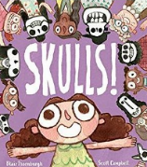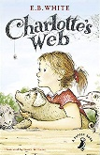 | 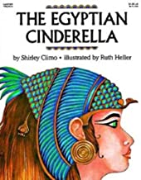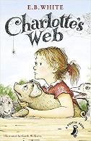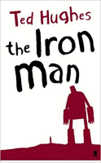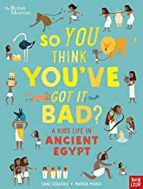 | 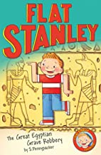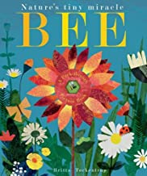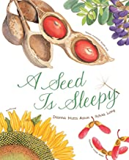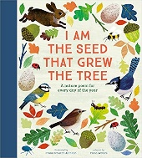 | 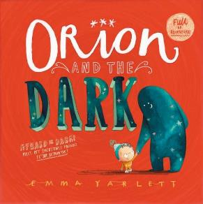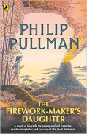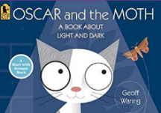 | 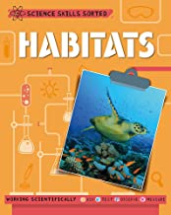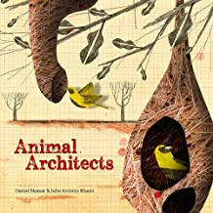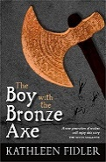
History | Stone Age to Iron Age  Develop a chronological secure knowledge and understanding the time period from the Stone Age to the Iron Age. Identifying connections and contrasts from these time periods and comparing them to now.  Ancient Egypt  Further understanding of world history. Identifying how the Egyptians have affected lives today. Developing informed responses to big questions that involve selection and organisation of relevant information, using a range of media.  Food Transport Democracy
Geography | Locational and place knowledge  - Identify the position and significance of longitude, Northern Hemisphere, Southern Hemisphere, Arctic and Antarctic Circle.  Human and Physical  - Why do these conditions affect the inhabitants of the climate?  Geographical Skills and Field Work  - Use maps, atlases, globes and digital media to locate countries |  | Locational Knowledge  - Locate Egypt and its cities  Human and Physical  Geographical Skills and Field Work  - Use maps, atlases, globes and digital media to locate countries  - Use four figure grid references |  | Locational Knowledge  - Locate key settlements of the iron age story and their major geographical features  Human and Physical Geography  - understand geographical similarities and differences through the study of human and physical geography of a region of Europe  - How does the location affect/influence where the settlements are and their lifestyle.  Geographical Skills and Field Work  - Use maps, atlases, globes and digital media to locate countries  - Use four figure grid references
Science | Rocks  Recognize that soils are made from rocks and organic matter. | Animals including humans  Identify that animals, including humans, need the right types and amount of nutrition. | Forces  Observe how magnets attract or repel each other and attract some materials and not others. | Plants  Investigate the way in which water is transported within plants. | Light  Find patterns in the way that the size of shadows change. | Living things and their habitats  Explore and use classification keys to help group, identify and name a variety of living things in their local and wider environment.
Working Scientifically
Developing pupils skills in working scientifically and create more careful, accurate and thoughtful scientists.
Scientists that changed the world
Compare scientists from then and now.
Maths
Art | Sketching  Annotate sketches to explain and elaborate ideas.  Ensure work is precise.  Sculpture:  Create and combine shapes to create recognisable forms (e.g. shapes made from nets or solid materials).  Use clay and other mouldable materials. Add materials to provide interesting detail. | Sketching:  Use different hardness of pencils to show line, tone and texture.  Sketch lightly (no need to use a rubber to correct mistakes).  Use shading to show light and shadow.  Use coiling, overlapping, tessellation, mosaic and montage.  Collage:  Select and arrange materials for a striking effect. | Painting:  Use a number of brush techniques using thick and thin brushes to produce shapes, textures, patterns and lines.  Mix colours effectively.  Use watercolour paint to produce washes for backgrounds then add detail.  Artist  Replicate some of the techniques used by notable artists, artisans  and designers  Create original pieces that are influenced by studies of others. | Printing:  Use layers of two or more colours.  Replicate patterns observed in natural or built environments.  Make printing blocks (e.g. from coiled string glued to a block).  Explore ideas in a variety of ways. | Drawing and painting: Use a number of brush techniques using thick and thin brushes to produce shapes, textures, patterns and lines.  Use different hardness of pencils to show line, tone and texture.  Collect information, sketches and resources.  Textiles  Shape and stitch materials. Use basic crosstitch and back stitch. | Sculpture:  Create and combine shapes to create recognisable forms (e.g. shapes made from nets or solid materials).  Use clay and other mouldable materials. Add materials to provide interesting detail.
DT | Structures  Shell structures  (including computer-aided design) |  | Food  Healthy and varied diet  (including cooking and nutrition requirements for KS2) |  | Textiles  2-D shape to 3-D product
PE | Gymnastics  Sequences. Speed, height, travel | Invasion games  Throwing, catching, possession and passing | Invasion games  Throwing, catching, possession and passing | Dance | Swimming  Stroke technique  Water safety  Athletics |  | Swimming  Stroke technique  Water safety  Athletics
Music | R&B, Western Classical, Musicals, Motown, Soul | Learning basic instrumental skills by playing tunes in varying styles | Reggae | Music from around the world | Disco/Anthem | Western Classical Music and your choice from Year 3
MFL | Core Vocabulary & Phonetics | I'm Learning French | Animals | Musical Instruments OR Fruits | Little Red Riding Hood | I can…
Computing

