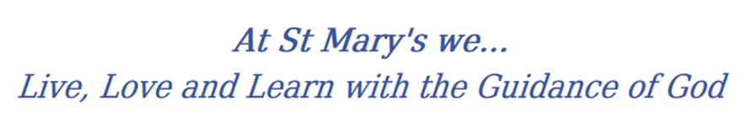
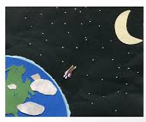
Year 2 Long Term Curriculum Map

2019-20 | Autumn 1 | Autumn 2 | Spring 1 |  | Spring 2 | Summer 1 |  | Summer 2
RE | Beginnings  Signs and symbols | Judaism  Preparations | Books  Thanksgiving |  | Opportunities  Spread the word | Rules  Islam |  | Treasure
PSHE | Being Me In My World  Hopes and fears for the year  Rights and responsibilities  Rewards and consequences Safe and fair learning environment  Valuing contributions  Choices  Recognising feelings | Celebrating Difference  Assumptions and stereotypes about gender Understanding bullying Standing up for self and others  Making new friends  Gender diversity  Celebrating difference and remaining friends | Dreams and Goals  Achieving realistic goals  Perseverance  Learning strengths  Learning with others  Group co-operation  Contributing to and sharing success |  | Healthy Me  Motivation  Healthier choices  Relaxation  Healthy eating and nutrition Healthier snacks and sharing food | Relationships  Different types of family  Physical contact boundaries  Friendship and conflict  Secrets  Trust and appreciation  Expressing appreciation for special relationships |  | Changing Me  Life cycles in nature  Growing from young to old  Increasing independence Differences in female and male bodies (correct terminology)  Assertiveness  Preparing for transition
English | Narrative | Narrative  Non Chronological Reports  Letter Writing (Letters to Santa) | Letter Writing  Poetry |  | Dairy entries  Non Chronological Reports | Narrative (link with local author visit)  Letter writing |  | Recount (personal experience – link with school trip)  Poetry (William Wordsworth)
Class Text | 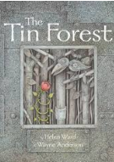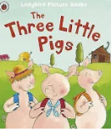 | 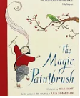 | 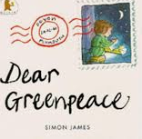 |  | 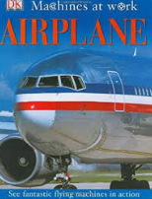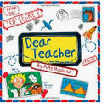 | 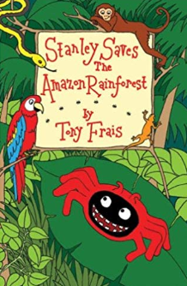 |  | 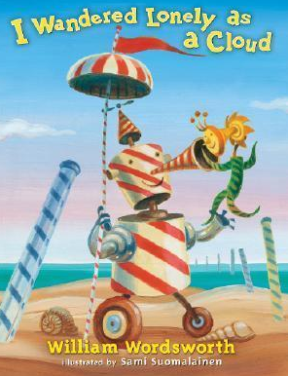
History | Travel and Transport  Describing events beyond living memory, such as the first flight Identifying and using common words and phrases relating to the passing of time first aeroplane flight.  Christina Rosetti and Rosa Parks  Identifying and describing significant historical people.  Isambard Kingdom Brunel/Rosa Parks(democracy)  Identifying and describing significant historical people and places in our own locality (Middlesbrough docks)  Describing changes within living memory  Changes in transport (trains, cars and aeroplanes)  Food Transport Democracy
Geography | Locational Knowledge  - Guisborough Woods  Human and Physical  - Hot and cold parts of the world  - UK and Europe  Geographical Skills  - Use maps, atlases and globes |  |  | Locational Knowledge  - 5 continents  - 7 oceans  - Equator  - North and South pole  Human and Physical  - Journeys around the world  - Use geographical vocabulary (beach, cliff, coast, forest, hill, mountain, sea, ocean, river, soil, valley, vegetation, season and weather)  Geographical Skills  - My route to school  - Use maps, atlases and globes  - Use simple compass directions  - Devise simple maps with keys |  |  | Locational Knowledge  - Name and locate towns and cities close to home.  Place Knowledge  - Middlesbrough  - Compare and Contrast – Middlesbrough with a Safari  Human and Physical  - Identify weather patterns and seasonal changes  - Identify key Physical features of our local area (hills, rivers, valleys, coast)  - Identify key human features (towns, factories, railways).  Geographical Skills  - Use maps, atlases and globes  - Use simple compass directions  - Devise simple maps with keys
Science | Everyday Materials and their uses  Discovering out how the shapes of solid objects made from some materials can be changed by squashing, bending, twisting and stretching. | Animals including humans  Find out about and describe the basic needs of animals for survival and the growth of animals. | Humans including animals  Describe the importance for humans of exercise, basic need, eating the right amounts of different types of food, and hygiene. |  | Movement  Compare how different things move. | Plants  Observe and describe how seeds and bulbs grow into mature plants |  | Habitats  Identify and name a variety of plants and animals in their habitats, including microhabitats.
Working Scientifically
Develop the idea of working scientifically and create confident and inquisitive young scientists. Children should ask questions and use practical investigations to answer them.
Scientists that changed the world
Compare scientists from then and now; looking specifically at Charles Mackintosh.
Maths
Art | DT focus | Artist  George Bellows, Men of the Docks, 1912  Describe the work of notable artists, artisans and designers.  Use some of the ideas of  artists studied to create pieces. | Portraits  Draw lines of different sizes and thickness.  Colour (own work) neatly following the lines.  Show pattern and texture by adding dots and lines.  Show different tones by using coloured pencils. |  | DT focus | Painting: Use thick and thin brushes.  Mix primary colours to make secondary.  Textiles:  Use weaving to create a pattern.  Join materials using glue and/or a stitch.  Artist  Paolo Uccello, The Battle of San Romano, 1438–40 |  | Seaside Collage Use a combination of materials that are cut, torn and glued.  Sort and arrange materials.  Mix materials to create texture.  Textiles  Use dip dye techniques
DT | Food  Design, make and evaluate chocolate bar and wrapper |  | Mechanisms  Wheels and axles |  |  | Textiles  Templates and joining techniques
PE | Games  Rolling, hitting, running, jumping, catching, kicking | Gymnastics  Movement travel, hold, climb, stretch, jump | Games  Rolling, hitting, running, jumping, catching, kicking |  | Dance  Move with careful control and coordination.  Link two or more actions to perform a sequence. | Athletics  Rolling, hitting, running, jumping, catching, kicking |  | Athletics  Rolling, hitting, running, jumping, catching, kicking
Music | South African styles | Christmas, Big Band, Motown, Elvis, Freedom Songs | Rock |  | Reggae | Pop, Soul, Film, Musicals |  | Western Classical Music and your choice from Year 2
Computing | 1 2 3 4 5 6 7 8 9 10 11 12 13 14 15 16 17 18 19 20 21 22 23 24 25 26 27 28 29 30 31 32  Unit 2.1 Coding Weeks – 5 Programs – 2Code Unit 2.2 Online Safety Weeks – 3 Programs – Various Unit 2.3 Spreadsheets Weeks – 4 Programs – 2Calculate Unit 2.4 Questioning Weeks – 5 Programs – 2Question, 2Investigate Unit 2.5 Effective Searching Weeks – 3 Programs – Browser Unit 2.6 Creating Pictures Weeks – 5 Programs – 2PaintAPicture Unit 2.7 Making Music Weeks – 3 Programs – 2Sequence Unit 2.8 Presenting Ideas Weeks – 4 Programs – Various

