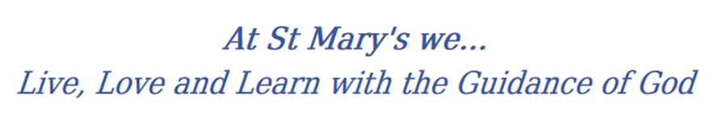
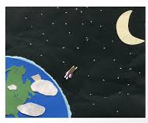
Year 1 Long Term Curriculum Map

2019-20 | Autumn 1 | Autumn 2 | Spring 1 |  | Spring 2 |  |  | Summer 1 | Summer 2
RE | Families  Belongings | Judaism  Waiting | Special people  Meals |  | Change  Holidays and holydays |  |  | Being sorry  Islam | Neighbours
PSHE | Being Me In My World  Feeling special and safe  Being part of a class  Rights and responsibilities  Rewards and feeling proud  Consequences  Owning the Learning Charter | Celebrating Difference  Similarities and differences Understanding bullying and knowing how to deal with it Making new friends  Celebrating the differences in everyone | Dreams and Goals  Setting goals  Identifying successes and achievements  Learning styles  Working well and celebrating achievement with a partner Tackling new challenges Identifying and overcoming obstacles  Feelings of success |  | Healthy Me  Keeping myself healthy  Healthier lifestyle choices  Keeping clean  Being safe  Medicine safety/safety with household items  Road safety  Linking health and happiness |  |  | Relationships  Belonging to a family  Making friends/being a good friend  Physical contact preferences  People who help us  Qualities as a friend and person  Self-acknowledgement  Being a good friend to myself  Celebrating special relationships | Changing Me  Life cycles – animal and human  Changes in me  Changes since being a baby Differences between female and male bodies (correct terminology)  Linking growing and learning  Coping with change  Transition
English | Narrative: writing about other’s experiences.  Labels, Lists and Signs: Getting and giving information | Familiar Characters: Paddington in the Garden.  Non-Fiction: Samuel Pepy’s Diary  Humorous Poems: Funny Poems | Traditional Tales and Fables: Sharing and Retelling  Instructions and Explanations: Pigeon Books by Mo Willems  Humorous Poems: Poems with repeating patterns and rhymes |  | Repeating Patterns: African Settings  Letters and Postcards: Letters in Different Contexts |  |  | Stories on a Theme: Superheroes  Information Texts: Comparing Non-fiction and Fiction  Poems on a Theme: Nature Poems (shape poems) | Traditional Tales and Fables: Fairy Tales  Letters and Postcards: Letters: Dear Greenpeace  Classic Poems: Traditional Poems
Class Text | 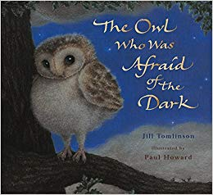 | 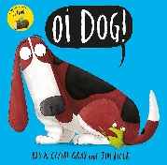  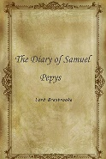  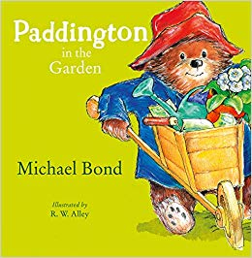 | 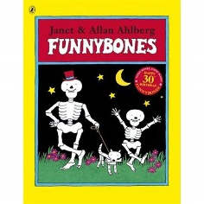  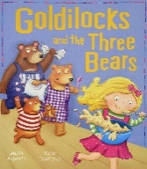  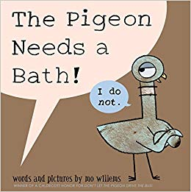 |  | 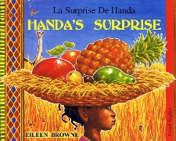 |  |  | 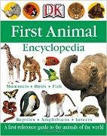  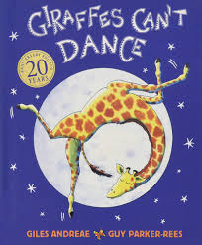  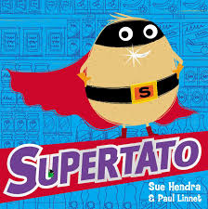 | 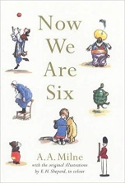  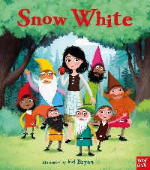  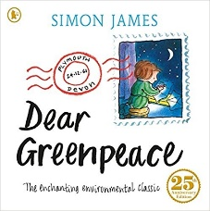
History | Describing changes within living memory  Changes in the local area Identifying similarities and differences between ways of life from the different time periods in Redcar and Cleveland. Developing ability to ask and answer questions on the local area, exploring historical events.  Changes in food  Changes in toys and books  Great Fire of London and The Gunpowder Plot  Developing knowledge on events of the Great Fire of London and the life of Guy Fawkes.  Captain James Cook  Identifying and describing the lives significant historical people who have contributed to national achievements. Develop understanding of places in our own locality.  Food Transport Democracy
Geography | Physical Features identify seasonal and daily weather patterns in the United Kingdom (ongoing)  Locational Knowledge  - The UK  - Middlesbrough  - Scotland, England, Ireland, Wales  - Names of the 7 continents | Geographical Skills  - Use maps and atlases  - Use simple compass directions  - Use aerial photographs to devise simple maps.  Place Knowledge  - Understand geographical similarities and differences through studying the human and physical geography of a small area of the United Kingdom (Link to Great fire of London). |  | Human Features  - Study of how land use may have changed  Grangetown, focussing on the steel works.  Human and Physical  - Compare and Contrast – School, Grangetown and York.  - Journeys around the UK  - Use geographical vocabulary (beach,  cliff, coast, forest, hill, mountain, sea,  ocean, river, soil, valley, vegetation, season and weather)  Geographical Skills  - Use maps and atlases  - Use simple compass directions  - Use aerial photographs to devise simple maps. |  |  | Place Knowledge  - Holidays in the UK  - Seaside  - Redcar and Cleveland  - understand geographical similarities and differences through studying the human and physical geography of a small area of  the United Kingdom  Human and Physical  - Guisborough Woods  - Use geographical vocabulary (beach, cliff, coast, forest, hill, mountain, sea, ocean,  river, soil, valley, vegetation, season and weather)  Geographical Skills  - Use maps, atlases and globes  - Use simple compass directions  - devise simple maps with keys
Science | Everyday Materials  Describe the simple physical properties of a variety of everyday materials. | Humans including animals  Identify, draw and label the basic parts of the human body. |  |  | Plants  Describe the basic structure of a variety of common plants including roots, stem, leaves and flowers. |  |  | Animals including humans  Identify and name a variety of common animals that are carnivores, herbivores and omnivores.
Seasonal Changes
Observe changes across the four seasons.
Working Scientifically
Introduce the idea of working scientifically and create confident and inquisitive young scientists. Children should ask questions and use practical investigations to answer them.
Scientists that changed the world
Compare scientists from then and now; looking specifically at Sir Joseph Swan.
Maths
Art | Drawing: fine motor skills, different types of line (directions, straight, curved). | Collage: Use a combination of materials that are cut, torn and glued.  Sort and arrange materials.  Mix materials to create texture.  Painting: Mix primary colours to make secondary.  Artist  George Bellows, Men of the Docks, 1912  Use some of the ideas of  artists studied to create pieces. | Drawing: Show pattern and texture by adding dots and lines.  Colour (own work) neatly following the lines.  Show different tones by using coloured pencils  Painting: Add white to colours to make tints and black to colours to make tones.  Digital media: Use a wide range of tools to create different textures, lines, tones, colours and shapes. |  |  | Sculpture: Use techniques such as rolling, cutting, moulding and carving.  Use rolled up paper, straws, paper, card and clay as materials.  Use a combination of shapes.  Printing: Use repeating or overlapping shapes.  Use repeating or overlapping shapes.  Press, roll, rub and stamp to make prints. |  | Painting: Use thick and thin brushes.  Mix primary colours to make secondary.  Join materials using glue and/or a stitch.  Artist  Paolo Uccello, The Battle of San Romano, 1438–40
DT | Food (science link) | Structures  Freestanding structures |  |  | Mechanisms  Sliders and levers |  |  |  | Food  Preparing fruit and vegetables  (including cooking and nutrition requirements for KS1)
PE | Games  Rolling, throwing, running, jumping, catching, team games. | Gymnastics  Movement travel, hold, climb, stretch, jump | Games  Rolling, hitting, running, jumping, catching, kicking |  | Dance |  |  | Athletics  Rolling, hitting, running, jumping, catching, kicking | Athletics  Rolling, hitting, running, jumping, catching, kicking
Music | Old School Hip Hop | Reggae, Hip Hop | Blues, Latin, Folk, Funk, Baroque, Bhangra |  | Latin Bossa Nova, Film music, Big Band Jazz, Mashup, Latin fusion |  |  | Film,Pop, Musicals | Western Classical Music and your choice from Year 1
Computing | 1 2 3 4 5 6 7 8 9 10 11 12 13 14 15 16 17 18 19 20 21 22 23 24 25 26 27 28 29 30 31  Unit 1.1 Online Safety & Exploring Purple Mash Weeks – 4 Programs – Various Unit 1.2 Grouping & Sorting Weeks – 2 Programs – 2DIY Unit 1.3 Pictograms Weeks – 3 Programs – 2Count Unit 1.4 Lego Builders Weeks – 3 Programs – 2DIY Unit 1.5 Maze Explorers Weeks – 3 Programs – 2Go Unit 1.6 Animated Story Books Weeks – 5 Programs – 2Create A Story Unit 1.7 Coding Weeks – 6 Programs – 2Code Unit 1.8 Spreadsheets Weeks – 3 Programs – 2Calculate Unit 1.9 Technology outside school Weeks – 2 Programs – Various

