**Catholic Social Teaching**

**We are called to serve and follow in Jesus’ footsteps…**

*‘Dear young people… The Lord wants to turn your hands, my hands, our hands, into signs of reconciliation, of communion, of creation. He wants your hands to continue building the world of today.’ Pope Francis*

At St. Thomas More’s we provide many opportunities for both our children and staff to develop knowledge and understanding of the principles of Catholic Social Teaching. It is our moral compass, guiding us on how to live out our faith in the world.

Our faith calls us to love God and to love our neighbours in every situation, especially our sisters and brothers living in poverty. Following in the footsteps of Christ, we hope to make present in our unjust and broken world, the justice, love and peace of God.

As a Catholic School we believe that God has a plan for creation, a plan that still exists in our modern world.  Our belief in God must permeate all aspects of our lives as responsible global citizens. We teach the children about the dignity of the human person, how we are called to live as family and community, about rights and responsibilities, that we are called to stewardship, our responsibility for the poor and vulnerable, about the dignity and rights of workers and about solidarity and the promotion of peace. We do this through RE lessons, Prayer, outside visitors and first-hand experience. As a result, our children feel that they are making a difference to the world.

The principles of Catholic Social Teaching are:

* Life and Dignity of the Human Person.
* Call to Family, Community, and Participation.
* Rights and Responsibilities.
* Option for the Poor and Vulnerable.
* The Dignity of Work and the Rights of Workers.
* Solidarity.
* Care for God's Creation.



**Life and Dignity of the Human Person**

***Dignity- of the human person***-Every human person is created in the image and likeness of God. Therefore, every person’s life and dignity must be respected and supported from conception until the end of their natural life on earth.

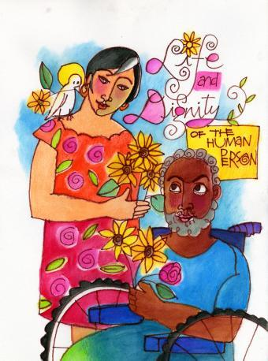

*God created man in the image of himself, in the image of God he created him,*

*male and female he created them. (Gen. 1:27)*

**

**Call to Family, Community, and Participation**

***We are called to live as Family and Community***-The human person is not only sacred, but social.  How society is organized, be it socially, economically, legally or politically has a direct impact on the dignity and growth of every human person and community.  Marriage and family should be supported and strengthened.  Every person has a right to work to support themselves and their families as well as the

building up of the common good for all.

*Local individuals and groups can make a real difference. They are able to instill a greater sense of responsibility, a strong sense of community, a readiness to protect others, a spirit of creativity and a deep love for the land. . . . Social problems must be addressed by community networks and not simply by the sum of individual good deeds.*

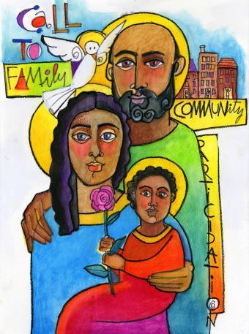



**Rights and Responsibilities**

***The common Good- Rights and Responsibilities***-Every person has a fundamental right to life.  It is this right that makes all other rights possible.  Everyone has the right to food, health care, housing, education and employment.  We all need to strive to secure and respect these rights for others both locally and globally.

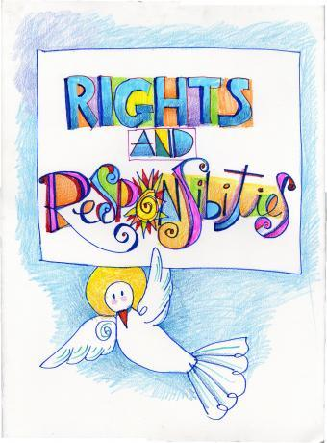

*Underlying the principle of the common good is respect*

*for the human person as such, endowed with basic*

*and inalienable rights ordered to his or her integral development.*

*It has also to do with the overall welfare of society*

*and the development of a variety of intermediate groups,*

*applying the principle of subsidiarity. Outstanding among those groups is the family, as the basic cell of society. Finally, the common good calls for social peace, the stability and security provided by a certain order which cannot be achieved without particular concern for distributive justice; whenever this is violated, violence always ensues. Society as a whole, and the state in particular, are obliged to defend and promote the common good.*

*(Pope Francis, On Care for Our Common Home [[Laudato](http://w2.vatican.va/content/francesco/en/encyclicals/documents/papa-francesco_20150524_enciclica-laudato-si.html)* [*Si'*](http://w2.vatican.va/content/francesco/en/encyclicals/documents/papa-francesco_20150524_enciclica-laudato-si.html)*], no. 157)*

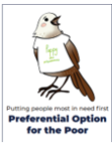

**Preferential Option for the Poor and Vulnerable**

***An option for the Poor and Vulnerable***-Society is judged on how it cares for the poor and vulnerable – our brothers and sisters.  We read in scripture how God has a special concern for the oppressed, poor, vulnerable and those forced to the margins of society. The Church calls us to respond to the cry of the poor and put their needs first.  This preferential treatment for the poor and vulnerable must be seen in action in our daily lives.

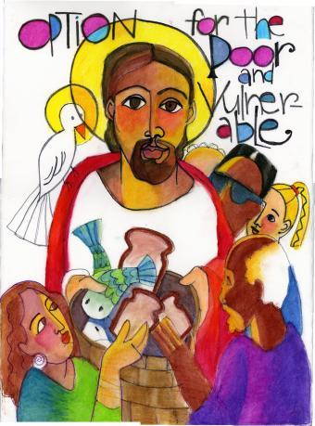

*It is not from your own possessions that you are bestowing alms on the poor; you are but restoring to them what is theirs by right.*

*For what has been given to everyone for the use of all, you have taken for your exclusive use.*

*The earth belongs, not to the rich, but to everyone.*

*Thus, far from giving lavishly, you are but paying part of your debt.*

*~St Ambrose of Milan.*



**The Dignity of Work and the Rights of Workers**

***Distributive Justice- The Dignity and Rights of Workers***-Work is a way in which we can continue to participate in God’s creation.  Work gives dignity to life and must be carried out in such a way that the basic rights of workers are respected.  Everyone has the right to productive work, to fair and liveable wages, and to organize and join a union.  The economy must be conducted so that it serves the needs of the people.

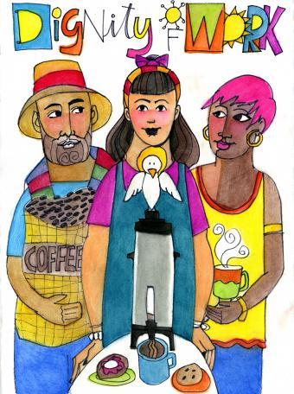

*“When each separate part works as it should, the whole body grows and*

*builds itself up through love” Ephesians 4:16*

**Solidarity**

***Solidarity***-We are all People of God, one family.  Therefore, what happens to one has an impact on all, locally, nationally and globally.  At the heart of solidarity is the pursuit of peace and justice.  Our love for all calls us to work for a peaceful and just society where everyone has a fair share of the goods needed for a sustainable life, and opportunities for growth and development are offered equally. The dignity of every person is respected. Pope Francis has challenged Christians to be true peacemakers bringing forgiveness and non-violent solutions to situations of hurt and violence.

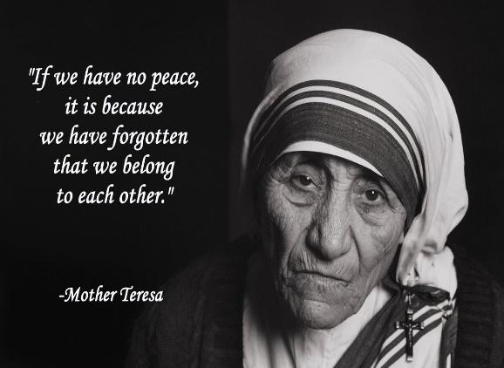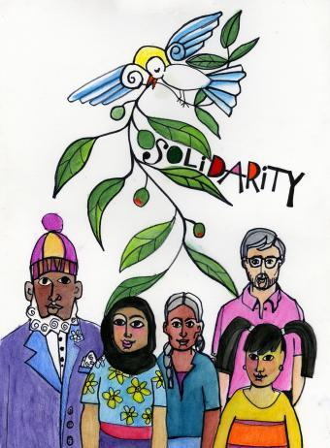

**Care for God’s Creation**

***We are called to Stewardship***-The world God has created for us has been entrusted to everyone and we are responsible and accountable to God as stewards of the earth. The world has been given to us as a gift, to enjoy and care for so that future generations can enjoy it too. It is in caring for creation that we show our love and respect for its creator.

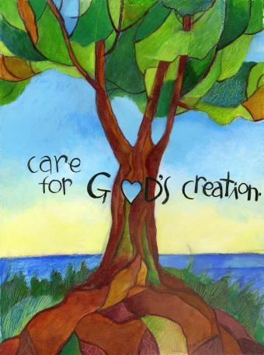

*‘...the world we have received also*

*belongs to those who will follow us.’*

*Pope Francis,*

*Laudato Si’ (Praise be), #159, 2015*