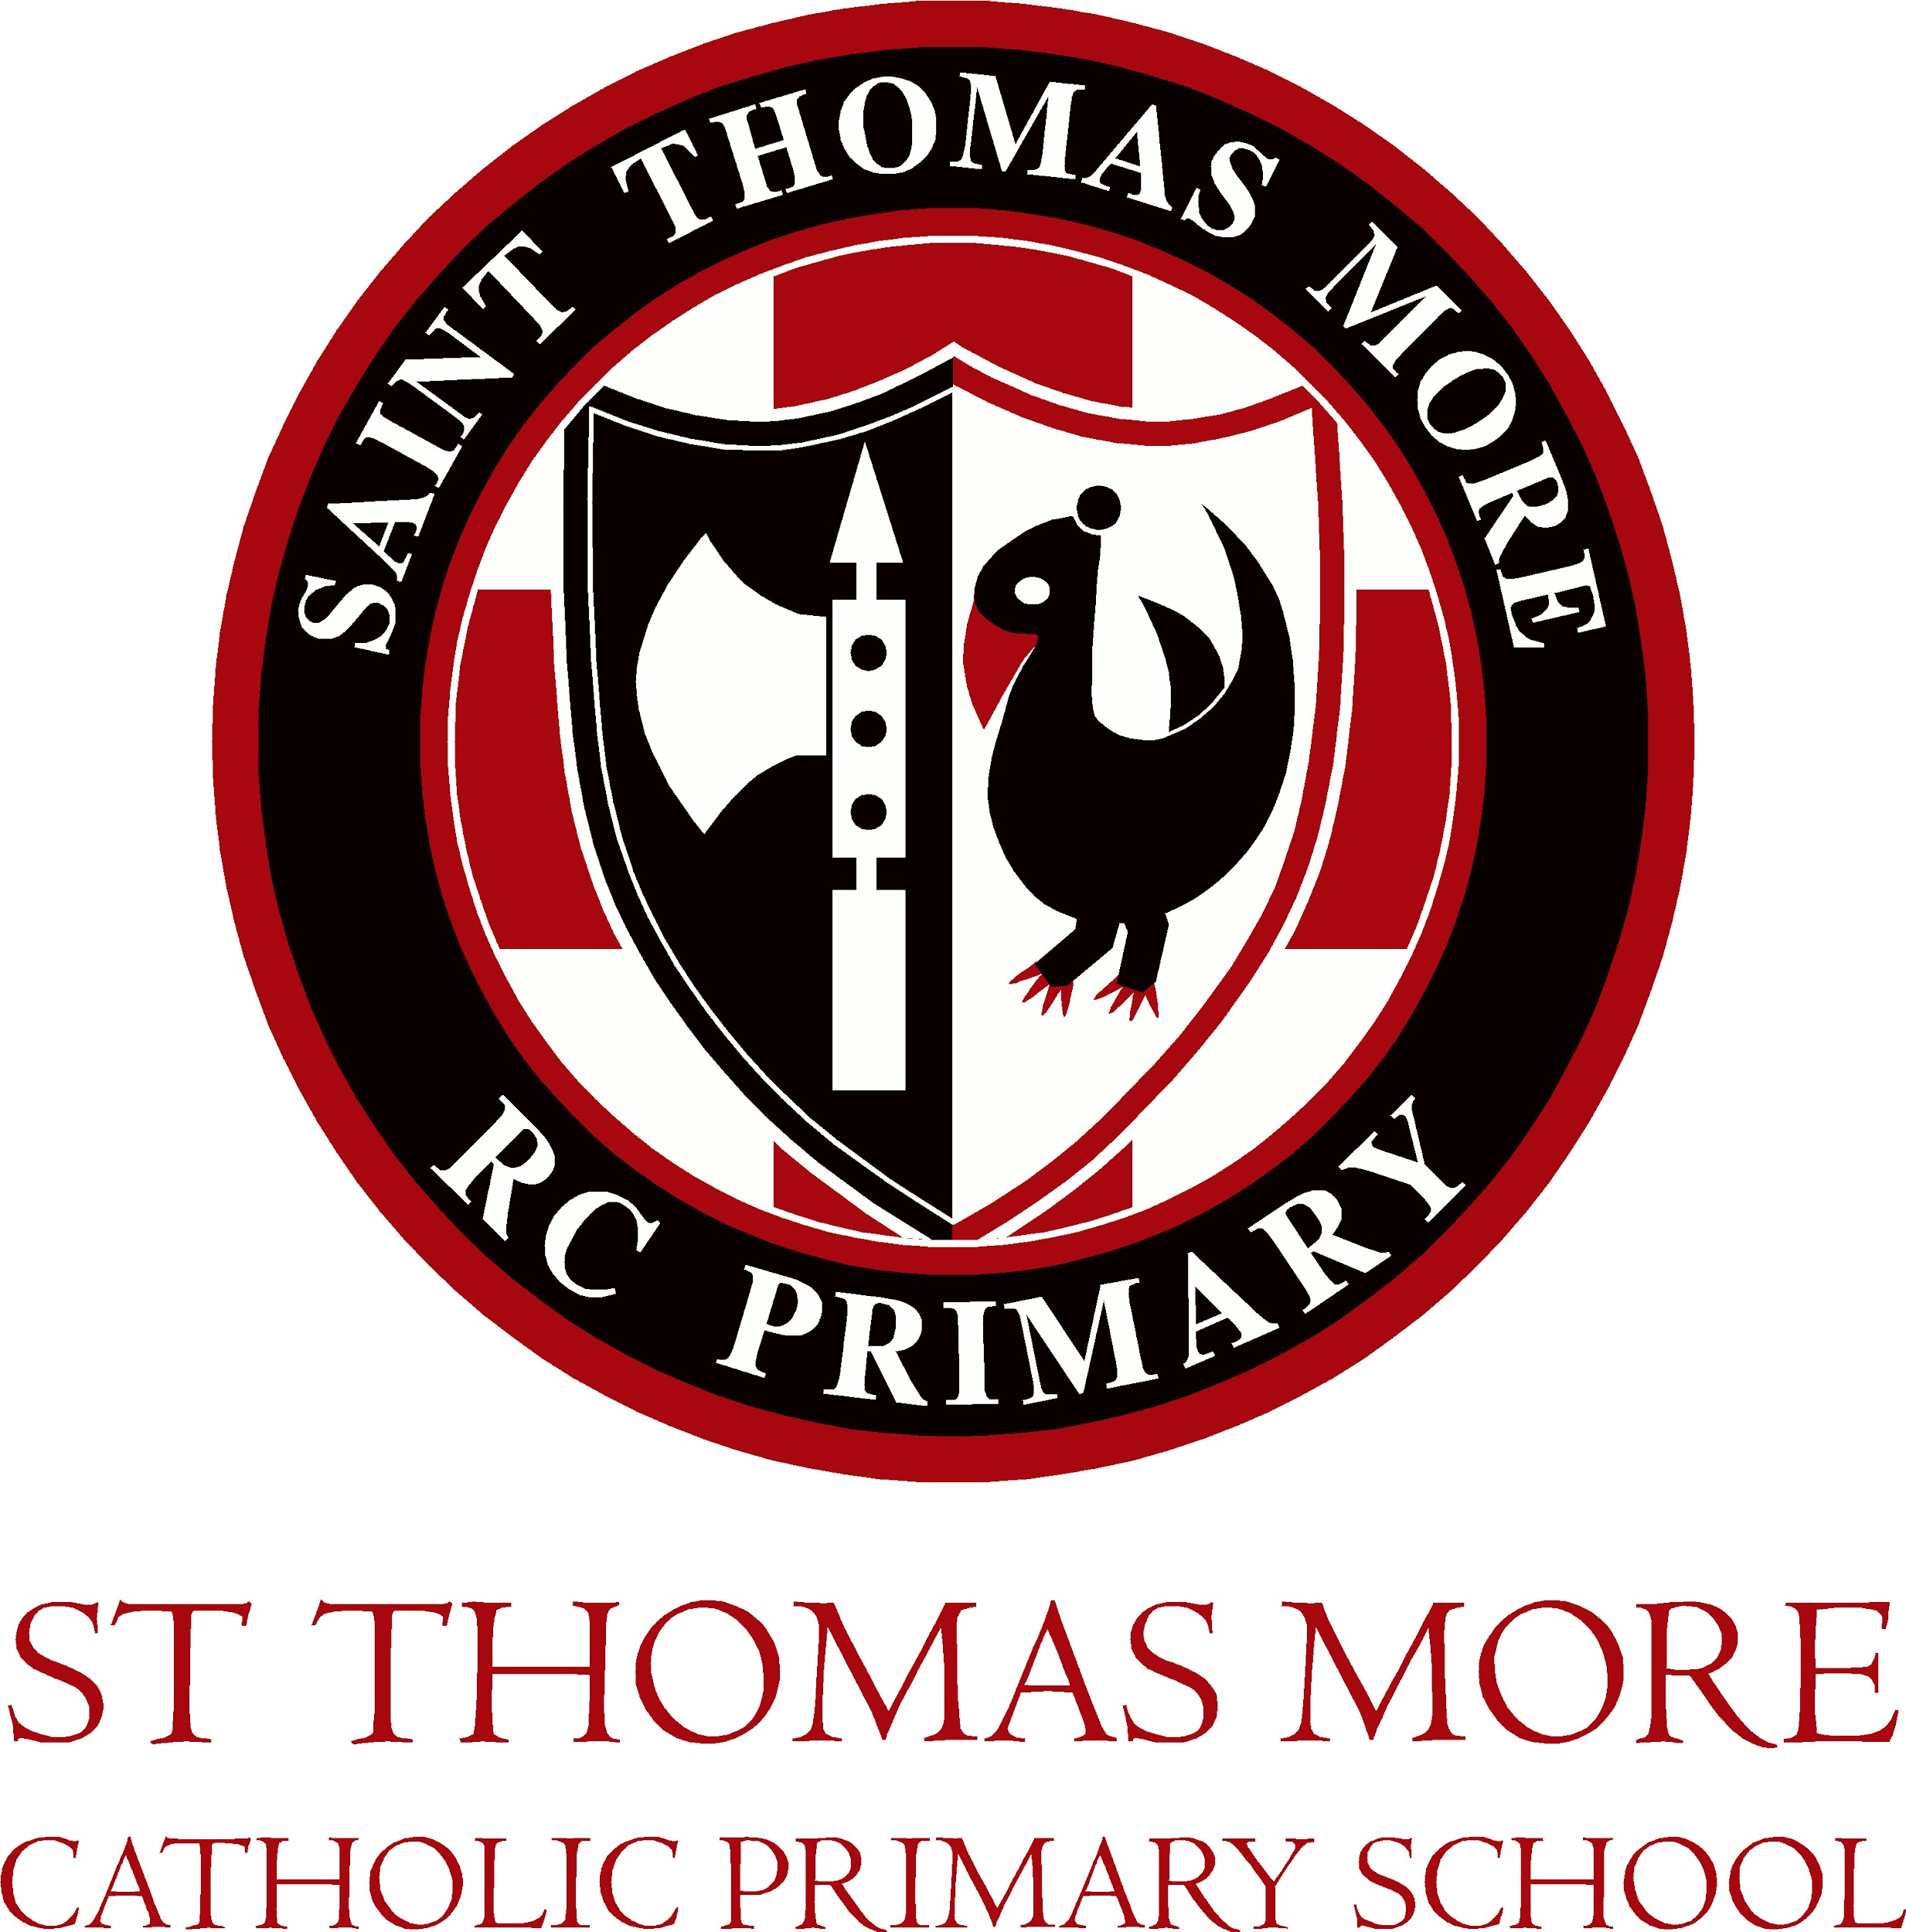

St Thomas More School Calendar 2021-2022

Autumn Term 2021 Start date : 02/09/21 End date: 17/12/21
September  PD 1st September  20th September Individual school photographs |  | November  15th November Anti-bullying Week  26th November School Closed
October  10th World Mental Health Day  12th October Parents Evening  13th October Parents Evening  PD 22nd October |  | December  15th December Flu Vaccinations
Spring Term Start date : 05/01/22 End date: 08/04/22
January  PD 4th January | March  3rd World Book Day
February  4th-11th Children’s Mental Health Week  8th Safer Internet Day | April
Summer Term Start date : 03/05/21 End date: 20/07/22
May  9th KS2 SATs week | July  PD 21st July
June  PD 6th June  20th - 24th June Sports Week | Notes  Please note: due to circumstances out of our control these dates may be subject to change but we will try our very best to keep to the planned dates in order to assist with your planning.

