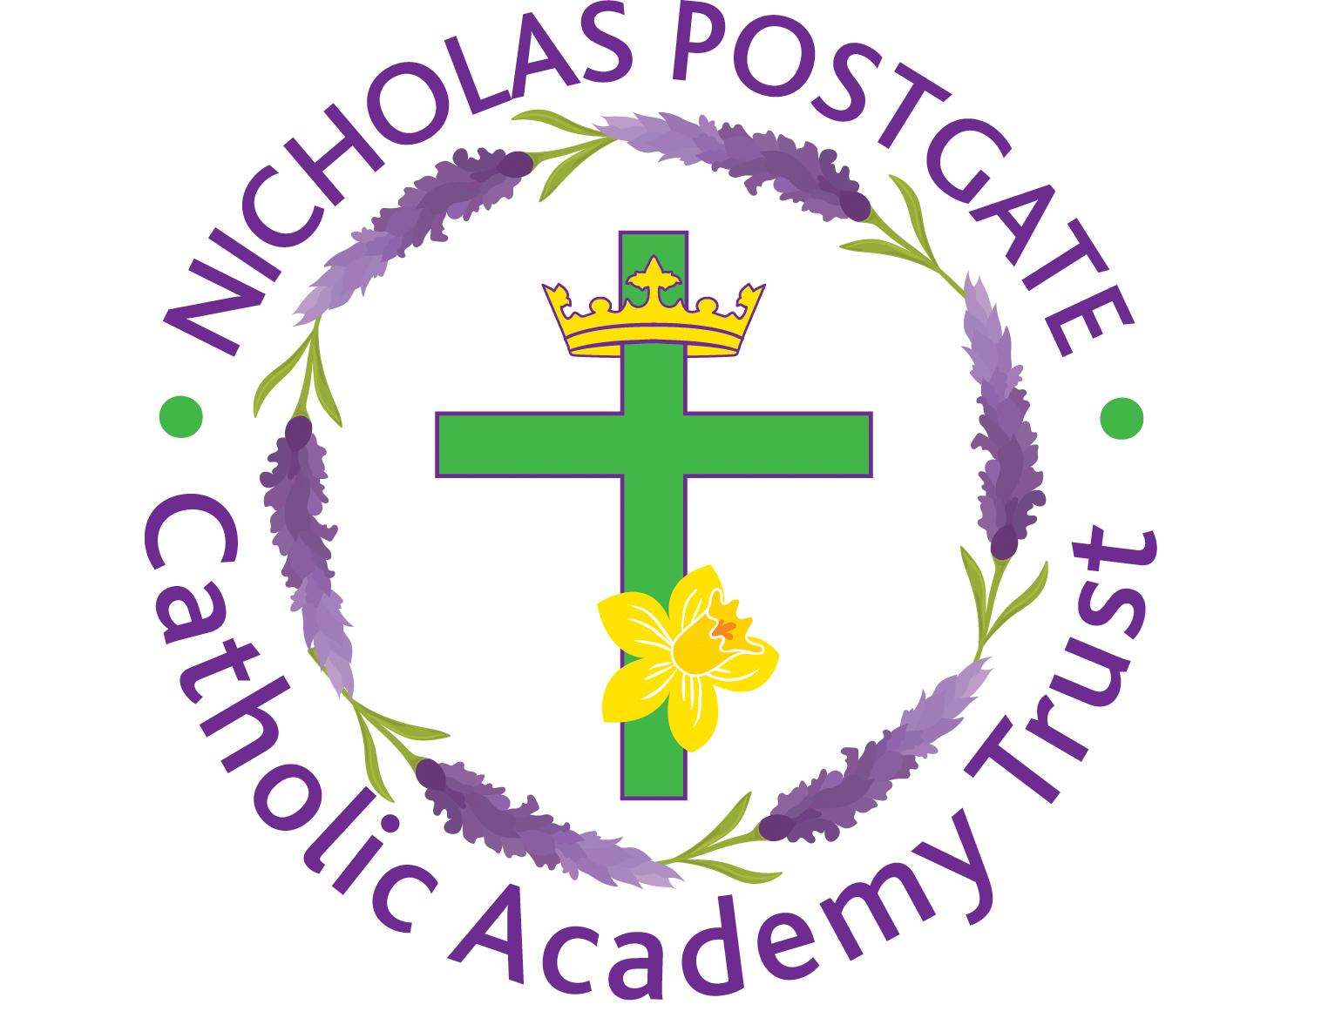
3rd March 2021

Dear Parent/Carer,

Full school re-opening on Monday,8th March - WELCOME BACK!
Following the recent letter from our CEO to inform you about the full opening of schools from next Monday 8th March, I write to confirm our plans at St Thomas More.

Thank you!
Firstly, a big thank you for all your hard work and support with home schooling.
I have been very impressed by the online learning the children have completed using Google Classroom and the work that they have sent into school for their teachers to mark. We know that it has been a very challenging time for everyone but Spring is almost upon us and it brings with it renewed hope for the future, particularly because we cannot wait to see all of our children and welcome them back!

Start and end of the school day
Please note that on the grounds of Health and Safety, on a morning the front and back school gates will be opened by school staff at 8.30am and closed at 8.55am when the bell goes. Children will enter the school building via their usual classroom routes. We kindly ask that if parents need to enter the school site to drop off or collect their child that they wear a mask. Only one parent is permitted onto the school site at a time.

On an afternoon, the front and back school gates will be opened by school staff at 3.00pm before the bell goes at 3.10pm. Gates will be closed at 3.25pm.

Breakfast Club and after school clubs
Breakfast Club will be provided between 8.30am and 8.40am within class bubbles and designated areas.
A full list of after school clubs will be sent out soon.

Social Distancing Measures – Hands, Face, Space
As a school, we are doing all we can to minimise risk and operate a safe learning environment – please support us in this by wearing a mask, washing hands regularly and keeping your distance using the 2 metre distancing rule at all times,

Precautions and control measures
We have worked hard to ensure that all measures are in place to keep our pupils and staff safe when everyone returns. Hand sanitising stations will be positioned in key areas on entry to classrooms and the building. Staff will instruct the children to sanitise their hands using the hand gel provided before they enter school. Adults will be expected to do this also.

Staff and pupils will be encouraged to wash their hands more frequently with instructions
displayed around school and in toilet areas. Enhanced cleaning of frequently touched surfaces will happen routinely and contact will be minimised. Pupils will be encouraged to catch and bin any coughs and sneezes using the tissues provided in classrooms, disposing of them in the lidded bins in each classroom.

You MUST NOT send your child to school if they have symptoms of coronavirus (COVID-19), or if you have someone in your house who does. We request that all parents and carers support us by engaging with the NHS Test and Trace process so that cases can be quickly identified and action taken.

If your child becomes unwell at school, you will be asked to collect them immediately. We therefore need you to be contactable at all times. Your child will be kept in isolation with a member of staff while we wait for your arrival. If coronavirus is suspected, the staff member will wear a disposable apron, gloves and mask. If anyone develops symptoms of coronavirus (COVID-19), they should remain at home for at least 10 days from the date when their symptoms appeared. Symptoms of coronavirus (COVID-19) are a new, continuous cough, or a high temperature, or a loss of, or change in, your normal sense of taste or smell (anosmia). Anyone with symptoms will be eligible for a PCR test - this is the type of test that is normally available and can be arranged via https://www.nhs.uk/ask-for-a-coronavirus-test or by calling 119. All other household members who remain well must stay at home and not leave the house for 10 days. This includes anyone in your ‘Support Bubble’.
Where a staff member or child tests negative for coronavirus, they may return to school and their household members may end their isolation. Where a staff member or child tests positive for coronavirus, the rest of their class group will be sent home and asked to isolate for the required period.

Behaviour
At St Thomas More’s we expect all our pupils, without exception, to live out our mission, “To Live as God calls us.” This in turn means that all our pupils must aim to live out our school values of Respect, Responsibility, Resilience, Compassion, Justice, Honesty and Self Belief. During our first week back, we will be revisiting and promoting our school values regularly in assembly and throughout the school day so that our children strive to become the best they can be. Where a pupil fails to reach the expected standard of behaviour, sanctions will be implemented in line with our behaviour policy.

Uniform and equipment
All pupils must return to school on Monday wearing full uniform – grey trousers or skirt, red sweatshirt, red polo and black school shoes. Please note that pupils are not expected to wear school uniform on their designated PE day. Instead they need to come into school wearing their full PE kit.

And finally………
On behalf of our staff and governors, thank you again for your continued cooperation and support through yet another lockdown period. We know that it has been an anxious time for parents, staff and children but it will be wonderful to see you all next week and working co-operatively together, we will hopefully ensure a safe and happy return for everyone.

Should you have any questions or concerns, please do not hesitate to contact school.

Take care and stay safe,

Mrs. Apolloni

