How to access Google Applications at home!

Children in all Nicholas Postgate Catholic Academy Trust (NPCAT) schools can now access all home learning resources through their school website. Your child has been issued with a ‘Gmail’ email account by their school and their email address and password have been sent home.

Example: 22j.bloggs@stpatricks.npcat.org.uk
The year they will leave primary school
Name of school
First initial and surname

Your child’s username is the first part of their email address. E.g. 22j.bloggs

This username and password will grant your child access to the full suite of Google Apps in a safe, secure environment. The steps below guide you through logging in at home in order to access learning remotely.

If you are using an iPad, tablet or smartphone, you will need to download the Google Apps (all of these apps are free). They include: Gmail, Google Classroom, Google Meet and Google Calendar
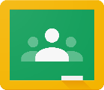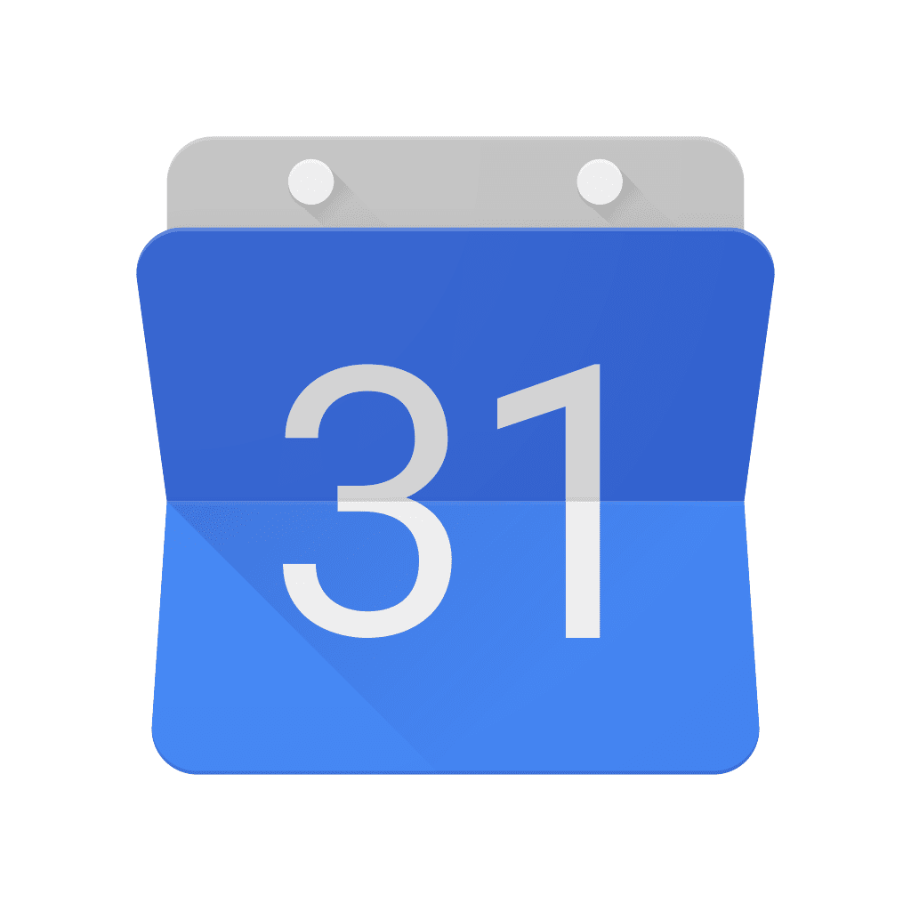
(Other Google Apps are available, but these ones you will require to learn successfully from home).

If you are using an iPad, tablet or smartphone, you will be asked to ‘login’ the first time you use the app. At this stage, you will need to type in your child’s school email address and password again.

NOTE: If you are using a computer or laptop you will not need to download any apps. You will simply use your web browser (Google Chrome is preferable to Internet Explorer/Microsoft Edge).

Important information:

Before logging into Google Apps on a computer or laptop, please make sure that you have logged out of any existing google accounts. To do this, close all browsing tabs apart from the one you are using currently and then log out of any accounts which are logged in.

To see whether any accounts are already logged in, please locate the button which is circled below on your google homepage, click on it and then hit sign out of all accounts. If you see ‘sign in’ where the circle is shown on the image below, then you DO NOT need to follow this step. It is important that you do this before attempting to follow any of the instructions on the next page.
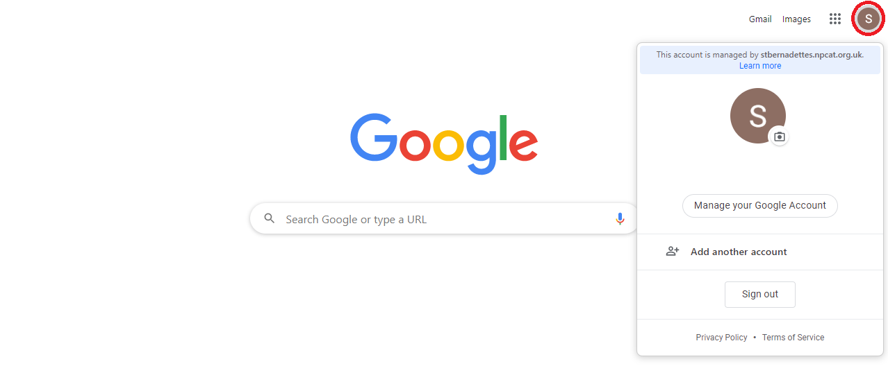

Step 1: Logging in to your school website

Find the correct school website by clicking the following link npcat.org.uk/our-academies/ This page provides links to all of the schools in NPCAT.

Once you have reached the page, locate the correct school and click on the link. You will then be taken to your school’s website homepage. Now, simply click on the green login button (this has been circled on the example below).
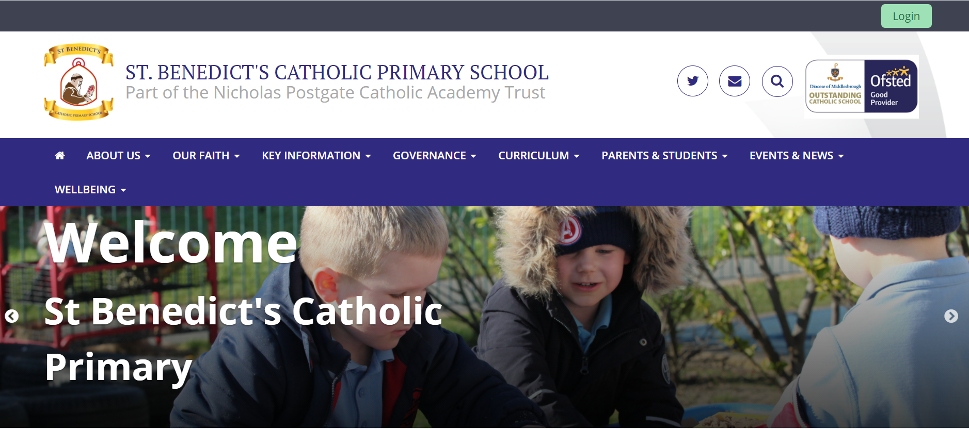

Step 2:

Once you have clicked on the link, you will be directed to the screen below (it will show your school’s logo). Please type in the correct username and password (remember the username is the first part of the email address. E.g. 22j.bloggs and the password will have been supplied by the school).

You should now have access to the website; all of the Google Apps, etc are displayed across the top of the page.

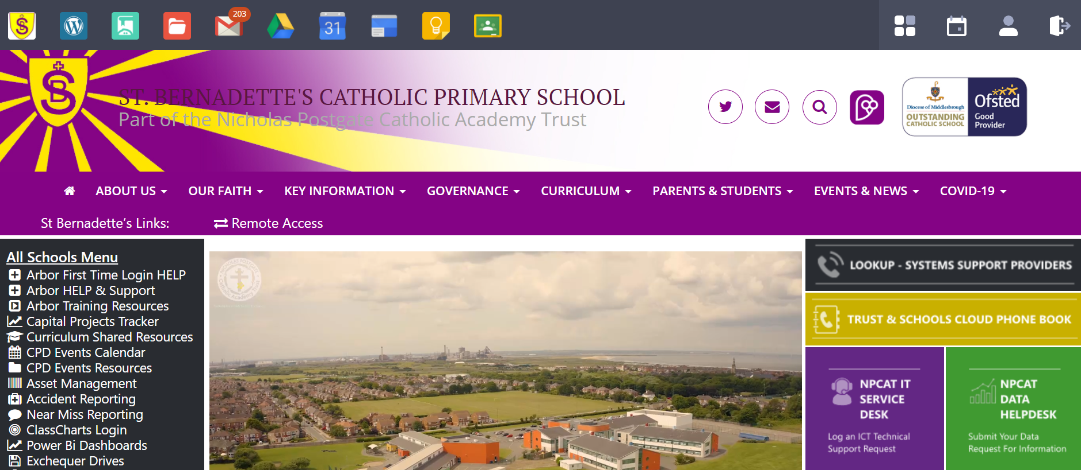

Logging in to Google Classroom!

Now that you are logged in, click on the green Google Classroom logo as shown below. This will take you to the correct online classroom.

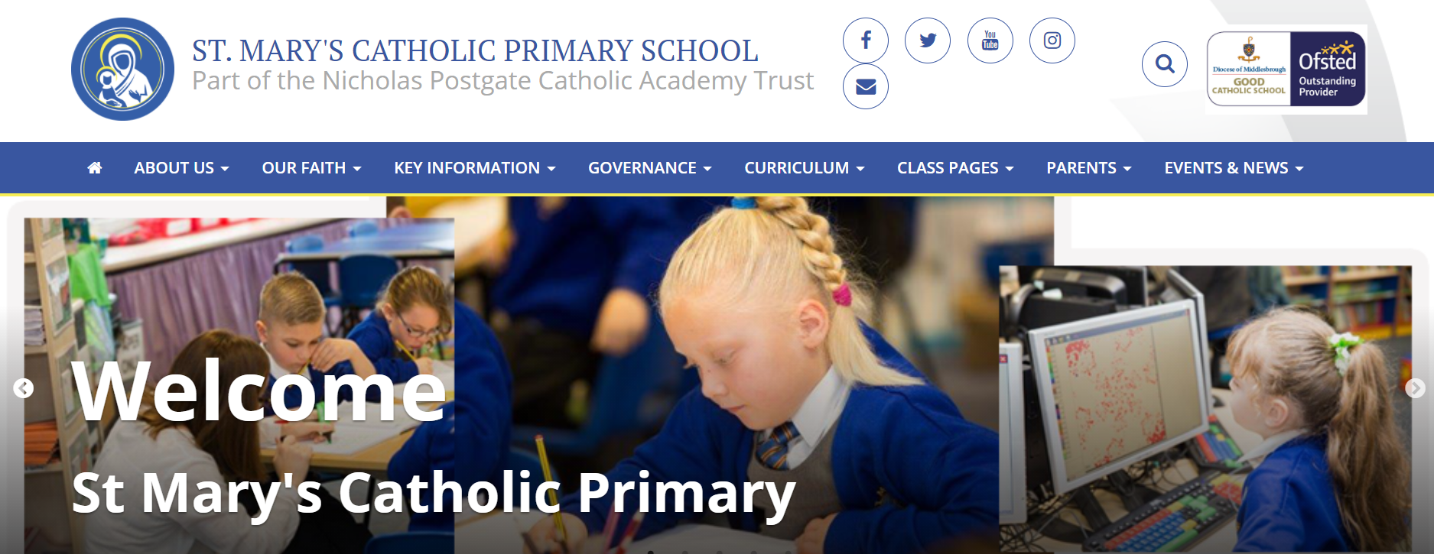
You will then be able to view your child’s class as shown below. Next, you need to click on the class to view the work set by your teacher.

Once you have clicked on the classroom page, you will be able to view all of the work set by your child’s teacher. You will initially see the class ‘stream’ which shows the work most recently set. In order to see all of your child’s current work, click ‘Classwork’.
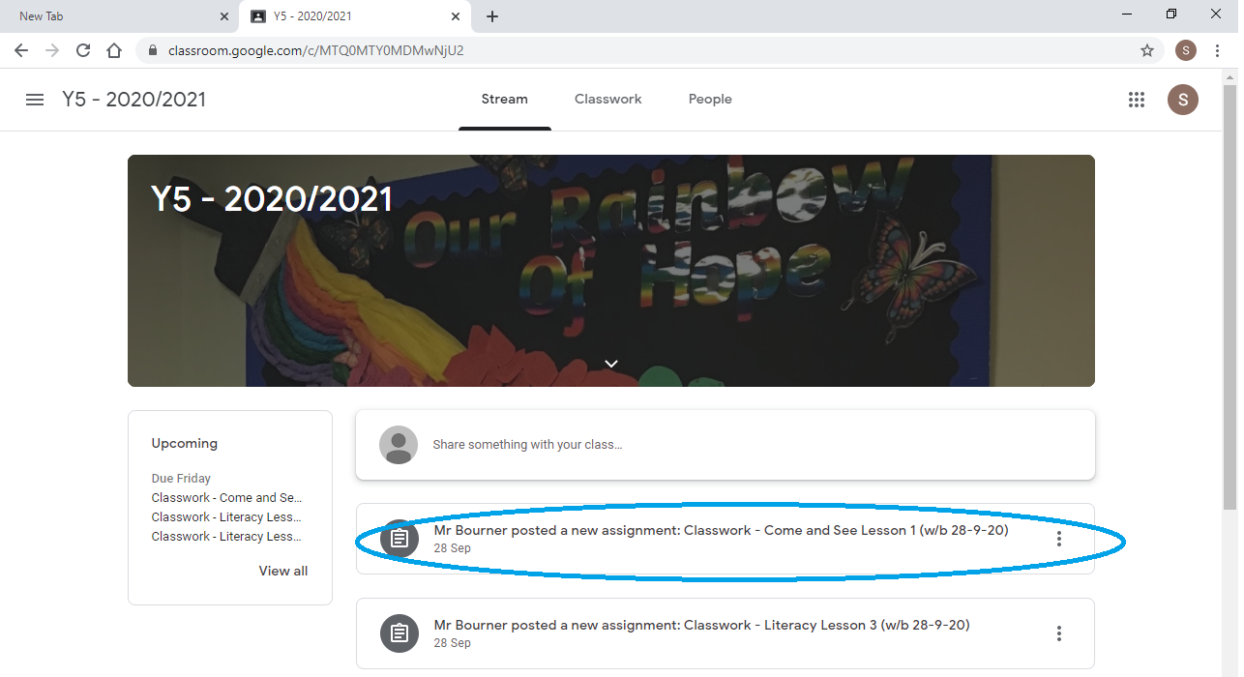

Once you have clicked on a specific piece of work, you will be taken to the assignment page, where you will find instructions and resources (e.g. videos, PowerPoints, worksheets, etc.). They can be seen below. The private comments section is only viewed by your child’s class teacher.

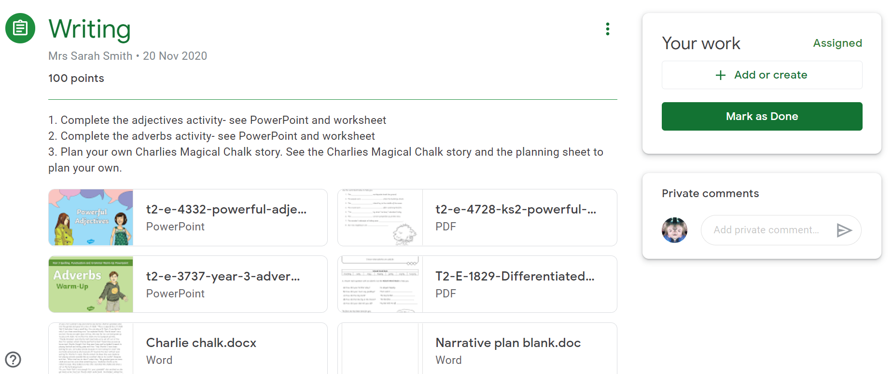
The information in this section provides instructions on the piece of work and resources (e.g. weblinks, PowerPoints, videos, etc.) may have been added to assist pupil’s learning.
This is where pupils can submit their work to their class teacher. They can upload documents they have been working on or send photos of their work.

Logging in to Google Mail (Gmail)!

Now that you are logged in to the website, click on the red and white ‘Mail’ envelope as shown below.

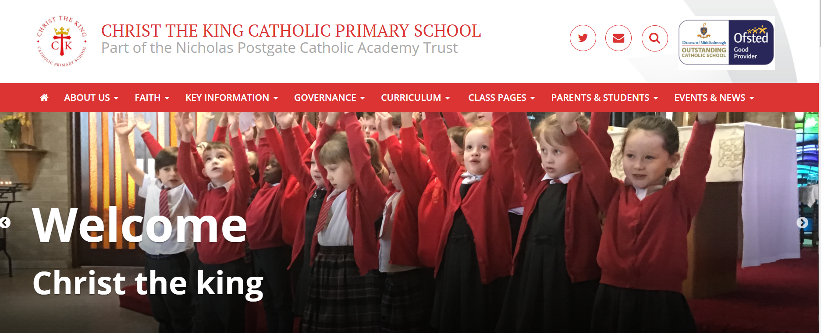

This will take you to your Gmail homepage or – if using a tablet or smartphone – the Gmail app.

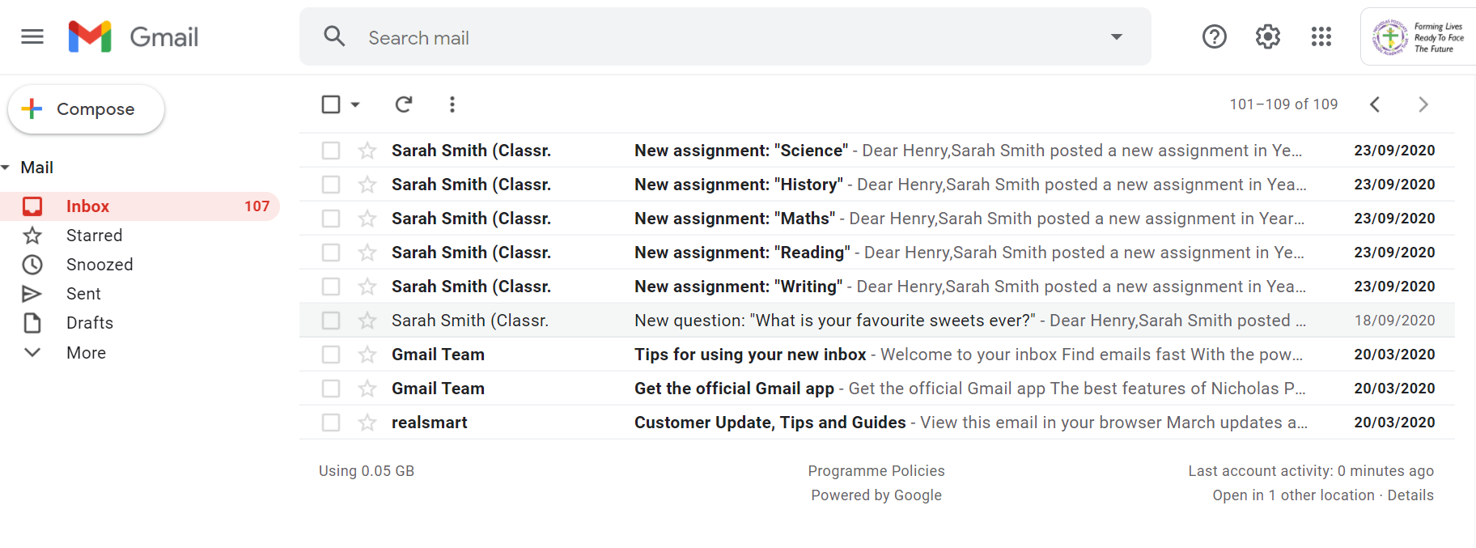
You and your child will now be able to view their email account.

Here, you can check and respond to emails from your child’s teachers. Your child will also receive notification emails through their Gmail account from time to time.

Logging in to Meet!

To log in to a Google Meet, you will need to again access Google Classroom as shown below.

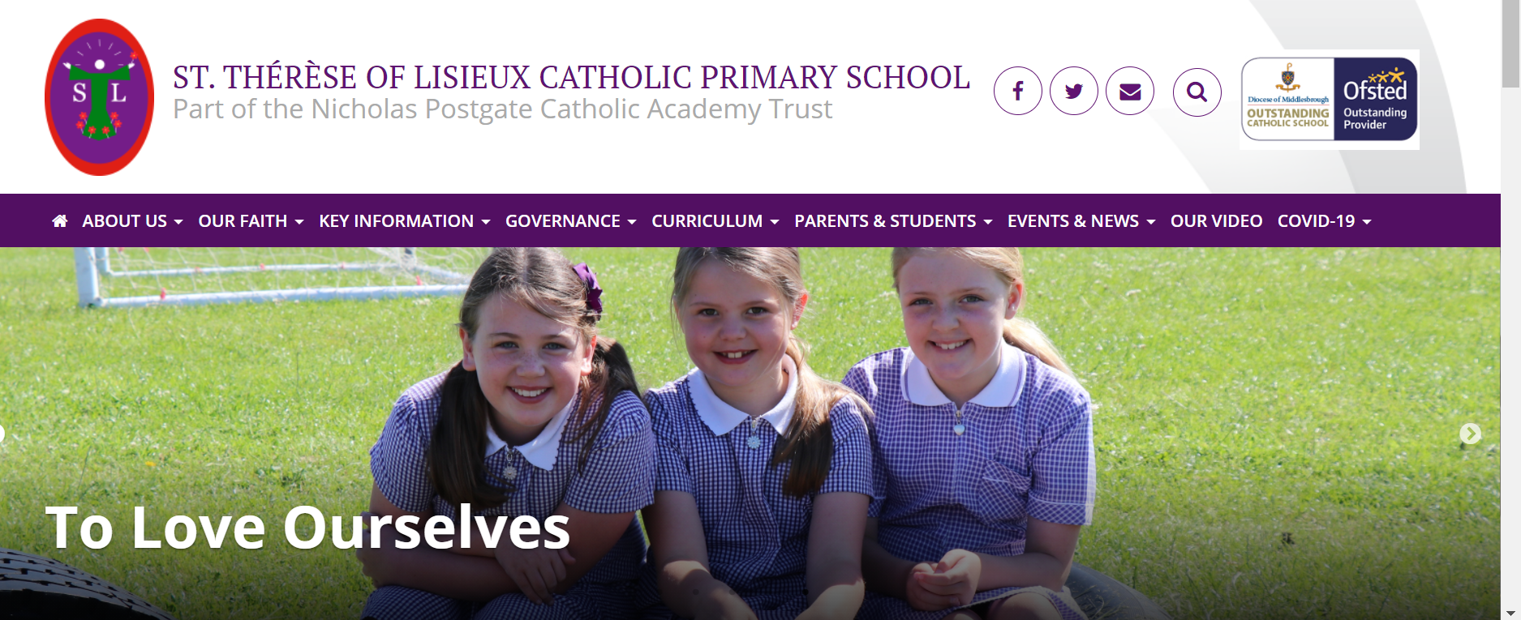

If you click on Classwork, you will be able to see Google Meets for your class and these contain the link for you to click on.

This will then give your child the option to ‘Ask to Join’ and your child’s teacher will know they are waiting. The meeting can only take place with the meeting host (class teacher) present and only they can allow people in to the meeting. Please ensure your child’s microphone is muted and that all live lesson protocols have been followed.
