How to return work on Google Classroom by attaching a photo

Step 1- Firstly, you need the Google classroom app on your device. Search “Google Classroom” on the play store or app store. Click on the first suggestion.
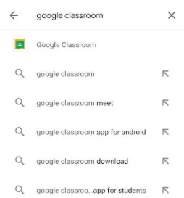

Step 2- Install the application
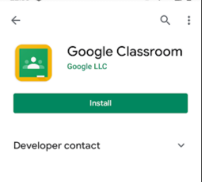

Step 3: Load the application and you will see a screen that asks you to sign in using your google email address. Type in your child’s email address into the bar. When you have typed it in click next.
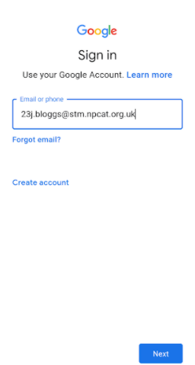

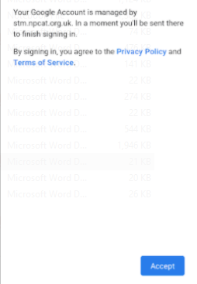
Step 4: A box will come up saying this account is managed by stm.npcat.org.uk click accept

Step 5: Click on the drop-down box and find “NPCAT- St Thomas More Catholic Primary School and then click continue.
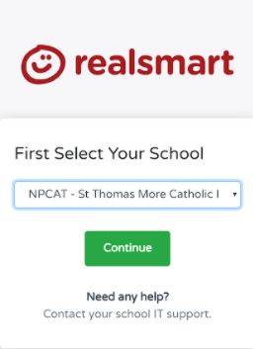

Step 6: It will then bring you to the next “realsmart” page. Type in your child’s email address and password and click sign in.

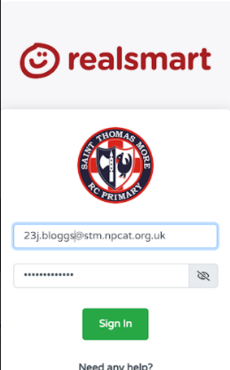

Step 7: Click on your child’s classroom and select the piece of work you want to attach the photo to.
1.
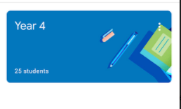
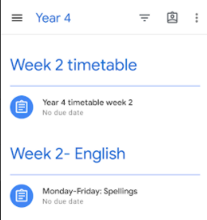
2.
3.
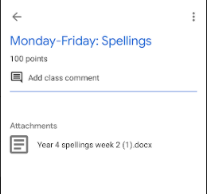

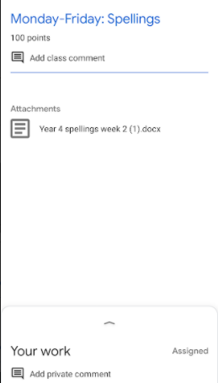
Step 8: Click on the arrow.

Step 9: Click take photo.
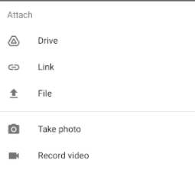

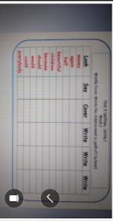
Step 10: If you are happy with the photo click the tick or if you want to retry click on the bin.

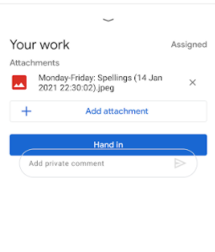
Step 11: If you want to add a comment about the work you can (optional) and then click hand in and the work will then go to the teacher to check and mark.

