How to access Purple Mash
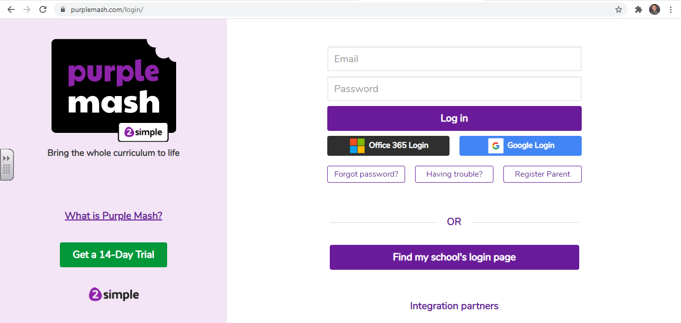
Step 1: Click on “Find my school’s login page”.
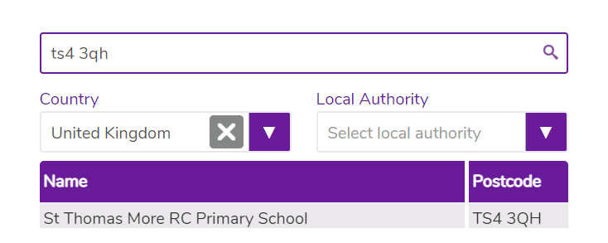
Step 2: Type in the postcode “TS4 3QH” and click on St Thomas More RC Primary School.

Step 3: Click on “Go to school portal”
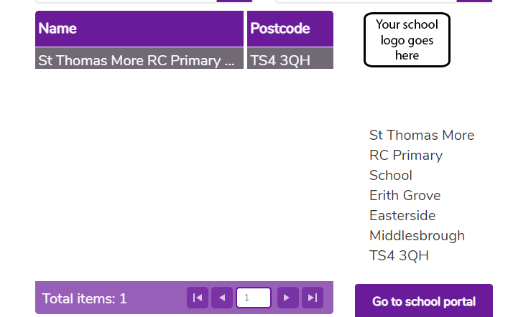

Step 4: Once you are on our school login page type in your username and password.
