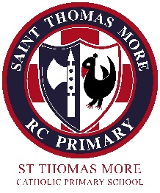
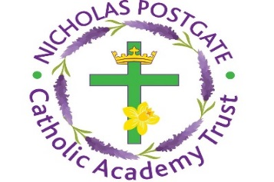
St Thomas More Primary
(Part of the Nicholas Postgate Catholic Academy Trust)
Erith Grove, Easterside, Middlesbrough TS4 3QH
Head Teacher
Mrs J Apolloni B.Ed.(Hons), NPQH
Email: enquiries@stm.npcat.org.uk
Telephone: 01642 317350

Website: www.stm.npcat.org.uk

Dear Parent/ Guardian,

Complaints
Despite school doing everything we can to protect staff and pupils to keep them safe from the transmission of COVID-19 both inside and outside of school, this week has been particularly difficult.
I have received several complaints, including one from Middlesbrough Council about parents and adults not socially distancing outside of the school building when dropping off and waiting to collect their children, particularly when they are waiting outside of the school gates.

The school gates are supervised daily by staff in order to ensure the health and safety of all our children

It is essential that every parent, career and adult plays their part in keeping themselves, their children and others safe.

Therefore, in order to address concerns raised, I reinforce once again and kindly request that you adhere to the following:

- One adult only to drop off and collect their child from school

- Pupils in Keystage 2 to walk from and to the school gate independently

- The 2 metre distance rule to be followed at all times inside and beyond the school premises

- No adult gathers in a group but keeps moving and disperses as soon as they have droppedoff/collected their child

- Parents and carers to wear masks at all times

Athough the wearing of masks cannot be enforced by school, this is important government guidance that is to be practised when the 2 metre distance rule cannot be followed. Many parents have contacted school to ask if they should wear masks and this is something we very much want to encourage, particularly in light of new restrictions from government about Middlesbrough’s local context.

Thank you for you support and cooperation during these very important times in which we must all take play our part and take responsibility in order to stop the virus spreading and save lives.

Yours sincerely,
Mrs Apolloni

