
GYM

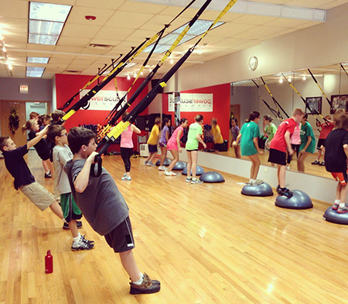
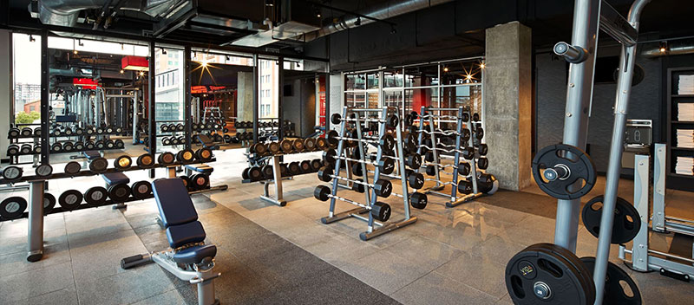
Dear Parent/ Guardian,

We are planning to open a health and fitness facility for children aged 5-11 years, as well as parents who will have access to a gym, personal training and fitness classes, in 2021.
The gym will offer the following services:
- Group gym classes for children overseen by a gym trainer.
- Studio fitness classes for children (boxercise, circuits, fitness games).
- Adult classes for parents (boxercise, circuits, les mills programmes, yoga).
- Open gym for adults including access to personal training.
- Downstairs health bar which offers healthy snacks, meals, shakes and hot drinks.
The purpose of Live it & Get Active GYM is to provide high quality gym and fitness classes to children, while parents have access to their own gym and classes in the same facility, helping the whole family to become fitter and healthier.

TO HELP US WITH SOME PRE-PLANNING WE WOULD REALLY APPRECIATE IT IF YOU COULD ANSWER SOME QUICK AND EASY QUESTIONS ABOUT PREFERENCES FOR THE LIVE IT & GET ACTIVE GYM, ON THE OVERLEAF. AND RETURN BACK TO THE SCHOOL BY 15th JULY.

Please tick ✓ the correct box ☐ or answer the question in the box

Would you be excited to have such a facility/ gym near your area?
Yes ☐ No ☐
Child membership will cost £30/ month (prices may vary). Do you think this price is reasonable?
Yes ☐ No ☐ If ‘No’ what price do you think is reasonable

Family membership for e.g. 2 adults and 2 children will cost £100/ month (prices may vary). Do you think this price is reasonable?
Yes ☐ No ☐ If ‘No’ what price do you think is reasonable

If your child/ children signed up monthly, would you OR/AND your partner join the gym for £20/ month each?
Yes ☐ No ☐ Other

What is the furthest you would travel to attend this gym?

If ONLY your child/ children attended this gym, where would you wait during their classes?
In the Health bar area ☐ I would leave them and come back ☐

Do you have any suggestions for this gym (classes, prices, facilities etc.)?

