St Gerard’s Primary School – Home Learning Grid
Year 5 Topic 4 2021- 2022
Tudors
This grid provides homework challenges to be completed during parts of both spring 2 and summer 1 half terms.

 | Thinking Levels
Areas of Study | Knowing  1 point | Understanding  2 points | Applying  3 points | Analysing  4 points
Language & Communication:  Speaking, listening, literacy, English and other languages | Make a list of all the Tudor monarchs – you can use illustrations. Add in the dates of birth and death | Research Anne Boleyn’s family and childhood. Around a picture of Anne, write all about the things that you have found out. | 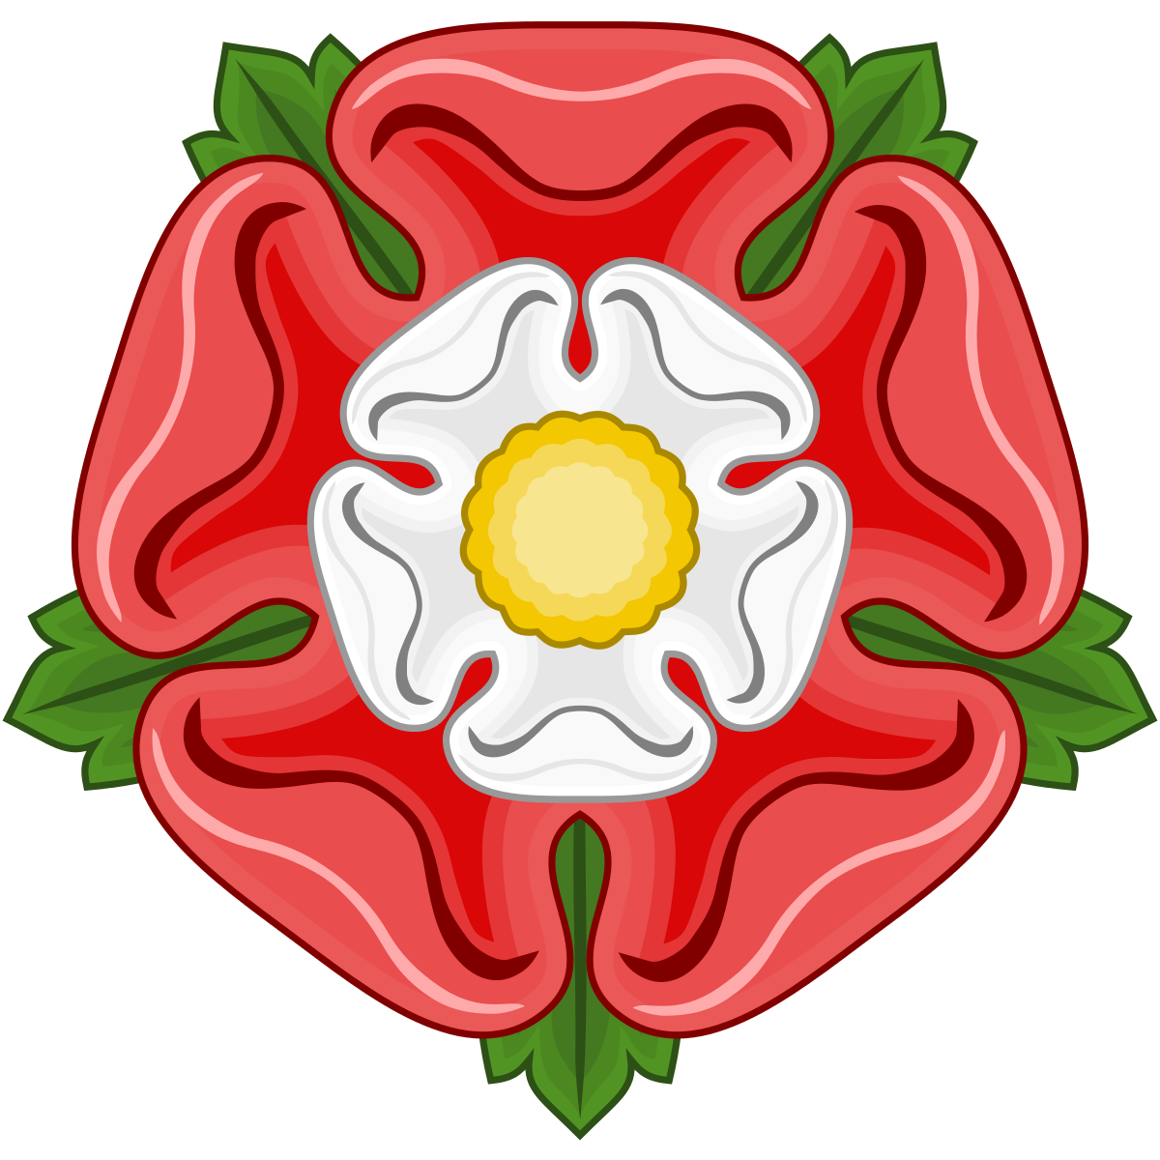Research the Tudor Rose, produce a fact sheet on it. | Write a Tudor story about a day with Henry VIII. Include a detailed description of the setting.
Health & Wellbeing:  Physical activity, food, personal/social/  Emotional development | 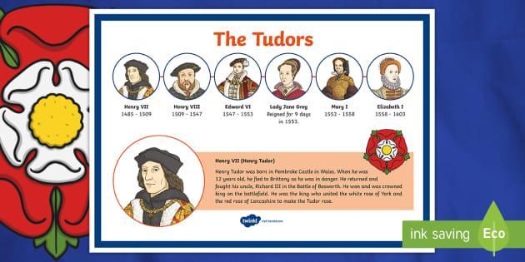 | Write a recipe for a typical Tudor meal.  Include illustrations. | Plan a healthy meal for a Tudor monarch.  Create a menu and illustrate it using Tudor style writing. | 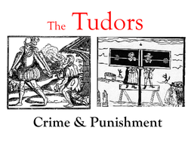Research Tudor crime and punishment, produce a poster on this.
Humanities & Citizenship:  History, Geography, R.E. Cultural, visits | Show where Hever Castle and Hampton Court Palace are on a map. Make your map look really old and authentic. | Create a map of Britain that Henry could have used when travelling around the country. Can you mark York, Lancaster, Portsmouth and London on the map? | 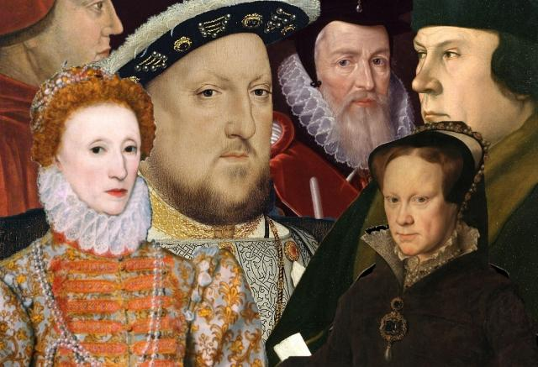 | Create your own poem about Henry VIII and his six wives. Can you write a verse about each wife?
Science & Technology:  Science, D.T., Eco issues | Name the main stages of the human life cycle. Put them on a timeline and add details of what changes there are during each stage. | Create a leaflet (or Powerpoint) relating to Healthy Lifestyle (diet, exercise etc.) | Design a Tudor Rose- can you make it so that it has moving petals. | Design and make your own Tudor game (linked to the wives of Henry VIII).  Test and evaluate your game. Is it suitable for purpose?
Creative Arts:  Art, Design, Music, Dance | The Tudor Rose is a famous emblem of Tudor times. Can you recreate it? You could use coloured paper, clay, salt dough, collage, felt or even ICT | Draw a Tudor portrait in the Tudor style. Choose a monarch or famous Tudor from your historical research. | 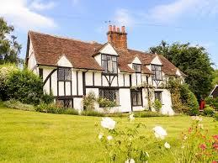 | Make a model of the Tower of London or an instrument of torture, complete with fake bloodstains.
Maths & Problem Solving:  Maths, Thinking Skills, Logic, Problem Solving | Produce at least 10 calculations in the form of Roman numerals | 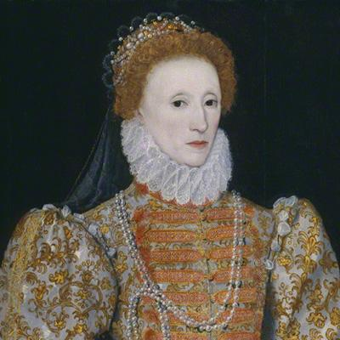 | Design a Tudor-themed board game to help children learn their times table facts. | Plan a trip to a local abbey, e.g. Rievaulx Abbey or Studley Royal with your family. Calculate how much it will cost, how long it will take to get there and write an itinerary for the day. Use search engine to help with research.

GUIDELINES: Choose a minimum of 8 activities, at least one from each row. Your aim is to gain more than 20 points over the term. You can do a maximum of 2 activities from any one row to make up your points. You must have evidence of all the activities you choose – bring it in to talk about with your class by Friday 6th May 2022.

