Y5 Spring Term 2022 Newsletter
Dear Year 5 parents, we hope you have had a wonderful Christmas break and wish you a happy 2022!

This term the children will be introduced to a new topic, and will build upon the skills and concepts learnt in previous years. As always, in year five, we will be working hard to make sure the children learn in a fun and exciting way. Please remember that you do not have to wait until parent’s evening/reports to get in touch. If you have any worries or questions about any aspect of school life, please do not hesitate to get in touch.
Year 5 RE Topics this term:
Local Church-Mission, Eucharist-Memorial Sacrifice, Lent/Easter- Sacrifice

Our first cross curricular topic will be, ‘Europe’ with a focus on the Big Question, ‘What does it mean to be European?’
Europe
What does it mean to be European?
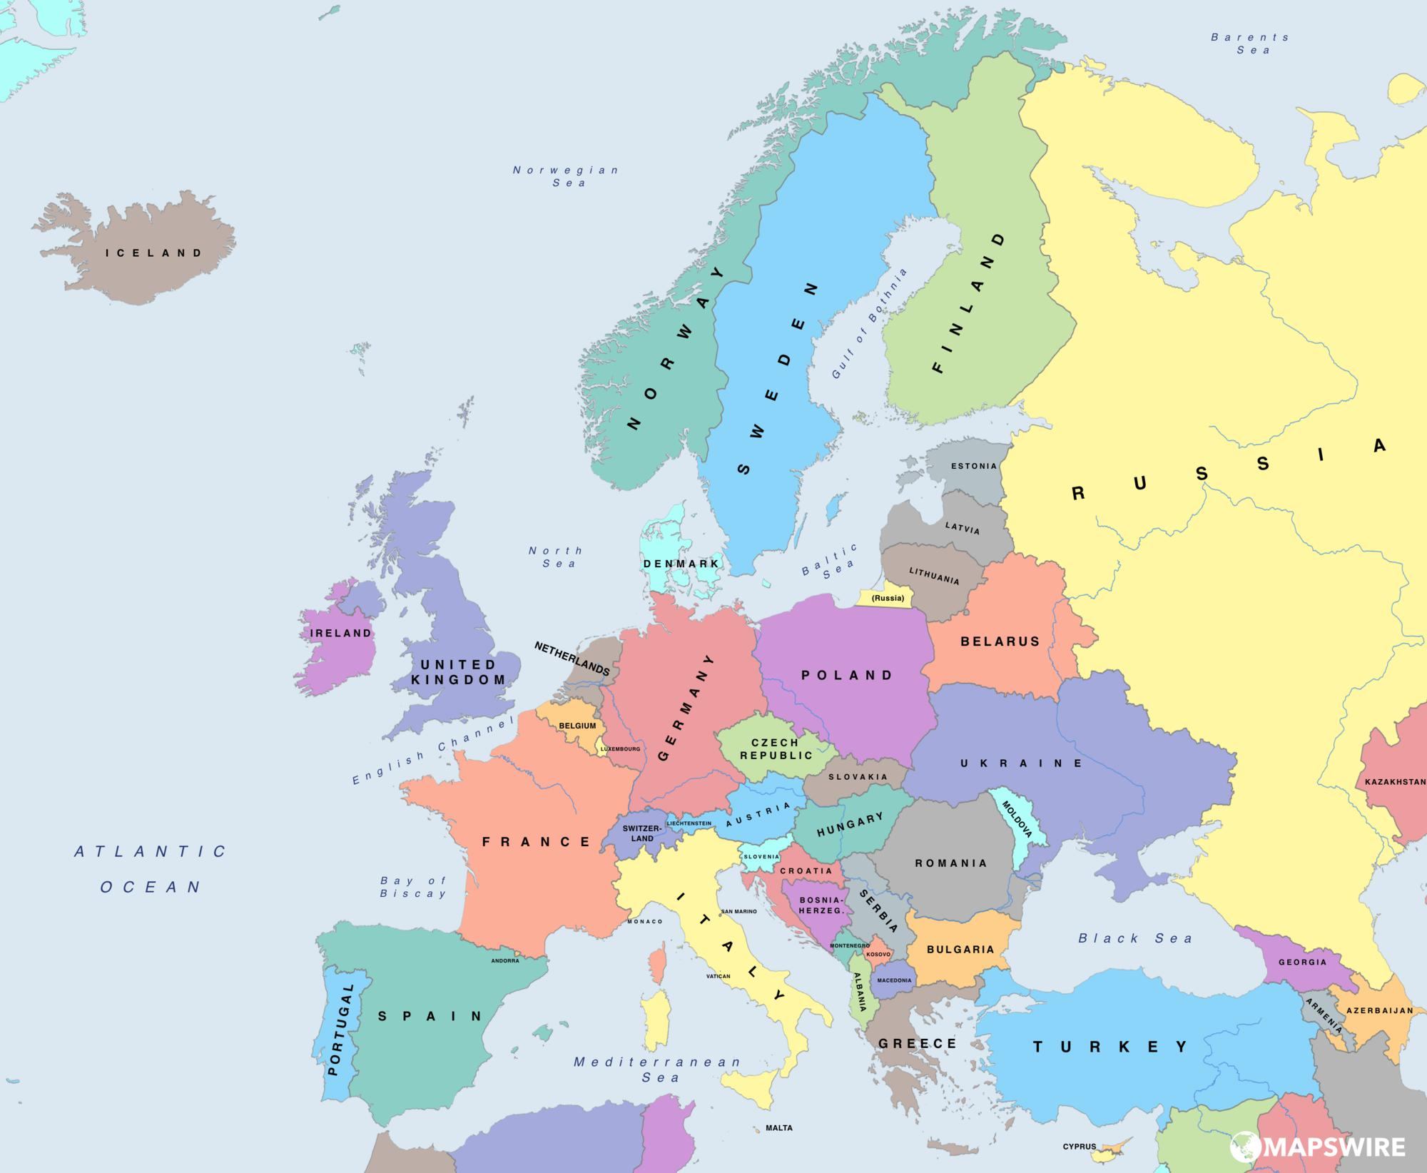

Class novels: Kensuke’s Kingdom and Rooftoppers
History: The History of the European Union
Geography: Aerial images of the Earth, geographical features, maps using 4-figure /coordinate grid references.
Literacy: to persuade- letters, to entertain-story writing, to persuade- speeches, to entertain- poetry
Science: Properties and changes of materials
Art: Drawing and printing- the artist Hokusai-a Japanese artist. Art work linked to Kensuke’s Kingdom.
Design: Moving objects, gears and levers
Computing: E-safety, Animation/photo story- European capital cities. (Film Presentations)

Our second topic is history based and is the ‘Terrible Tudors’- with a focus on the Big Question- Is it right to make your own laws?
‘Terrible Tudors’
Is it right to make your own laws?
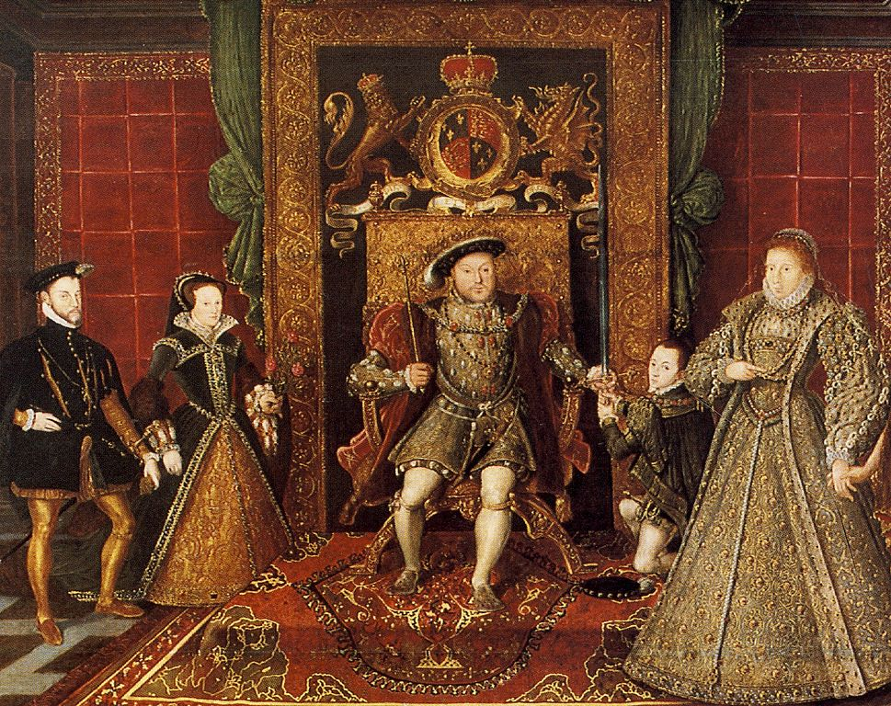

Class novel: Treason
History: The Tudor timeline, Monarchs reign and family tree. The life of Anne Boleyn- chronology, Tudor crime and punishment, rich and poor Tudors,
Geography: Comparing maps of Tudor and modern-day London, looking at settlements, maps and plans of the Tower of London.
Literacy: to inform- historical recount/biography, to entertain- treason description, to inform- Tudor crime and punishment non-chronological report.
Science: Living things and their habitats.
Art: Portraits of Tudors- Hans Holbein. Design: 3D- models of Tudor homes.
Computing: Animation/photo story-Tudor children. (Film Presentations)
Compulsory Homework
Compulsory homework includes reading at least four times a week, learning their spellings and learning their times tables and completing a selection of arithmetic problems.
Reading
As always, we will be relying on your support to ensure that the children are reading to an adult at home at least four times a week. It is important that pupils develop their speed reading so that they can access longer comprehension tasks in a given time. Please can you acknowledge when you have heard your child read, whether this is with a short comment or just a signature. This is how your child will earn their reading certificates, every time they have read ten times at home, they will receive their next certificate. Home reading records will be brought home every day, to be returned to school the following day.
Spellings
Spellings will be given out on a Thursday, and the children will be tested on the spellings the following Thursday. Please help your child to learn their spellings and apply them to some independent writing, as this will help to improve their literacy skills further.
Times Tables
Year 5 pupils should know all their times tables and can recall some of the corresponding/matching division facts. This is a key mathematics skill and essential to tackle the mathematics work throughout Year 5/6. Please spend time helping your child by testing their recall skills. If your child is struggling and still has not learnt their multiplication tables and matching division facts, it is essential that they spend 5 minutes per night on recall!
Arithmetic/Mathematical Reasoning
Arithmetic homework will be sent out on some Fridays and must be brought back into school on the following Friday as this is when it will be reviewed.

Non-Compulsory Homework
Non-compulsory homework are the suggestions on the ‘Europe’ and ‘Terrible Tudors’ homework grids. Those children who earn 20 homework points or more will be given a certificate at the end of the term. At the end of the term, one child will be picked from the class to receive a prize for either producing the most homework or for the most effort put into their homework.
Additional homework
Additional homework may be sent out to consolidate class learning, particularly in RE and mathematics.
PE
PE lessons will take place on Tuesdays and Wednesdays. Pupils should come into school in their PE kits on these days. Remember, the school PE kit is a white top with blue or black shorts. NO football kits are to be worn. Children can wear a tracksuit/joggers/sweatshirt on top of their PE kits. Trainers must also be worn on these days.

Do not hesitate to ask if you are unsure about anything.
With thanks for your continued support, Mrs Taylor (Y5 class teacher/KS2 Coordinator) and Mrs Hamilton (Y5 class teaching assistant)

