Autumn Term 2021

Dear Year 5 parents and carers,
We hope you have had a wonderful summer break!
This term the children will be introduced to a new topic, and will build upon the skills and concepts learnt in previous years. As always, in year five, we will be working hard to make sure the children learn in a fun and exciting way. Please remember that you do not have to wait until parent’s evening/reports to get in touch. If you have any worries or questions about any aspect of school life, please do not hesitate to get in touch.
Year 5 RE Topics this term: Ourselves, Life Choices, Hope.
The term will concentrate on key skills needed to successfully complete Y5. We will review some Y4 learning and close any gaps that are evident.
We are in for a treat this term as for our cross curricula topic we will be learning all about the historical and geographical importance of the Anglo-Saxons.
The Angry Anglo Saxons
History Focus: The Anglo Saxons Geography Focus: Mapping Skills
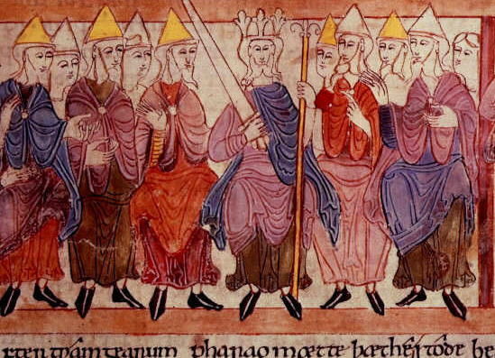
History: Timeline of world history- focus on early civilisations, TimeLine of history during the Anglo-Saxon period, Anglo Saxons: invasion, kings, religion, clothes, writing and homes.
Geography: Location of the Anglo-Saxon civilization, location- mapping of settlements, physical features and climate
Literacy: Explanation Text-How did the Vikings invade the Anglo Saxons? Narrative-King Arthur. Playscript/Poetry Beowulf. Newspaper Report- The Battle for England’s Throne. Fact file- Anglo Saxon God’s
Science: Forces and Earth & Space
Art: Drawing and printing- reflections local area and Anglo-Saxon images
Design: Moving objects, gears and levers- Anglo Saxon Warrior
Computing: Using the internet for topic research and Film Presentations on the Anglo Saxons.
Compulsory Homework
Compulsory homework includes reading at least four times a week, learning their spellings and learning their times tables and completing a selection of arithmetic problems.
Reading
As always, we will be relying on your support to ensure that the children are reading to an adult at home at least four times a week. It is important that pupils develop their speed reading so that they can access longer comprehension tasks in a given time. Please can you acknowledge when you have heard your child read, whether this is with a short comment or just a signature. This is how your child will earn their reading certificates, every time they have read ten times at home, they will receive their next certificate. Home reading records will be brought home on a Friday evening, to be returned to school the following Friday morning. They do not need to come to school on any other day.
Spellings
Spellings will be given out on a Thursday, and the children will be tested on the spellings the following Thursday. Please help your child to learn their spellings and apply them to some independent writing, as this will help to improve their literacy skills further.

Times Tables
Year 5 pupils should know all their times tables and can recall some of the corresponding/matching division facts. This is a key mathematics skill and essential to tackle the mathematics work throughout Year 5/6. Please spend time helping you child by testing their recall skills. If your child is struggling and still has not learnt their multiplication tables and matching division facts, it is essential that they spend 5 minutes per night on recall!

Arithmetic/Mathematical Reasoning
Arithmetic homework will be sent out on some Fridays and must be brought back into school on the following Friday as this is when it will be reviewed.

Non-Compulsory Homework
Non-compulsory homework are the suggestions on the ‘The Anglo-Saxons’ homework grid. Those children who earn 20 homework points or more will be given a certificate at the end of the term. At the end of the term, one child will be picked from the class to receive a prize for either producing the most homework or for the most effort put into their homework.

Additional homework
Additional homework may be sent out to consolidate class learning, particularly in mathematics.

PE
PE lessons will take place on Tuesdays and Wednesdays. Pupils should come into school in their PE kits on these days. Remember, the school PE kit is a white top with blue or black shorts. NO football kits are to be worn. Children can wear a tracksuit/joggers/sweatshirt on top of their PE kits. Trainers must also be worn on these days.

Do not hesitate to ask if you are unsure about anything.
With thanks for your continued support, Mrs Taylor (Y5 class teacher/KS2 Coordinator)

