Welcome to the Year 4 Newsletter ...

Dear Parent / Guardians,
We are so excited to start this new school year as a single year group. The children have quickly settled in to their new classrooms and are already working hard.
Our P.E days are Tuesdays and Thursdays and will take place outside so outdoor PE kit will be needed.
Books will be changed on Monday, Wednesday and Friday whenever possible but we encourage nightly reading and a short comment from parents.

Mrs Brady & Mr Joyeux (Year 4 Teachers)
Autumn 2024


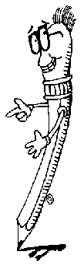
Autumn Term  Reading – The Queens nose  The Raven  The Girl who stole an elephant | Writing – Poetry forms and performance  Persuasive writing - adverts  First person diary entries  Critical analysis of poetry  Thirs person adventure stories  News reports
This term will focus on the following elements of the new English Curriculum.
Reading 1 – children will read daily from a range of genres and purposes. We will focus on the mechanics of reading, pace, fluency expression, volume as well as reading using inference, summarising discussing predicting and forming our own opinions about characters themes and plot.
Writing - children will cover a range of spelling, grammar and punctuation in their daily lessons. They will read and analyse model texts to work out layout and structure. Children will plan effectively following a plan and write their own longer piece of writing using their plan to support them. Finally, they will use a range of strategies to edit and improve their writing.

Autumn Term term (Revisit and extend the following units)
Place Value:
Children will be taught to represent and partition numbers to 1000 and use number lines to place these. They will then extend this for numbers to 10,000. We will learn 1,10,100,1000 more or less than a number, compare and order numbers to 10,000. We will learn about Roman Numerals. Children will also be taught how to round to the nearest 10, 100. 1000 before learning to round to the next 10, 100 or 1000.
Addition and Subtraction:
Children will begin this unit by adding and subtracting 1, 10, 100 or 1000 from a given 4-digit number. Children will be taught to add 4- digit numbers without exchanging before moving on to addition with exchanges. They will then learn to subtract 4-digit numbers without exchange before finally subtracting including exchanges.
Area: Children will recap what the term area means. We will initially begin by counting squares, making shapes and comparing areas.
Multiplication and Division:
Children will work systematically through their multiplication tables beginning with multiples of 3, multiplying and dividing by 3, 6 x tables and division facts, multiplying and dividing by 9, 9 x tables and division facts, 3,6 & 9 x tables, 7 x tables before moving on to 11 and 12 x tables. We will learn about multiplying and dividing by 1 and 0 as well as dividing a number by 1 and itself. We will end our term by practising multiplying by 3 numbers.

Please note Year 4’s will be required to sit the statutory Multiplication check in June 2025. It is expected that they know all multiplication facts up to 12 x 12 by the end of Y4.

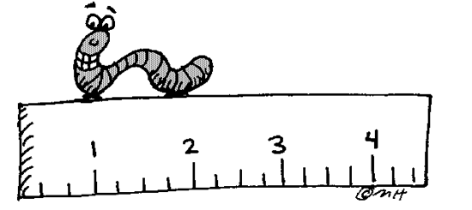

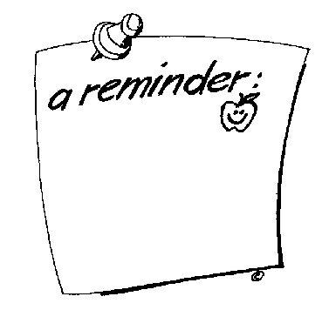
Foundation subjects

Water bottles to be brought in daily.
Outdoor PE kit required Tuesdays and Thursdays.
Please label your child’s uniforms – we have so much left behind with no name.
Home Reading books to be brought in to be changed Mon, Wed & Friday.

SCience
The Human Body
In our lessons we will be taught that All living things are made
French

Bonjour !!
French lessons in year 4 will revisit the calendar in French (days months and numbers) before moving on to colours, numbers and emotions.
We continue to say prayers and follow simple instructions in French.

up of cells, our body requires nutrients to keep healthy,
Nutrients are found in the food we eat. We will learn
about the four types of teeth: digestion and healthy eating.
.
Classification of plants & Animals
In this topic we will learn a range of ways to classify plants and
Animals, using terms such as vertebrates and invertebrates, cold
and warm blooded, mammals, insects, molluscs & arachnids.
.

History/Geography
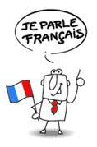
Our History topic for Autumn Term is Ancient Greece We will learn that Greece was made up of made up of independent city-states including Athens and Sparta. We will learn about key figures in Greek history.
Our Geography topics this term begin with Spatial sense. Mapping skills focussing on lines of latitude. Longitude and the tropics.
Our second topic is Mediterranean Europe, considering weather climate, position as well as making comparisons.

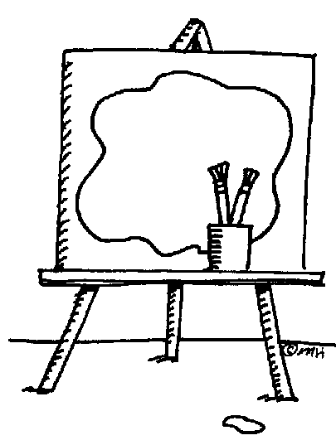


D&T/Art
Art – Line - Exploring line and using our sketchbooks we will explore
with Line weight, study how artists use line in different ways including how
Hokusai – The Great Wave was created.
Colour still life and Form - In our lessons we will be introduced to still life.
Creating form with tone drawing a still life using cross-hatching. We will study
Cezanne and draw a still life using colour.
D&T - topics will be food and nutrition and mechanisms.

Computing & Music
Computing systems – a look at networks, the WWW and will include internet safety and ownership.
Creating media – digital recording & creating podcasts.
Music – In class we will be learning using the Sing up scheme focussing on Pentatonic scale, gospel music, off-beat, rhythm, call-and-response
We will work with Mrs Maxson each week.

Religious Education
We will follow the new RE scheme – Be still and know;
Our first topic is Creation and Covenant which teaches us about the Old Testament and the covenant made between God and Abraham. Our second topic is Prophesy and Promise which will help us to prepare for Christmas.
Physical Education
PE TIMES: Tuesday & Thursday mornings
Our topics this term will be Athletics, and dance, Children will be taught skills, rules as well as
teamworking
and leadership
skills.

PSHE: We will continue to follow our Jigsaw PSHE scheme, Topics this term will be;
- Being me in my world.
- Celebrating difference.

