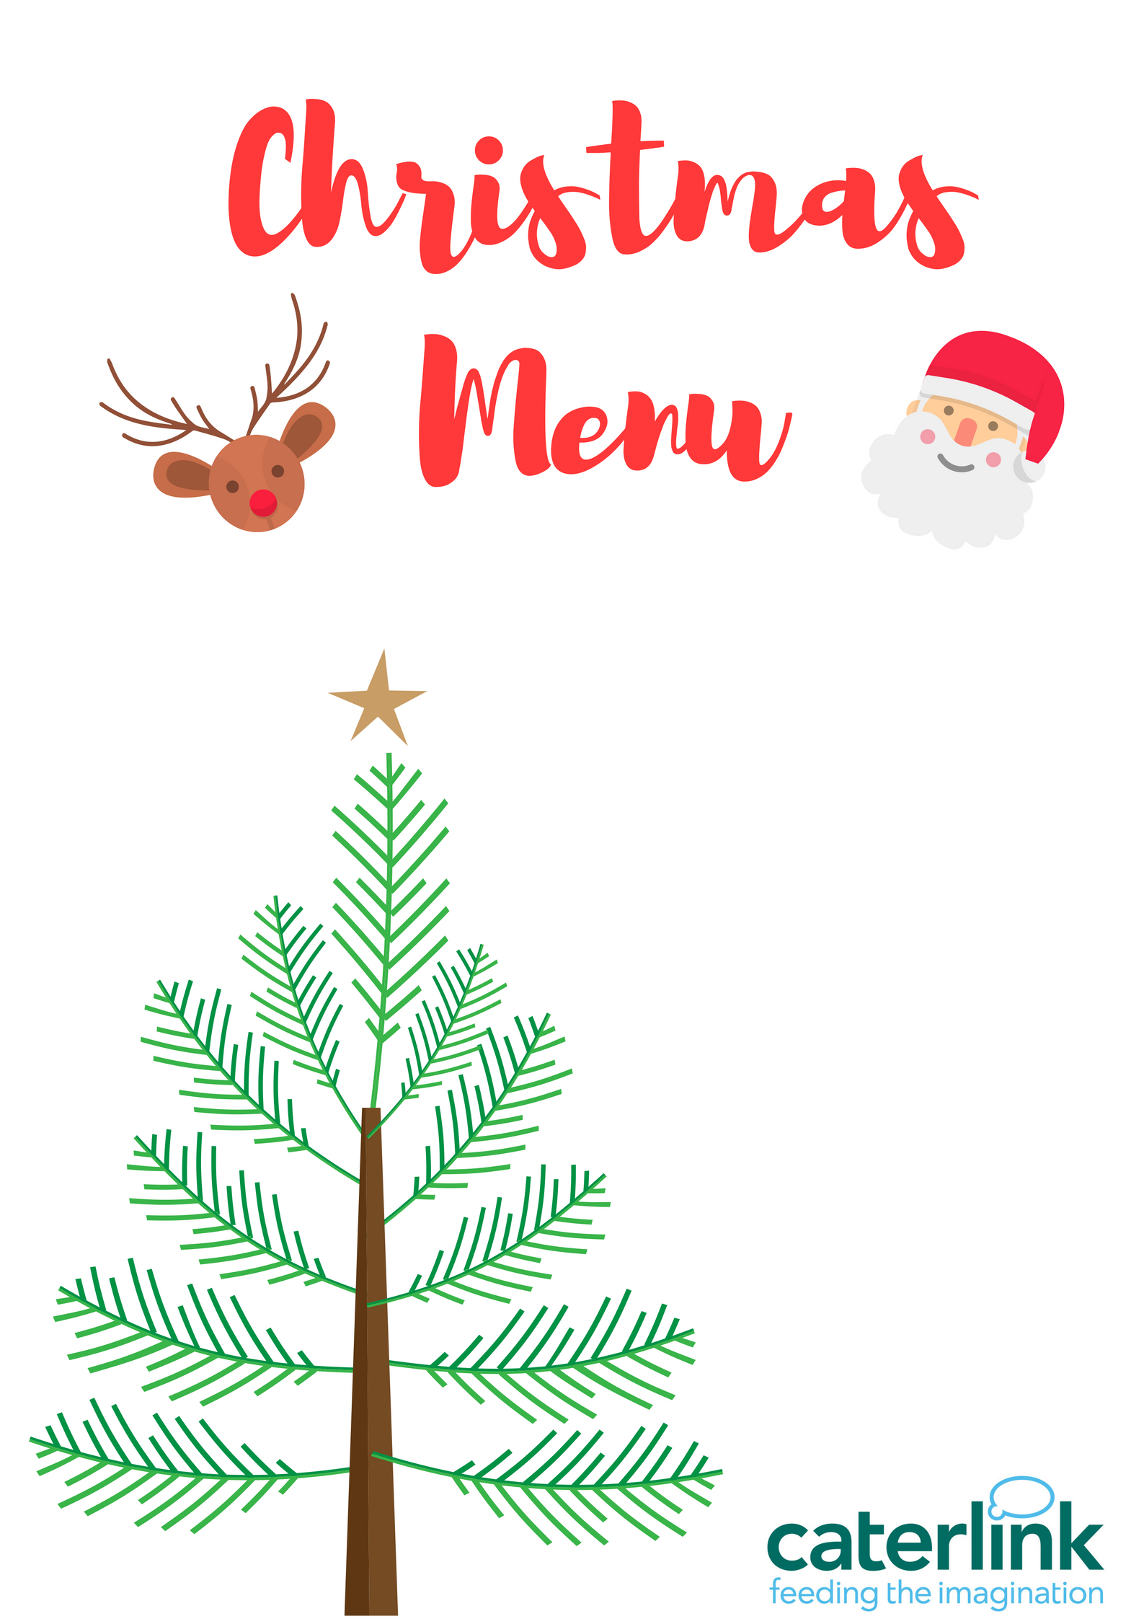

Roast Turkey with pigs in blankets, Stuffing & Gravy
or
Quorn Fillet
Roast & Mashed Potatoes
Peas & Carrots

Chocolate Frosted Xmas Log
Ginger & Orange Cake
Christmas Biscuits

Dessert Option

