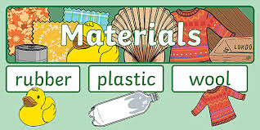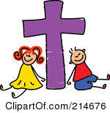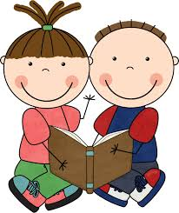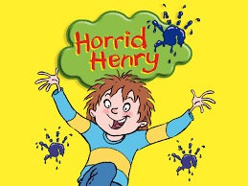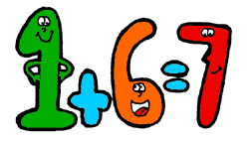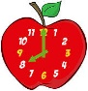

**Science**

**Uses of everyday materials**

The children will identify and compare

the suitability of some everyday materials

for particular uses. Plastic and fabrics are

looked at in detail. We will find out how the shapes of solid objects made from some materials can be changed and think about new uses for materials.

**RE**

This term we will be studying the three themes of Local Church (Community), Lent (Easter) and Eucharist (Relating).

We will approach the themes

through the following topics:

* **Books**
* **Thanksgiving**
* **Opportunities**

**Curriculum**

Geography in Spring term is all about Mexico. We will learn all about this South American country, its physical geography (landscape, weather & climate) and its human geography (people, beliefs and culture).

In Art we will be studying art from other cultures, again taking inspiration from Mexican art and artists. We will focus on painting, drawing and sculpture. In Design and Technology, the children will create their own Mexican menu. They will experience tasting a range of different Mexican foods and learn about the different ingredients used in Mexican cuisine.

Our music topic for this term will be “Reflect, Rewind and Replay”. This focuses on Western Classical Music. The material presents an integrated approach to music where games, the interrelated dimensions of music (pulse, rhythm, pitch etc.), singing and playing instruments are all linked.

P.E. will be taught on a Wednesday and Thursday. Children can come into school wearing their full P.E. kit on both of these days.

PSHE will be taught through a cross curricular approach, covering the following themes: Health and Well Being, Relationships and Living in the Wider World which will be interwoven into the curriculum.

**English**

**Roald Dahl:** The Magic Finger

**Francesca Simon Stories:** We will use the Horrid Henry books as a stimulus for writing with a focus on chapter books and short novels. We will compare stories by the same author.

**The Enchanted Wood by Enid Blyton**: The children will focus on descriptive writing to set the scene and create characters.

**Non Narrative Writing**

**Persuasive Writing:** We will use “The True Story of the Three Little Pigs” as a stimulus for this. We will also be making links to our science topic – materials.

**Information Texts:** ‘The children will learn how to organise and find information using a glossary, index and contents page.

**Phonics, spelling and handwriting as well as speaking and listening skills will continue to be embedded throughout the English curriculum.**

Dear Parents/Guardians,

This newsletter will provide an overview of the curriculum this Spring Term. The curriculum outlined here will mirror work in school and remote learning for continuity. You will be able to see an overview of the objectives covered in each subject. Work will be assigned daily and we will do our very best in order to support you and your child as best we can by uploading the necessary resources and learning tools. There may be some teething problems along the way as we navigate remote learning and live lessons but please bear with us. If you have any problems or queries please do not hesitate to get in touch. Our very best wishes to all of you,

Mrs Fox, Mrs Harris-Matthews and Miss Melvin

**Year 2 Medium Term Planning**

**Spring 2021**

**Mathematics**

During the Spring Term work will be centred around the following topics.

* **Number and Place Value**
* **Addition and Subtraction**
* **Multiplication and Division**
* **Fractions**
* **Geometry**
* **Measures**
* **Money**
* **Time**